**A Naked-eye Guide to the Night Sky**

**The Stars of August**

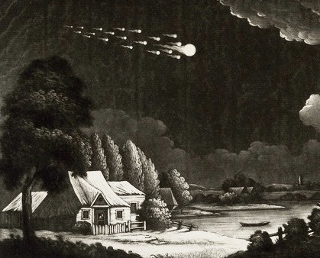

*Meteor Shower in the Night Sky. Henry Robinson ca 1783.*

*August* is not just the eighth month of the year. The word also describes something regal or majestic. And what could be more majestic - or *august* – than a sky strewn top to bottom with the lights of stars and meteors?

In some traditions, August heralds the start of fall. For the Celts, the month began with observance of Lammas, the cross-quarter midpoint between solstice and equinox. Commencement of the harvest was celebrated by baking bread from the season’s first cut of wheat.

To be sure, even as the warmth of summer lingers, signs of fall are in the air. Is it something in the slant of light? Something in the colors of leaves? Or is it something audible in the voice of the wind? Whatever the case, the midday Sun is drifting south. By mid-month the familiar stars of summer will have begun their slow slide toward the west, while elsewhere in the darks a host of figures will make new appearance to herald the change of seasons.

The pages that follow will introduce you to the stars alight in this month’s sky. Printable maps are attached to the end of this guide - they depict the stars as seen from mid-northern latitudes in the hours shortly after sunset, and will serve reasonably well for the entire month. Viewing is best on a moonless night. You’ll want a vantage point with an uncluttered horizon, away from the glare of lights. A general sense of the cardinal compass directions is also helpful. If you’re not already familiar with how to read a map of the sky, there’s an attachment offering some pointers – you might take a few moments to look it over before your session with the stars. Otherwise, print the charts, grab a red-filtered flashlight, and head outside for an evening under an *august* sky….

**The Northern Sky**

We’ll start with a look at the northern sky. Stars near the pole will be familiar from recent months, but their positions have shifted with the passage of time and our planet’s movement through space. Begin by locating the pattern of stars known as the **“Big Dipper**.**”** It’s comprised of seven prominent stars, relatively equal in brightness, and probably the most widely recognized figure in the sky. End-to-end, the Dipper measures about a hand-span, viewed at arm’s length with fingers splayed wide. It’s visible most nights of the year from any location in the Northern Hemisphere - hour by hour and season by season it circles the northern skies, sometimes appearing “right-side-up” and other times spilling its contents. Nevertheless, face the Big Dipper and you know you’re looking north-*ish*.

Now find the stars **Merak** and **Dubhe** at the end of the Dipper’s bowl. The names of these stars come from Arabic, and refer to the figure of a bear – reminders that the Dipper is part of a larger group of stars called **Ursa Major,** the **Great Bear**. But Merak and Dubhe are also known as “the pointers,” because an imaginary line drawn through them points to **Polaris,** the **North Star**.

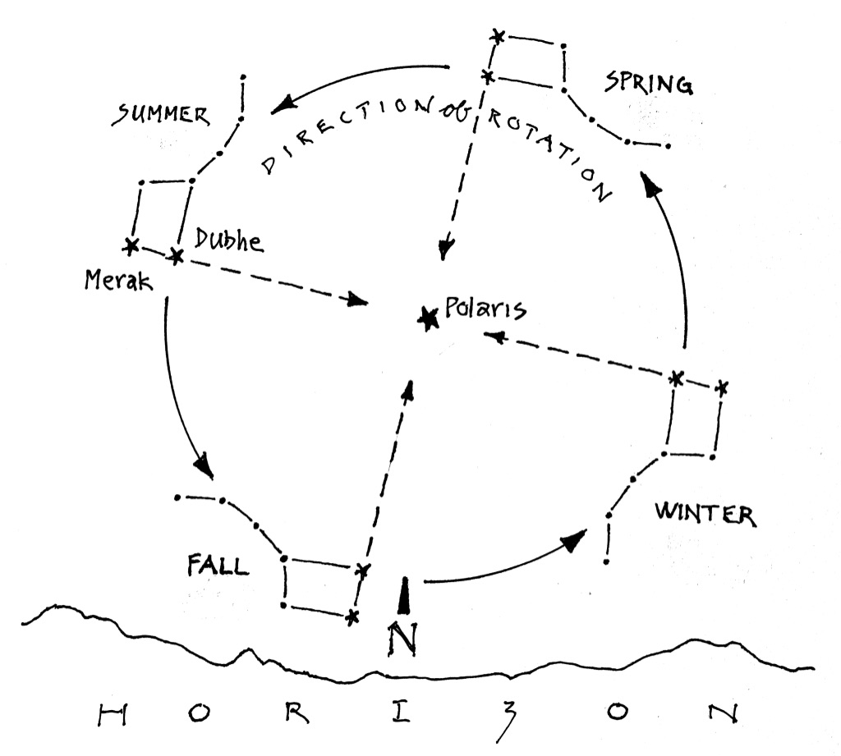

**Figure 1: Finding North by the Big Dipper.**

*Merak and Dubhe point the way to the North Star, Polaris.*

*Diagram shows approximate position of the Big Dipper, season by season,*

*in the hours shortly after sunset. On August evenings, you’ll find the Dipper “falling” toward its position in the skies of fall.*

The North Star is not especially bright, but it’s the first prominent star you’ll spot along that line from the pointers. Seen from mid-latitudes, Polaris sits roughly halfway between the horizon and zenith, the point directly overhead. It’s the only star in the sky that stays put, no matter the hour or season. Face Polaris, and you’re looking north – not just north-*ish*, but the *Real Deal*.

Once you have your bearings, it’s time to pull out your star chart. Face Polaris and hold the chart in front of you like a steering wheel, with “N” at the bottom, pointing toward the ground. That “N” on the chart represents the north point on the horizon in front of you. Stars in the lower half of the chart will match what you see in the northern sky.The center of the chart represents zenith - anything above that on the chart is actually in the sky behind you.

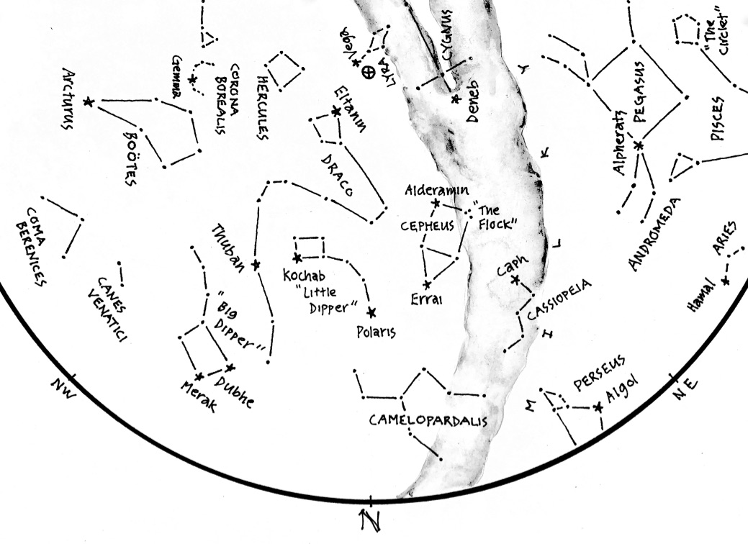

**Figure 2: The Northern Skies of August**

*A detail from this month’s star chart: Dippers, the Royals,*

*and a Dragon lording over all.*

From Polaris, look for an arc of dim stars leading upward and left to a small rectangle. These stars form the figure of the **“Little Dipper”**, the most visible part of **Ursa Minor,** the **Lesser Bear**. **Kochab**, brightish star at the Dipper’s rim, is sometimes called “the Guardian of the Pole.”

Look next for an arc of dim stars wrapped neatly around the Little Dipper, curving upward at the right to end in a group of four. This is the writhing figure of **Draco,** the **Dragon.** The group of four marks the Dragon’s head - brightest of the bunch is **Eltanin**, Arabic for “head of the Dragon.” Elsewhere in the figure you’ll find **Thuban** – inconspicuous perhaps, but it marked the pole when the Egyptians were building their pyramids. The Dragon is an ancient figure, long associated with disruption and chaos. Last month’s star guide described the Dragon’s hold on Earth’s axis, and the drift of the northern pole – stark reminders that fame is fleeting, and that even stalwart Polaris will be unseated in the course of time.

Now return to the pointers Merak and Dubhe, and extend a line *past* Polaris to the next star you see. This is **Errai**, a prominent star in the figure of **Cepheus, King of Aethiopia**. The assemblage resembles a house you might have drawn as a five-year-old, turned upside-down on these late-summer eves. Classical depictions show a monarch seated on a throne, but there’s humility beneath the royal veneer. Errai is Arabic for shepherd, well-suited for a star on constant watch. Errai never sets – instead, it tirelessly circles the pole, comfort and companion to shepherds through the long darks of night. See if you can locate “the flock” quietly grazing elsewhere in the figure of the King.

Clockwise from the King, look for the distinct zig-zag of five stars marking his consort, **Cassiopeia.** You might be familiar with the tale of havoc wreaked by her boasts of beauty. The star atop the figure is **Caph**, which translates to “hand”. Imagine it clutching a mirror, into which the Queen gazes in self-admiration. While she’s otherwise distracted, take a moment to note that a line drawn from Caph through Errai, the shepherd, points roughly to Polaris - a handy guide to the pole star if the pointers of the Dipper are obscured.

Below the Queen you might glimpse **Perseus,** the **Hero**. He’ll make full appearance in September with a story to tell, but his entrance is already heralded with fanfare: In the darks of mid-August, the Hero throws forth a spectacle known as the Perseid Meteor Shower. More to say about the fireworks later. For now, look for the Hero in three brightish stars inching clear of the northeast horizon.

Last in the north, look directly below Polaris for an indistinct smattering of stars marking the figure of **Camelopardalis**. The name is a Latin mash-up of the Greek words for “giraffe” and “leopard.” If you have difficulty making much of the figure, you’re in good company – the Greeks deemed this portion of the sky devoid of stars. On these evenings of August, the giraffe-leopard treads lightly along the horizon, escaping the gaze of the Dragon high above.

Most of the stars we’ve identified in the northern sky are *circumpolar*. You’ll find they’re always visible - clock and calendar in the northern sky, turning slowly ‘round the Pole through the hours of the night and the seasons of the year.

**The Western Sky**

Shift your attention to the west with a quarter turn to the left. Rotate your star chart so “W” is at the bottom, toward the ground. What you see in the bottom half of the chart will match the brightest stars in the western sky, as seen in **Figure 3**. You’ll likely recognize many of them from last month’s star chart. Now, they steer for the horizon after a season overhead - much as our own star, the Sun, seeks respite in the west at the close of day.

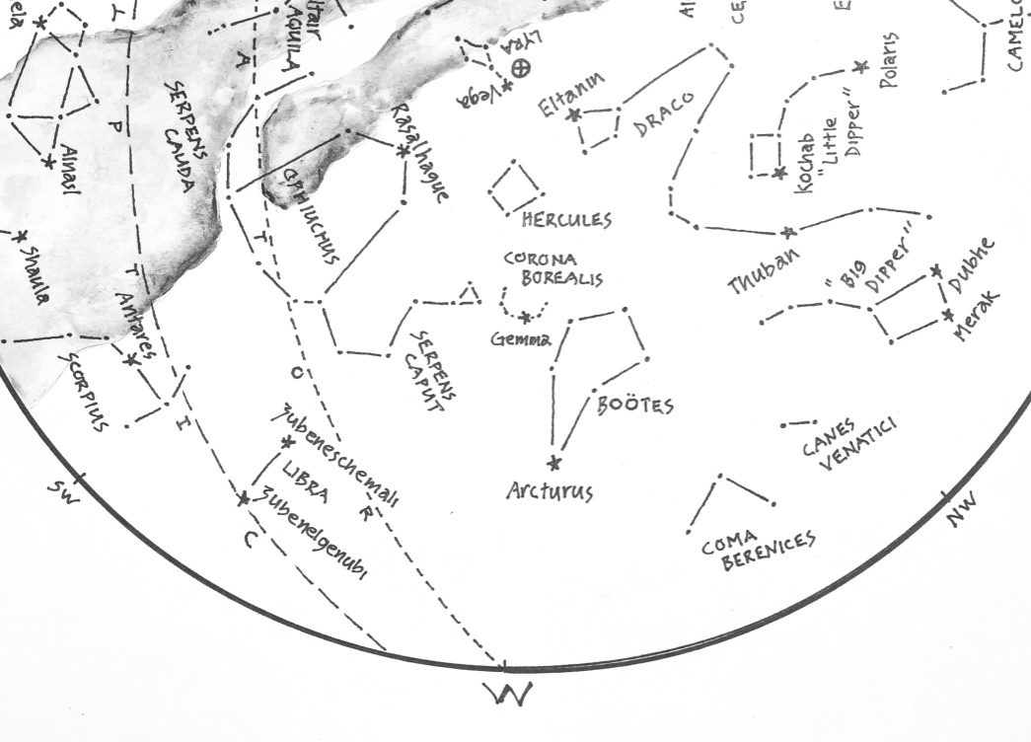

**Figure 3: The Western Sky**

*Arc to Arcturus….*

Find again the Big Dipper, and extend the arc of its handle left to the bright star **Arcturus** (handy reminder:*“Arc to Arcturus”…).* Arcturus is distinctly red, third brightest star in the sky. It marks the figure of **Bootes** the **Herdsman**, looming just above Arcturus in a kite-shaped group of dimmer stars. Sometimes known as the “Bear Driver”, Bootes keeps watchful eye on Ursa Major circling the pole nearby. The Herdsman is aided by his faithful dogs, **Canes Venatici.** You’ll find them to the right, nipping at the heels of the bear.

Between the Herdsman and his dogs, look for the wispy figure of **Coma Berenices**. Named for an Egyptian queen and her beautiful hair, the figure marks the direction of our galaxy’s northern axis. A look in that direction is *upward and out* of the disk of the Milky Way to reaches of emptiness beyond our home. Watch this month as the axis sinks westward, drawing the band of our galaxy higher.

Just left of the Herdsman you’ll find **Corona Borealis**, the **Northern Crown**. Brightest star in this lovely figure is **Gemma,** truly a prize in the western sky. The Crown has inspired many interpretations: A string of jewels, certainly, but for some a circle of elders, or a smoke-hole in the celestial sweat lodge… even a boomerang in the eyes of indigenous Australians. The Mesopotamians knew the figure as **Nanaya**, goddess of love and sensuality. Her name means “the one who keeps calling”, reference perhaps to the figure’s persistent charms.

Now follow the arc of the Crown upward to the “keystone” of **Hercules**. Four thousand years ago, the keystone was seen as **Marduk**, patron god of Babylon. It was Marduk who established world order by defeating **Tiamat**, the agent of chaos, a Herculean task by any measure. later, the Greeks saw Hercules as the **Kneeling Man**, forever bearing the weight of the atmosphere on his shoulders. Last month found him at zenith, upholding the arch of the sky. This month he leans westward, hoping to off-load his burdens.

Next, look for **Ophiuchus**, the **Snake Handler**. The figure can be hard to identify owing to its sprawling size, but the brightish star **Rasalhague** is a good place to start – the name translates from Arabic as “head of the snake charmer.” Formerly known as **Serpentarius**, the figure is testament to the long association between snakes and healers. As for the snake, you’ll find it here in two halves: the tail, **Serpens Cauda**, curls upward in warning to the left, and the head, **Serpens Caput**, rears upward to the right, eyes narrowed on the Gem in the Northern Crown.

Below the Serpent Handler, look for two stars marking the **Scales of** **Libra**. Once connected to the figure of **Scorpius** the **Scorpion**, these stars have come to symbolize balance by virtue of their similar appearance. But their names betray their origins: higher of the two is **Zubeneschemali** and the lower is **Zubenelgenubi** – “northern claw” and “southern claw” in Arabic. The Scales belong to the Zodiac, the circle of figures through which the Sun and Moon and planets pass on their migrations.

**The Southern Sky**

Position yourself to view the southern sky with another turn to the left. Rotate your star chart so “S” is at the bottom, pointing toward the ground. You’ll know for sure that you’re facing south if Polaris, the North Star, is directly behind you.

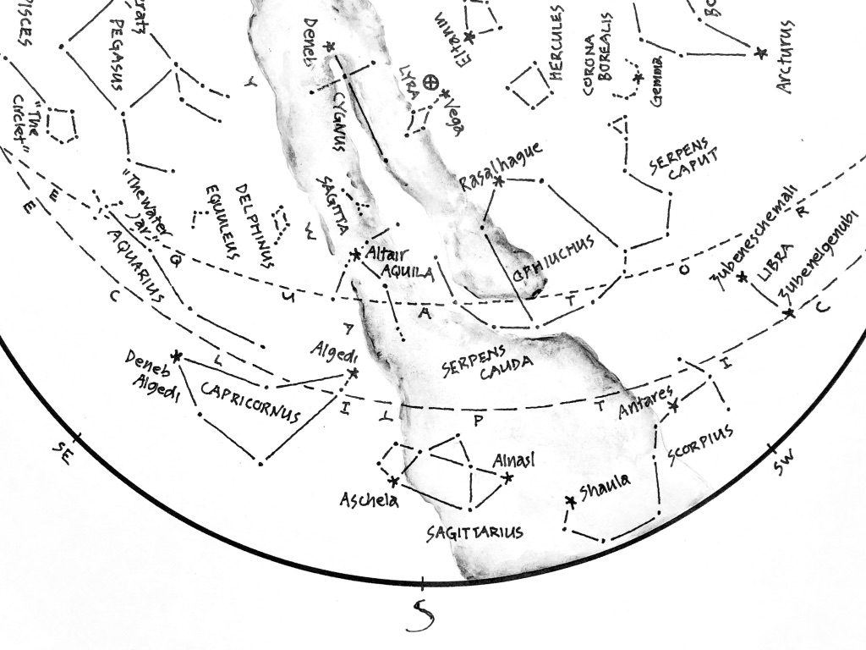

**Figure 4: The Southern Sky**

*Home of the**winter Sun.*

Begin your survey of the southern skies by looking for the distinct red star **Antares,** “Rival of Mars.” It’s the brightest star in the figure of the **Scorpius,** mentioned earlier. The body of the Scorpion curves downward and left from Antares, then upward to end at **Shaula**, “the sting.” Pacific Islanders saw here the image of a fishhook, used by the trickster Maui to raise islands from the sea.

Left of the Scorpion, look for the figure of **Sagittarius,** the **Archer**. It’s close to the horizon, buried in the glow of the Milky Way. The Archer itself is hard to picture in the arrangement of stars - you’re more likely to recognize the familiar form of a teapot with steam of the Milky Way issuing from its spout. The star **Elnasl** translates as “the point,” a reference to the Archer’s arrow - as luck would have it, a handy signpost to the center of our galaxy, alight with a multitude of stars. For comparison, trace the galaxy’s curve across the sky overhead, and you’ll see that it dims noticeably toward its outer reaches in the north behind you. The band of the Milky Way has inspired numerous interpretations: a bridge, a river, a suture in the heavens… or, as its name suggests, a splash of milk. For some, it marks the Road of Souls, traversed by the dead and lit with the glow of their campfires as they journey from this incarnation to the next. The Archer stands as guardian of the underworld, pointing the way to a gathering of souls in the light at the end of The Road.

Continuing to the left you’ll find the **Goat-Fish**, **Capricornus.** It’s a dim triangle of stars, challenging to discern. The star **Algedi** translates as “head of the goat.” Opposite, look for **Deneb Algedi** – “tail of the goat”, as one might expect. Thousands of years ago, the Goat-Fish played host to the Sun on the winter Solstice. Over time, the wobbling drift of our planet’s axis has moved the Solstice into the figure of Sagittarius, but the Goat-Fish’s claim on the solstitial point lingers on as the Tropic of Capricorn.

For northern observers, the Goat-Fish is never far from the horizon. It stands on the western shore of the Celestial Sea, an expanse of sky awash with figures we’ll meet in the weeks ahead. For now, look for **Aquarius**, the **Water-Bearer**, in a string of stars above and left of the Goat-Fish. The figure is vaguely reminiscent of an ocean swell in its gentle undulation. The string is tied to a Y-shaped cluster known as “the Water-Jar”. For the ancients, passage of the Sun through the stars of Aquarius heralded the promise of rain. **Sadalmelik**, a star close by the Water Jar, translates as “lucky Star of the King”, reference perhaps to bounties of spring that follow the passage of winter.

Scorpius, Capricornus, and Aquarius are signs of the Zodiac. They and others like them line the *ecliptic*, the path of the Sun, Moon, and planets across the backdrop of stars. The Moon is most energetic of the bunch, cycling though the Zodiac in the course of a month. The planets are slower by far, owing in part to their *retrograde motion -* moments of doubt and indecision when they stop to admire the view, or move *backwards* in search of something dropped or forgotten. This penchant for planets to retrace their steps confounded astronomers for centuries, thwarting attempts to understand the mechanics of the clockwork overhead.

The Sun, meanwhile, plods steadily eastward along the ecliptic at the rate of one degree per day - roughly the width of your up-raised pinky as seen at arm’s length. The word “degree” derives from an ancient root meaning “to go” or “walk” – inspired by observations of the Sun’s movement through the background of stars. You can see this movement unfold by watching signs of the Zodiac nearest the horizon just after sunset or just before sunrise. Over time, the signs will be seen to shift as the Sun progresses. The movement, of course, is illusion, brought on by our planet’s waltz through space. But the illusion is compelling, and over the course of a year the Sun appears to make a full circuit of the ecliptic, visiting in turn each of the twelve signs of the Zodiac. The geometry is wonderfully forgiving: One degree per day works (roughly) to thirty degrees per month; twelve such months equate (roughly) to a year. A year, therefore, sees (roughly) twelve full cycles of the Moon, each of which sees the Sun amble through thirty degrees of the Zodiac. *Three* passes of the Moon, and Sun travels *ninety* degrees - a quarter circle ‘round the year, equivalent (roughly) to a season. Inexact? Well, yes…. but close enough to have inspired calendars since the beginning of time.

The constancy of the cosmic clockwork has served for thousands of years as welcome relief from the messy realities of a world prone to disaster. *Dis-aster*: literally, “against the stars” - a nod to the lights above, steady in their courses and held in high esteem for their measured predictability. So unlike the world close at hand, where systems fail, empires crumble, and winds of fortune swirl with uncertainty. The stars appear unwavering, Imperturbable arbiters of space and time with nary a disruption of their clockwork precision.

Or so it would seem - but nothing could be farther from the truth. The stars are *not* immutable. They’re subject to caprices unfolding on timescales far beyond the confines of human experience and comprehension. Only over *long* arcs of time are changes in the cosmos apparent. Two thousand years ago, the Greek astronomer Eratosthenes observed that Antares, brightest star in the Scorpion, was out-shone by Zubeneschemali in the Scales of Libra. But three hundred years later, Ptolemy of Alexandria observed that the two stars were of *equal* brightness. Which begged a question: Had Antares grown *brighter*? Or was the Northern Claw slowly *dimming*? In either case, evidence that we live in a universe where change is one of the rules. And so we wait and watch in the darks, alert for hints of a wrinkle in the fabric overhead.

For now, remember that August heralds a change of season. As the Sun sets *westerly,* stars to the *south* – a quarter turn along the horizon *-* show where it will take up lodging in the months ahead: with the Scorpion for Thanksgiving, with the Archer for the Solstice, with the Goat-Fish in the New Year, and with Aquarius in the month of February. Of course, you’ll not see those figures behind the glare of the Sun, but you can well imagine them as they appear now, strung shoulder-to-shoulder across the southern skies.

**The Eastern Sky**

Direct your attention now to the eastern skies, and adjust your chart accordingly. You’ll know you’re facing east if Polaris, the Pole Star, is directly to your left.

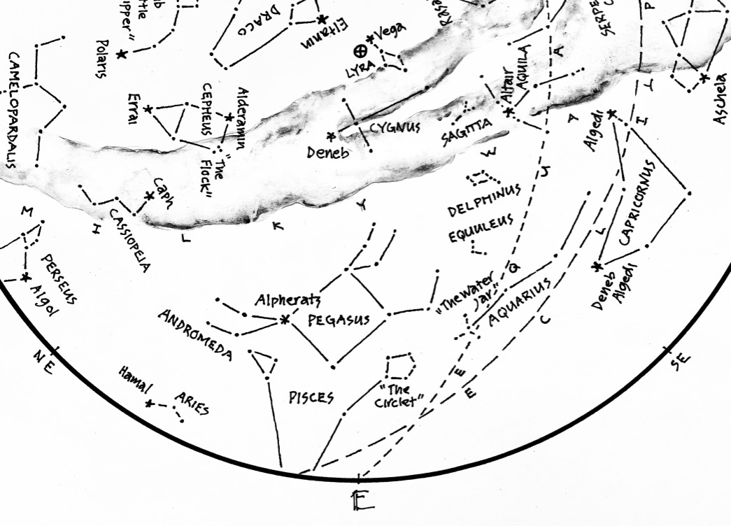

**Figure 5: The Eastern Sky**

*Some of the smallest figures to be seen - and one of the largest.*

Last month’s eastern sky was dominated by the Summer Triangle - three conspicuous stars, each the brightest in a figure of its own. This month they ride even higher, carried aloft on the back of the Milky Way. Brightest of the three is **Vega**, fifth brightest star in the sky. It belongs to the figure of **Lyra**, the **Harp**, along with five dimmer stars close beside. In the hands of Orpheus, the Harp is said to have charmed rivers with its music, and drowned the calls of sirens as they tempted sailors at sea.

Vega is one of the most studied stars in the sky. Twelve thousand years ago it commanded attention as the Pole Star, before the wobble in Earth’s axis gradually cast it aside. In the centuries that followed it wandered the skies in ever-widening circles, a herald for the change of seasons and beacon of navigation for prehistoric sailors. Later, it was the first star to be photographed. Later still, it was the first to have its color spectrum analyzed. Today, it serves as a standard for gauging the brightness and colors of other stars. One might wonder what further distinctions await Vega before it returns to the pole in thirteen thousand years.

Now look below and slightly left of Vega for **Deneb**, another star of the Summer Triangle and brightest in the figure of **Cygnus** the **Swan**. Deneb is Arabic for ‘tail” - you can spot the Swan to the right, winging southward for the change of seasons. By December it will have molted, shedding feathers to reveal itself as the **Northern Cross**.

Complete the Summer Triangle by finding **Altair**, brightest star in the figure of **Aquila**, the **Eagle**. Some traditions saw the Eagle as a messenger, in full command of the void between heavens and Earth. Others saw a vulture, revered for scavenging bodies and returning souls skyward. In either case, it’s easy to picture the bird with wings outstretched against the band of the Milky Way.

The stars of the Summer Triangle figure prominently in the tale of the Weaver and the Cowherd, star-crossed lovers banished to opposite sides of the River of Stars. The story survives today as inspiration for the Chinese Festival of Double Sevens. Each year, on the seventh day of the seventh lunar month, the Weaver and Cowherd – embodied in the stars Vega and Altair – unite for a single evening, crossing the Milky Way on a bridge of magpies through the figure of the Swan. On the Gregorian calendar, the Night of Sevens usually falls in the month of August, as fine a time as any for a tryst on a riverbank of stars.

Another trio awaits in the eastern skies, dim by comparison but worthy of attention. Look first for **Sagitta**, the **Arrow**, close by Altair of the Eagle. The Arrow has survived in map and myth for over two thousand years. To the Greeks it was “Oistos”. To the Arabs, “al-sahm”. An arrow by any name, loosed to fly among the stars. Next, look for **Delphinus**, the **Dolphin**, cavorting in the darks below the Arrow - easy to miss, but cherished for centuries as a patron of sailors. The stars on the Dolphin’s back bear the curious names of **Sualocin** and **Rotanev**. Curious, that is, until they’re spelled backwards: *Nicolaus Venator*, name of the Italian astronomer who secretly (and permanently) enshrined his name among the stars. Last and lower still, see if you can find **Equuleus**, the **Foal.** It’s hardly a wisp of light, the smallest figure recognized in the northern hemisphere.

Now shift your sense of scale and look for the **Great Square** of **Pegasus**, an imposing group of four stars left of the Foal. Pegasus is the **Great Winged Horse** of antiquity, famed for its role in the story of Perseus – as already mentioned, a tale to be told when all the players are assembled. For now, the Horse commands the eastern sky, neck straining forward and legs furiously pumping front and rear. The figure appears upside-down to northerners, but the image of a horse is unmistakable.

The star at the northern-most corner of the square is **Alpheratz**, Arabic for “the horse’s navel.” Interestingly, it’s a star shared by two different figures: those hind legs of the galloping horse are actually the figure of **Andromeda**, daughter of Cepheus and Cassiopeia. She’s the archetype for the classic maiden-and-dragon storyline, but like Pegasus her tale will have to wait for the arrival of Perseus in the fall.

Last in the eastern skies, look for a lovely pentagon of stars below the figure of the Horse. These stars are known as “the Circlet”, and they represent one of the fishes in the Zodiac sign of **Pisces**. The other fish is harder to discern in a group of stars below the maiden Andromeda. The sign of the Fishes will become more apparent in the weeks ahead. For now, note on your star chart that the Circlet lies close by an intersection of the Ecliptic and the Celestial Equator – the “First Point of Aries”, home to the Sun come the Equinox of Spring.

**The Sky Overhead: Zenith**

We’ve made a complete circuit of the skies of August. Now set your chart aside, lay back on the ground, and take in the Big Picture. Stars in the west are bound for slumber, while those in the east awaken for a season aloft. Southward, the center of our Galaxy slips quietly past on the back of the Archer, as stars in the north mark time in their circles around Polaris.

You’re likely familiar with “shooting stars” – those fleeting streaks of light that spark a thrill when they happen to appear. Meteors, as they’re properly known, are bits of rock or metallic material heated to incandescence as they hurl through Earth’s atmosphere at unimaginable speed. Typically numbering several per hour, they can appear at any time of night, at any time of year. Most are smaller than a pea and disintegrate before they reach our planet’s surface, but larger “fireballs” sometimes survive the fall to Earth.

It’s estimated that between 5 and 40 tons of interstellar debris falls on our planet *every day*. To put that into perspective, consider that as much as 25% of the dust on the ground around you arrived from space. Estimates like these are based in part on studies conducted in Antarctica. Far removed from the dust of the continents, astronomers there collect and measure debris from space preserved in layers of annual snowfall.

The rain of debris is constant, but sometimes an abundance of dust presents as a meteor “shower.” Showers occur when our planet encounters a cloud of debris left by a passing comet. They happen predictably over the course of a year, as the planet passes through the same streams of dust and clutter in its annual journey around the Sun. Such is the case in the month of August, as Earth passes through remains from Comet Swift-Tuttle. This comet orbits the Sun every 133 years, re-seeding the neighborhood with a fresh load of dust and debris on every go-‘round. Earth’s passage through the cloud of dust produces the annual Perseid Meteor Shower, so-named because the meteors involved *appear* to radiate from the figure of Perseus, glimpsed earlier near the northeast horizon. In truth, Perseid meteors have nothing whatever to do with the stars of the celebrated Hero - the stars lie at remote distances, while meteors that shower the sky are within our planet’s atmosphere.

The Perseid Shower begins each year around July 17th, and peaks on the 12th of August. It’s a favorite among sky-watchers, known for producing up to a hundred meteors per hour. But don’t be surprised if you fail to see more than the usual handful of streaks across the sky during your early evening stargazes. Meteors are more common in the hours after midnight, for reasons illustrated in **Figure 6**.

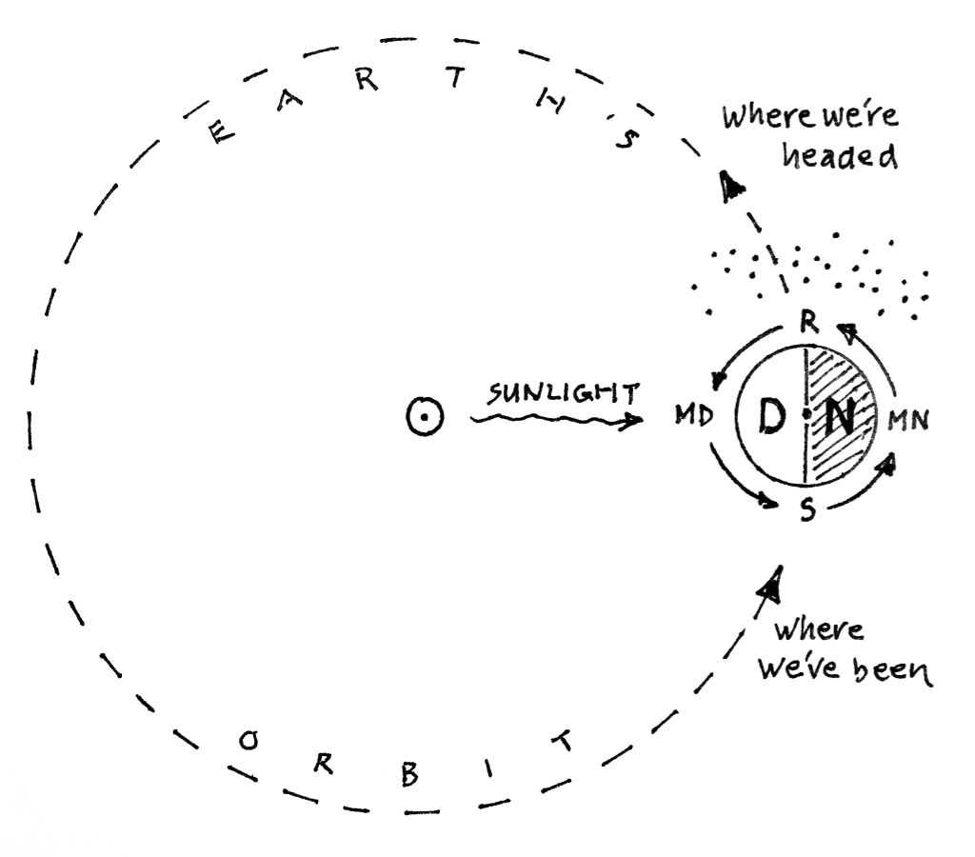

**Figure 6: The Mechanics of Meteor Showers.**

*Like so many bugs on a windshield…*

The diagram offers a simplified illustration of Earth’s two primary motions: Daily *rotation* on its axis, and annual *revolution* around the Sun. Note as well the little smattering of specks in the diagram – debris in the wake of Comet Swift-Tuttle. At any given time, half of the planet is bathed in sunlight (see D for “daytime”), and half faces away into the darkness of space (see N for “nighttime”). As the Earth rotates, we’re carried alternately through the daytime and nighttime halves of the planet – MD in the diagram represents our location at midday, and MN shows our location at midnight. R and S, meanwhile, represent our positions at sunrise and sunset, respectively. Now, setting Earth loose on its orbital path, you can see that in the hours between sunset (S) and midnight (MN) our view into space shows *where we’ve been* – a lot like looking into a rear-view mirror as we drive down a highway. On the other hand, in the hours between midnight (MN) and sunrise (R), a view into space shows *where we’re headed* - like peering through a windshield, into a rain of falling stars.

The Perseids and the shifting skies behind them serve to remind that we inhabit a rock sailing through space, affording us views into realms beyond with its every twist and turn. And so we return to where we began, to promises regal and majestic: to Kings and queens, to dragons and heroes, to a river of stars cascading overhead, and to skies alight with a shower of meteors, falling like leaves in the change of season.

To a*ugust* skies in every sense of the word.

© theblueskyclassroom

**The Stars of August**

**drawn for latitude 38° N**

**Early August @ 11 pm, mid-month @ 10 pm, late August @ 9pm**

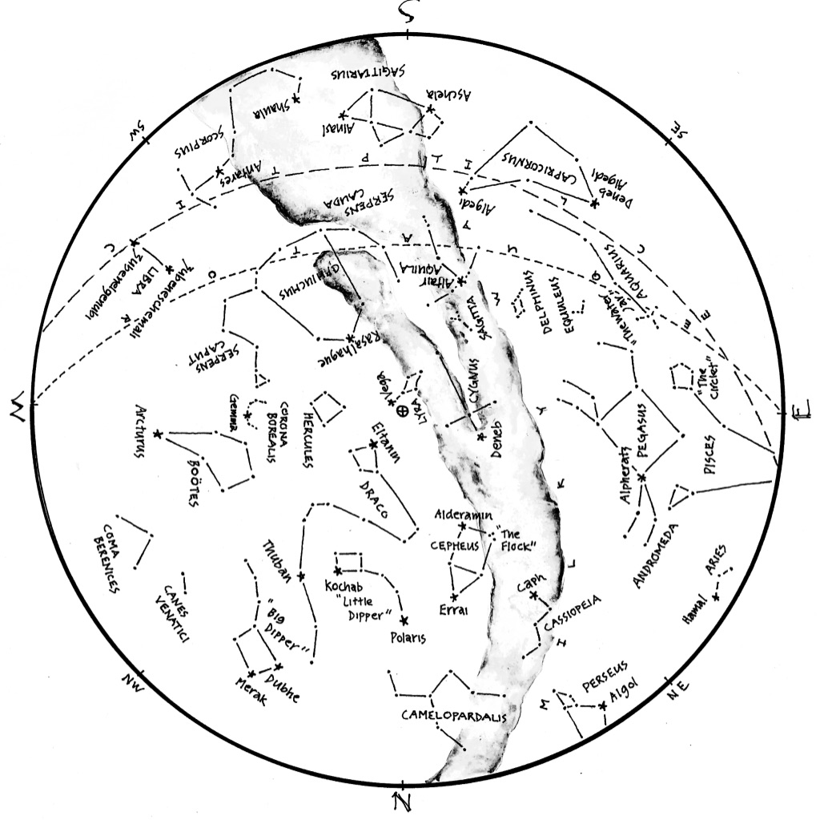

© theblueskyclassroom

**The Stars of August (lines only)**

Here’s a chart of the August skies, without the labels. Try labeling it yourself when you think you’re familiar with all that it shows.

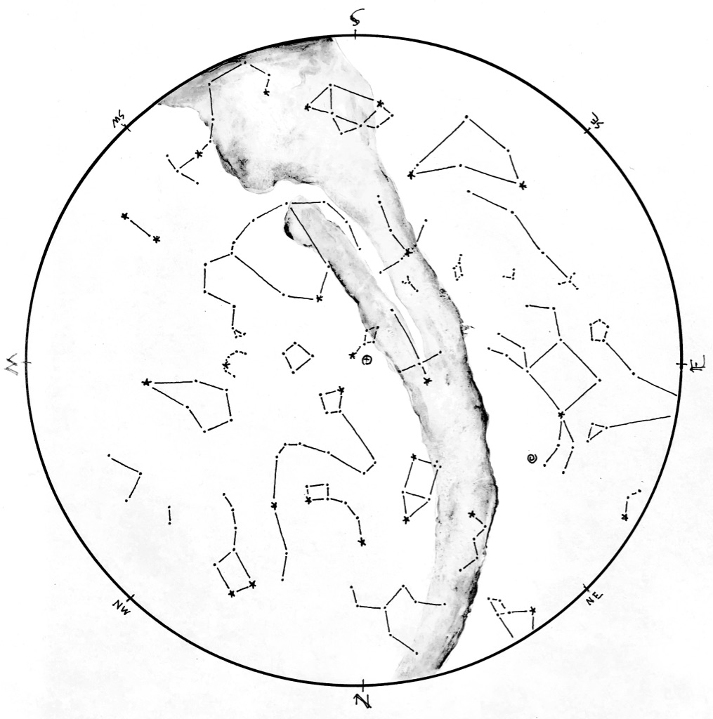

© theblueskyclassroom

**The Stars of August (blank)**

The chart below shows the promininent stars in this month’s sky. You can print the chart and test yourself - connect the dots, draw the figures, see what you remember from your nights out under the stars… or, if you’d rather, invent some figures of your own!

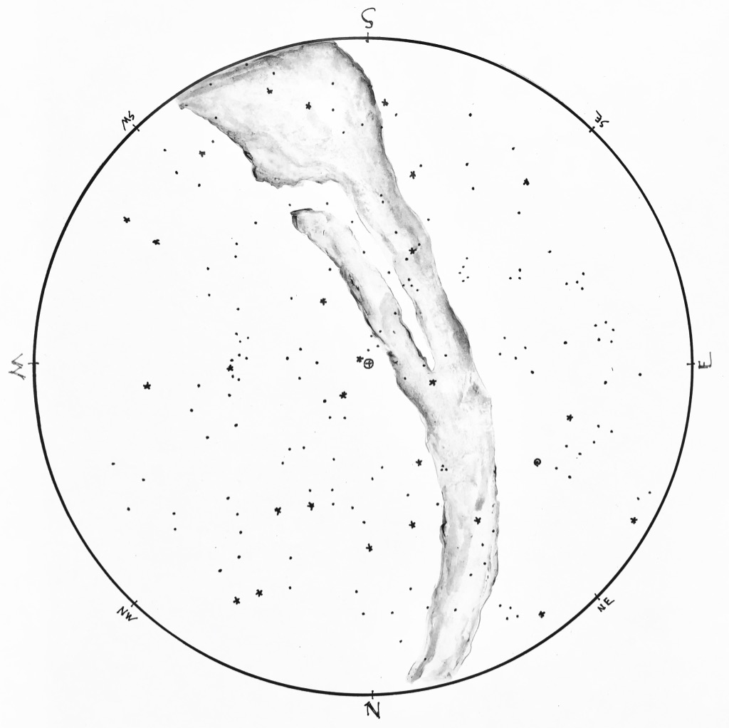

© theblueskyclassroom

***A Naked-eye Guide to the Night Sky***

**How to Read a Star Chart**

No one needs instructions on how to look at the stars. You wait until dark, you head outside, and you look up. Pretty simple. But if you want to *learn* the stars – if you want to know their names and come to recognize the figures they form, month after month and season after season – you might turn to a star chart for guidance.

A star chart is a lot like any other map you might have seen: It shows where things are located, identifies features by name, and lays out a picture of familiar or prominent landmarks. But a map of the sky differs in many ways from a map of the ground, and you might find it useful to get your bearings before you head out to acquaint yourself with the stars.

First, it helps to imagine the sky as a dome, arching overhead. When rendered on paper, the dome flattens into a circle, like the one seen in **Figure 1**. The outer edge of the circle represents the horizon. It’s marked with the compass directions, but notice that they’re arranged differently than the way we usually see them. This is because a map of the sky looks ***upward***, the reverse of ***downward,*** and it throws the placement of compass directions a little helter-skelter. Don’t worry if this is confusing - it will all become clear when you get outside to use a chart.

Everything *inside* the horizon circle is the sky – again, imagined as a dome, and flattened on paper. At the center of the chart you’ll often find a symbol marking “zenith”, the point in the sky directly overhead. The word zenith comes from an Arabic expression meaning “the way or path of the head”.

Finally, know that a chart is not complete – it shows just a few of the brightest stars in the sky for a given time of year. To include *everything* that’s visible in the night sky would be impossible!

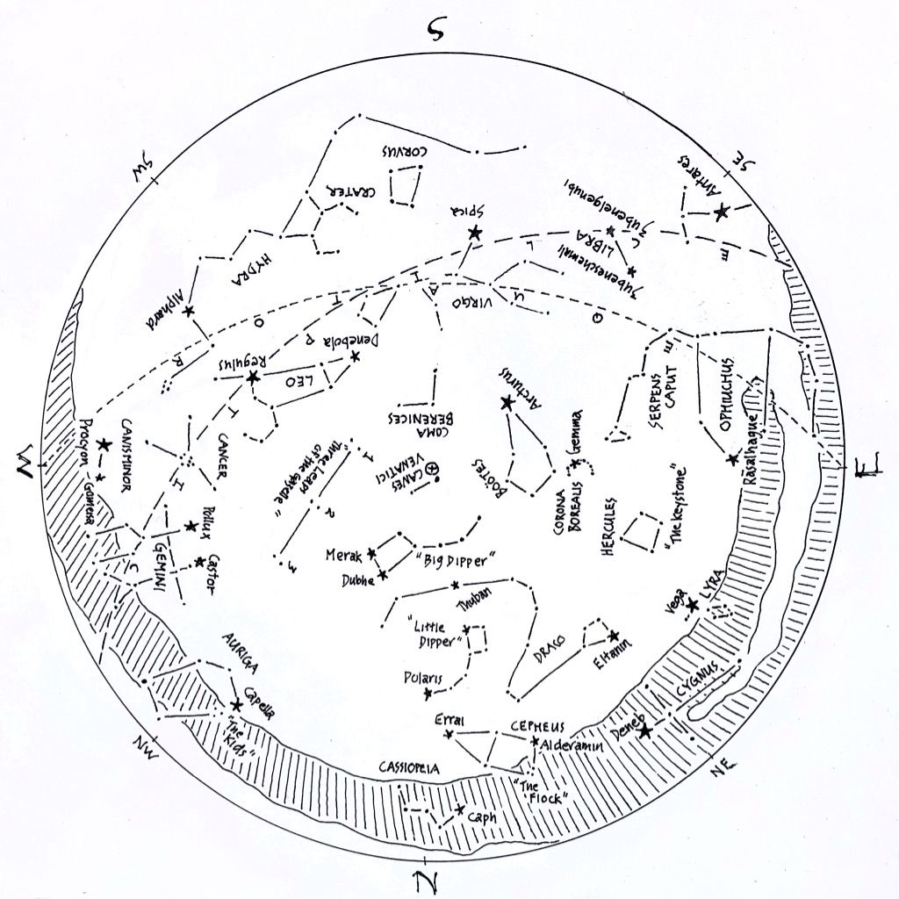

**Figure 1: A sample star chart.**

*Drawn for the skies at around 9:30 pm. in mid-May.*

*Compass directions are listed around the horizon ring.*

*At the center of the chart, a (+) symbol inside a tiny circle of its own marks zenith, the point in the sky directly overhead.*

Keep in mind that the planet you’re standing on is moving – it spins on its axis once per day, and orbits the Sun once per year. Both of these motions determine what stars will be visible at a particular hour for a given night. The star chart shown above is drawn for the skies of mid-May, about two hours after sunset. If you were to use it at a time or date very different than that, the chart would be less accurate, and you’d have a harder time matching it to the sky overhead.

To read a star chart, it’s held in hand like a steering wheel. The chart is rotated so that the direction you’re facing is at the bottom of the chart. Held in this way, the curve at the bottom of the chart represents the horizon, and everything in the *lower half* of the chart depicts the sky in front of you. Remember that the center of the map represents the point in the sky directly overhead – as you hold the map like a steering wheel, everything in the *upper half* is actually found in the sky behind you. If you want to look at those objects in the sky, you need to *face* that direction and rotate the map so that the new direction of sight is at the bottom of the map. As before, everything in the lower half of the map will match what you see in the sky ahead of you.

By turning your body to face different directions, and by turning the star chart to match your view, you can relate what’s on the map to what’s visible in every quarter the sky. The detail in **Figure 2**, below, shows the May star chart oriented to view the southern sky.

If you prefer to lie down to look at the stars, a star chart works in this case as well. Simply lay on the ground with your head pointing north, looking upward at the sky. Hold the map above you, again like a steering wheel, so that the northern mark on the horizon ring is pointing toward the north as well. In this orientation, the cardinal compass directions on the map will match those on the horizon around you, and stars on the map will match what you see in the sky. Of course, you may need to move the map aside a bit to see the stars hiding behind (above???) it.

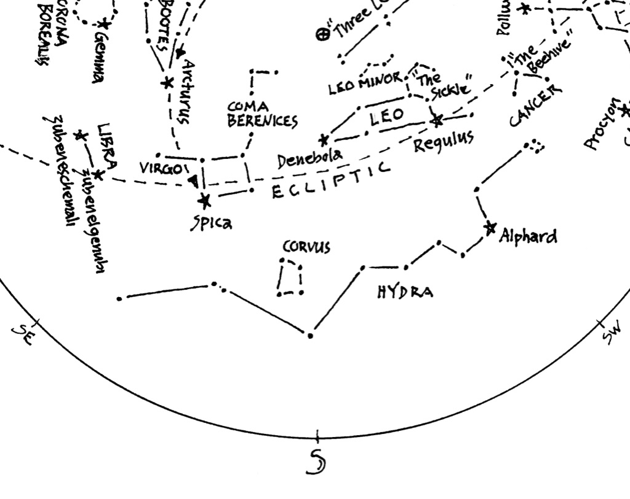

**Figure 2: Detail from the chart in Figure 1**

*Star chart oriented to view the southern sky. South horizon is at the bottom of the chart. Zenith, the point directly overhead, is marked with (+). Stars and figures in the lower portion of the chart match those visible in the southern sky.*

Last, a note about lighting. Many stars are dim and difficult to see, even under the best conditions and darkest skies. As you look at the night sky, your eyes will adapt to the dark, opening slowly to admit more light. But if you illuminate the map to read it in the dark, your eyes may respond by closing down again and becoming less sensitive. For this reason, a red-filtered flashlight is recommended for reading a star chart in the dark. Red lighting does not affect our eyes the way that bright white lighting does, and so a red light will allow you to read a star chart without the risk of closing your eyes off to the dimmer stars in the sky.

You might already have a headlamp with a red bulb option, and that will work just fine. Otherwise, you can easily modify an ordinary flashlight to be red-filtered: Just cover the lens of the flashlight with masking tape, and color the tape with a red marker. A Sharpie works great. So does a red crayon. It may take a few layers of tape and marker to get the light to quiet down sufficiently. You’ll want enough light to read your star chart in the dark, but not so much that it blinds your eyes to the stars. It may take some experimenting to find what works best.

Equipped with a map of the sky and your red-filtered light, you’re ready to become better acquainted with the stars overhead. And as you greet them by name, and trace with your fingers the figures and shapes they form, the skies overhead will draw ever closer as a part of the place you call home.

©theblueskyclassroom