The Stars of May
drawn for latitude 38° N
Early May @ 9 pm / late May @ 8 pm (PST)

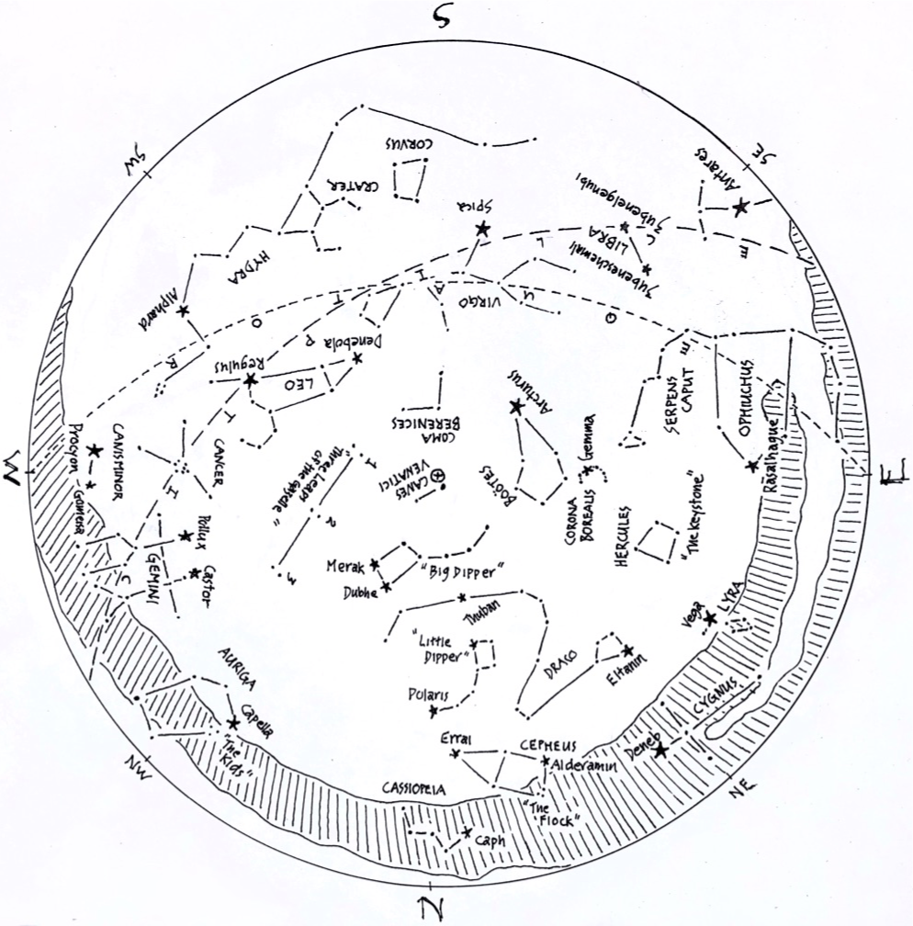
© theblueskyclassroom

The Stars of May (lines only)
Here’s a chart of the May skies, without the labels. Try labeling it yourself when you
think you’re familiar with all that it shows.

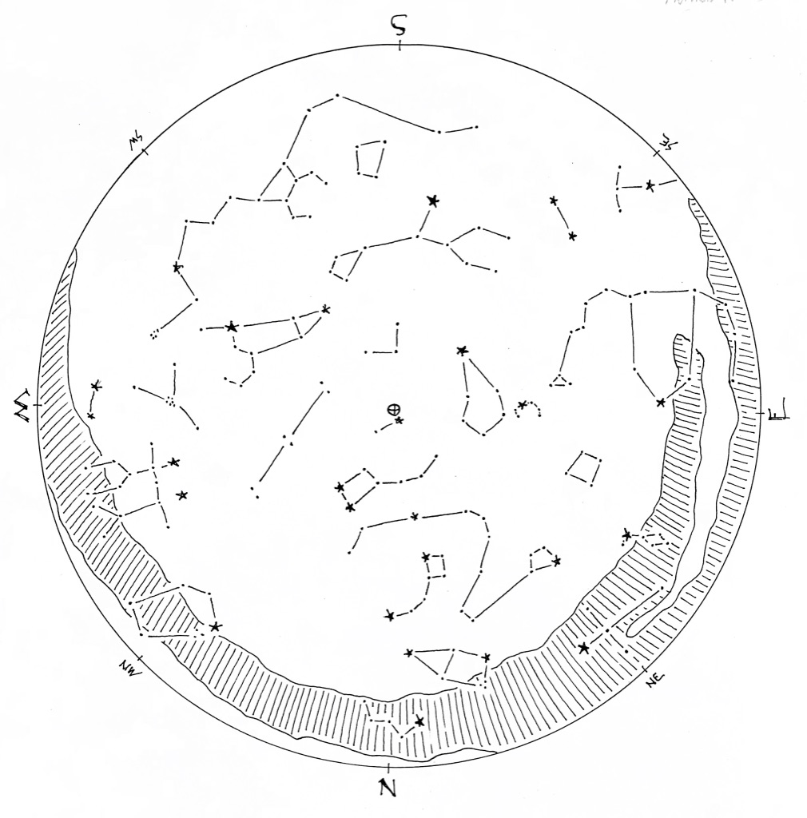

© theblueskyclassroom

The Stars of May (blank)
The chart below shows some promininent stars in this month’s sky. Can you recognize them without their names or labels? You can print this chart and test yourself –
connect the dots, draw the figures, see what you remember from your nights out under the stars… or, if you’d rather, invent some figures of your own!

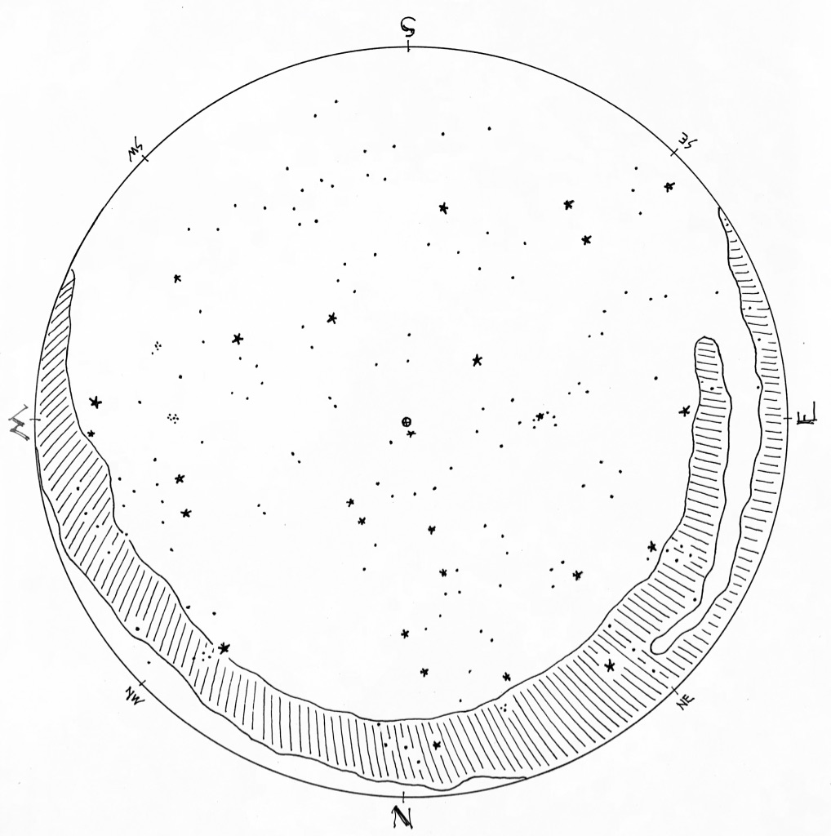

© theblueskyclassroom

