**A Naked-eye Guide to the Night Sky**

***A Voyage Across The Celestial Sea***

Through the last week of July, the Moon will traverse the Celestial Sea – a vast expanse of darkness lapping gently against the southern horizon. For northerners, the Sea plays host to the Sun in the seasons of wet and rain, inspiration for the region’s long-held association with the element of water. Now, with the Sun elsewhere in the circle of the year, the full Moon bobs alone at the Sea’s western shore, sails hoisted and brightly lit as it awaits the outgoing tide.

The Celestial Sea is home to some interesting figures, though difficult to find on even the darkest of nights. You’ll need patience and a keen eye to spot them, especially so with the brightly-lit Moon commanding your attention. Still, they await your discovery as you stand peering into the depths.

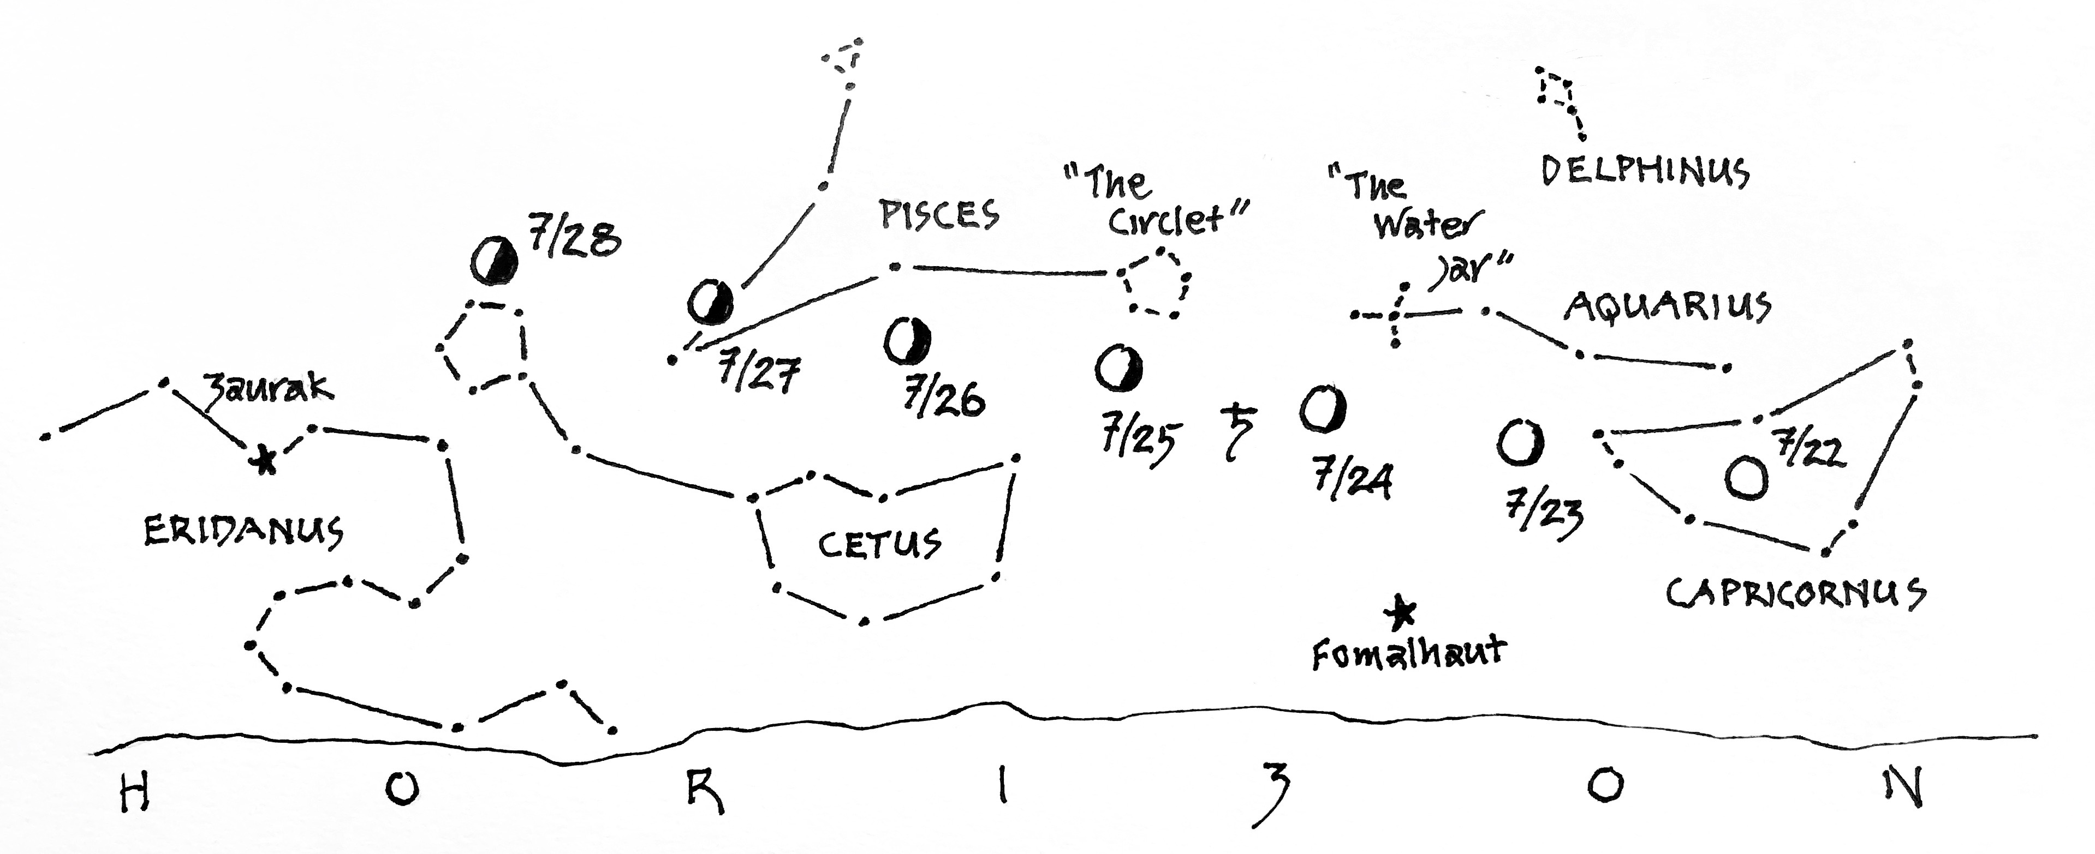

***The Celestial Sea***

*A chart of the Moon’s passage across the Sea through the last week of July, 2024.*

*Drawn for observers at latitude 38° N, in the hours shortly before midnight.*

The diagram above charts the Moon’s passage across the Celestial Sea through the last week of July. Night by night, the Moon will wend its way eastward against the background of stars. With each passing day it will rise an hour later, dimming gradually in accordance with its position relative to the Sun. You might then imagine it receding into the distance – which in fact it is! July 24th finds the Moon at ***perigee***, defined as its closest approach to the Earth in its monthly elliptical orbit. In a very real sense, then, the Moon will be further from our shores with each passing night, as it crosses Celestial Sea.

***Denizens of the Deep***

On the night of the 22nd, the full Moon appears in the belly of **Capricornus**, the *Sea-goat*. Capricornus is a sign of the Zodiac, associated with waters since the time of the ancient Sumerians. On the 23rd, a stiffening breeze carries the Moon into the sign of **Aquarius**, the *Water-bearer*, to be joined there by the planet Saturn on the 24th (see symbol ). You’ll have no trouble finding Saturn amid the glare of the Moon, two ships passing in the quiet of the night. Saturn, by the way, is a gas giant whose density is less than that of water – all the easier to imagine it afloat in the sea.

Above the Moon and Saturn, look for a group of four stars in the shape of the letter “Y”. Together they form the “water jar” of Aquarius. Ancient depictions show it spilling its contents earthward – a graphic reminder that water came to our planet from *out there*, cascading through space on the backs of comets and asteroids. Higher still, you might be lucky to glimpse the figure of **Delphinus**, the *Dolphin*, leaping clear of the ocean spray.

Meanwhile, below the Moon and close to the horizon, keep watch for the star Fomalhaut, brightest in the figure of **Piscis Austrinus**, the *Southern Fish*. Often known as the “Solitary One,” Fomalhaut has served as a calendar marker for centuries – its appearance before sunrise on the cross-quarter day of Beltane announces the start of summer for the northern hemisphere.

After passing Saturn, the Moon navigates the waters between the figure of **Pisces**, the *Two Fishes*, and **Cetus,** the *Whale*. On the 25th, it crosses the celestial equator at “First Point of Aries,” home to the Sun on the Vernal Equinox. The point is close by “the Circlet” which marks the *Western Fish* of Pisces. From there the Moon will climb higher in the sky, night-by-night, until it’s launched from the sea on the 28th with a flick of the Whale’s tail.

Below the Moon’s anchorage on the sea’s far shore, look for the River **Eridanus.** It meanders dimly along the horizon, draining into the Sea from the east. The bright star Zaurak translates from the Persian word for “boat.” The ancients saw here a celestial counterpart to the Nile, reminder that the seas are fed by waters gathered on land, in a cycle of constant motion and exchange.

As above, so below…

© theblueskyclassroom