**The Stars of September**

**drawn for latitude 38° N**

**Early September @ 11 pm, mid-month @ 10 pm, late September @ 9pm**

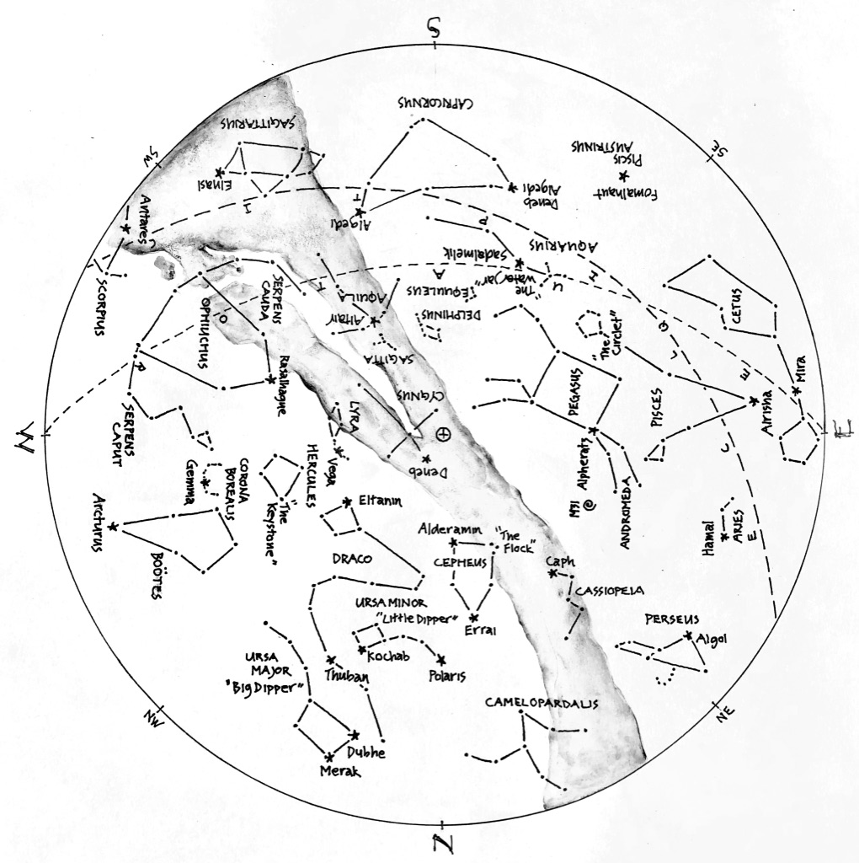

© theblueskyclassroom

**The Stars of September (lines only)**

Here’s a chart of the September skies, without the labels. Try labeling it yourself when

you think you’re familiar with all that it shows.

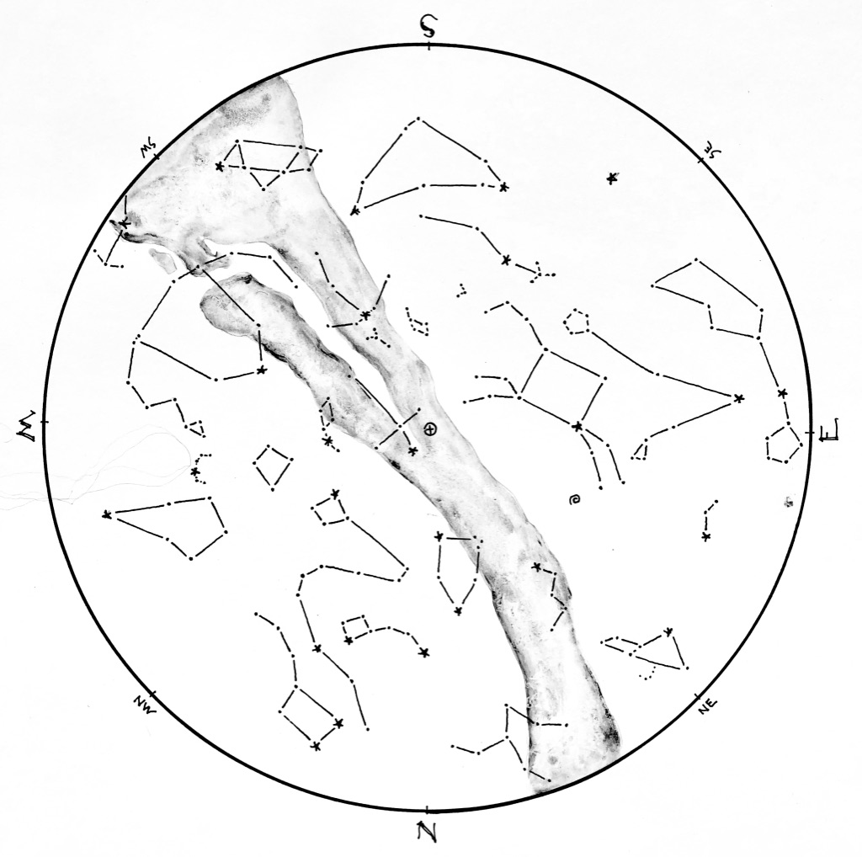

© theblueskyclassroom

**The Stars of September (blank)**

The chart below shows some promininent stars in this month’s sky. Can you recognize them without their names or labels? You can print this chart and test yourself – connect the dots, draw the figures, see what you remember from your nights out under the stars… or, if you’d rather, invent some figures of your own!

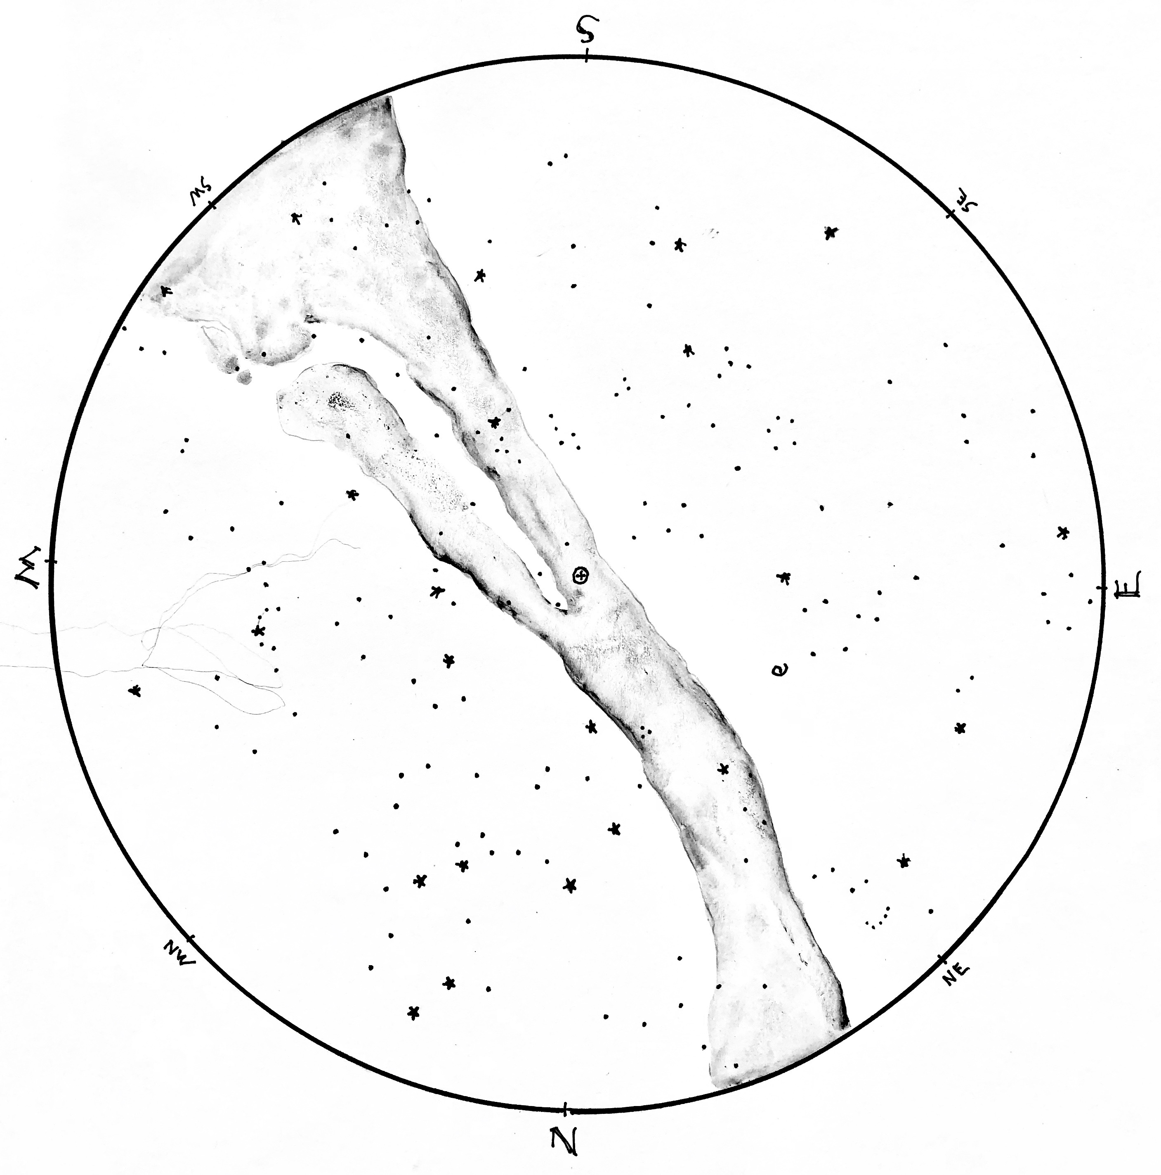

© theblueskyclassroom