**The Stars of December**

**drawn for latitude 38° N**

**Early December @ 9 pm, late December @ 8pm**

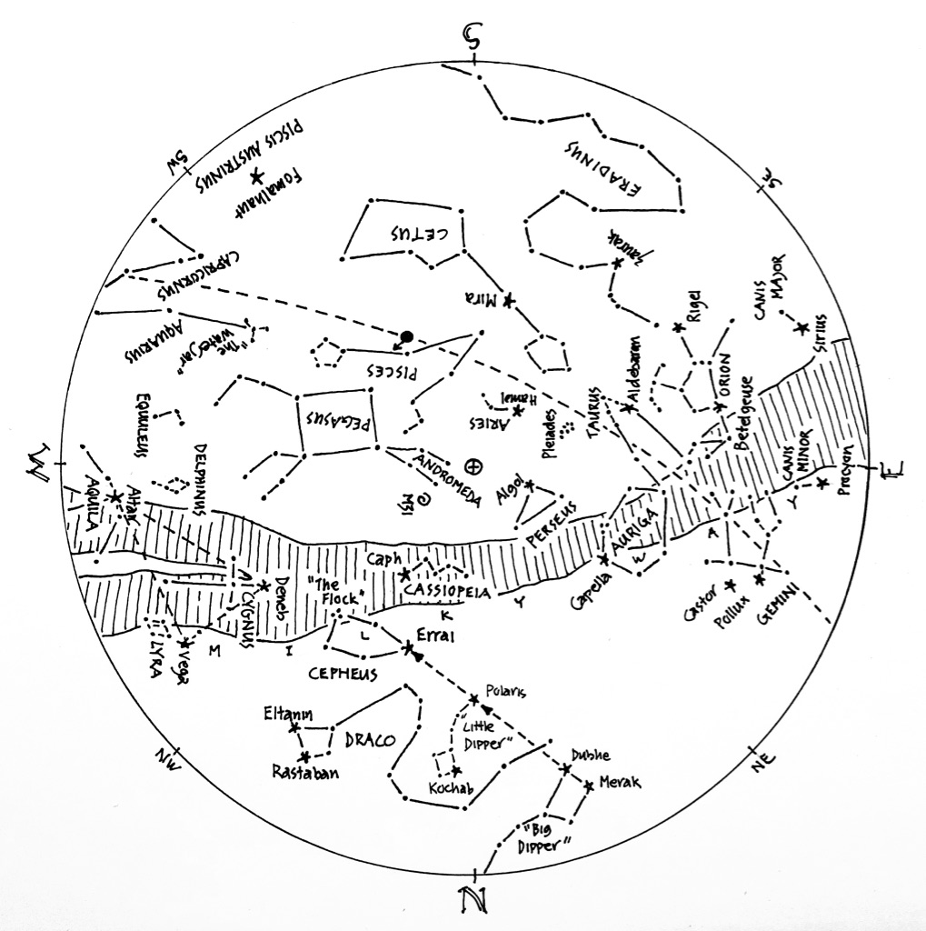

© theblueskyclassroom

**The Stars of December (lines only)**

Here’s a chart of the December skies, without the labels. Try labeling it yourself when

you think you’re familiar with all that it shows.

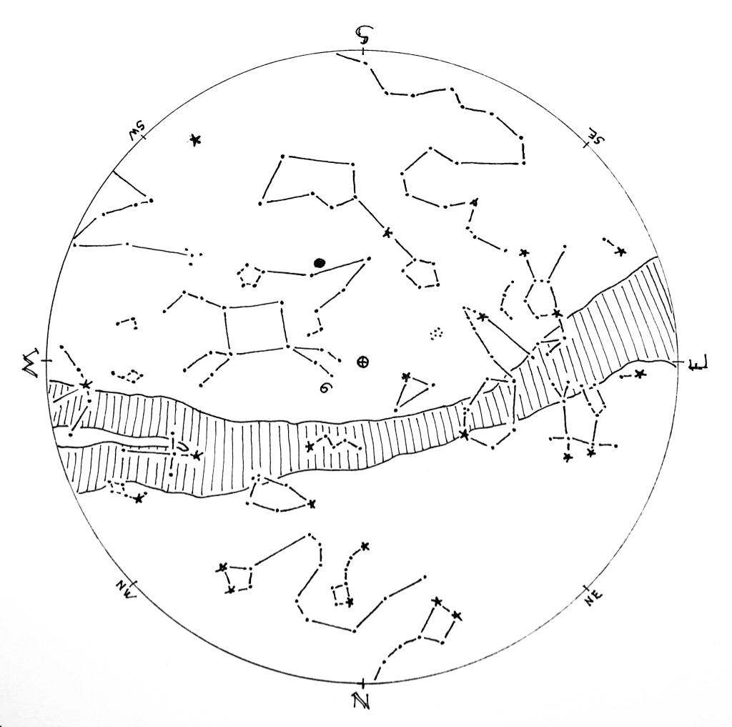

© theblueskyclassroom

**The Stars of December (blank)**

**T**he chart below shows some promininent stars in this month’s sky. Can you recognize them without their names or labels? Print this chart to test yourself – connect the dots, draw the figures, see what you remember from your nights out under the stars… or, if you’d rather, invent some figures of your own!

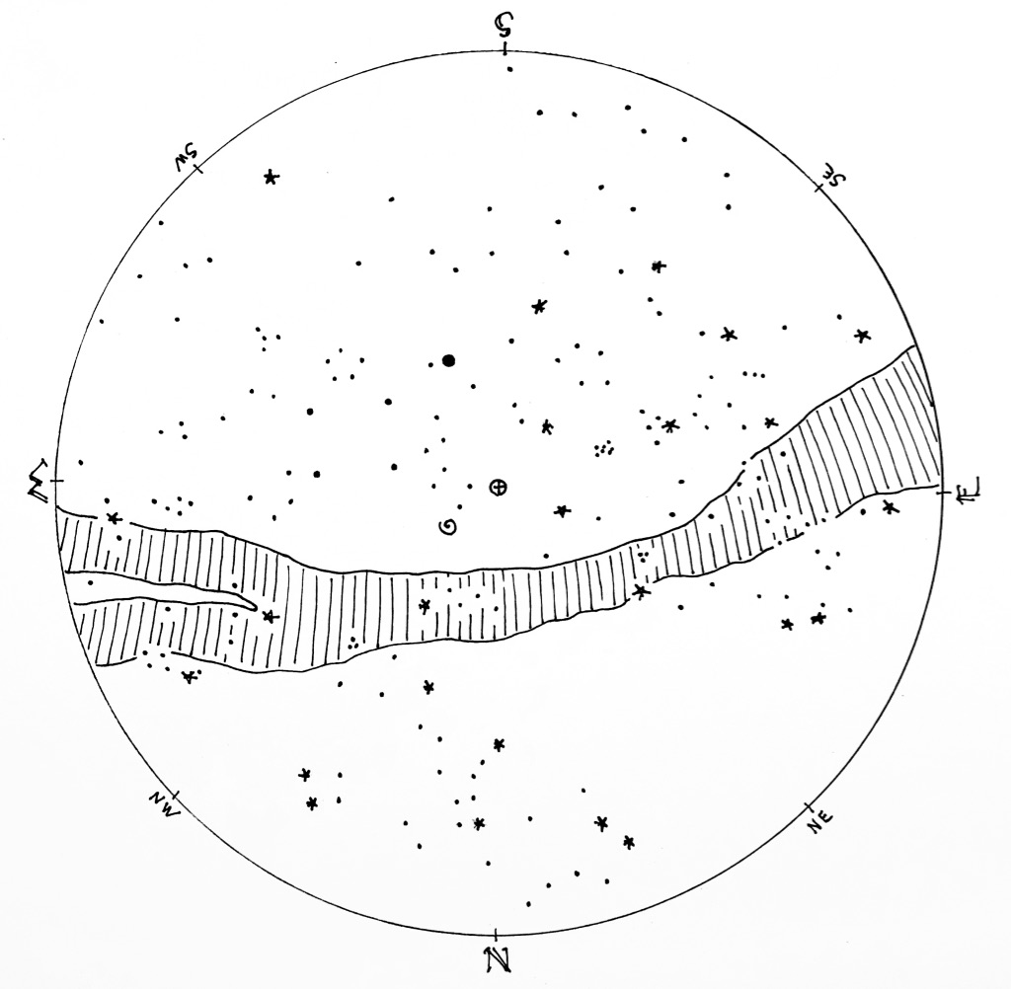

© theblueskyclassroom