**A Naked-eye Guide to the Night Sky**

**Time in the Hand of the Queen**

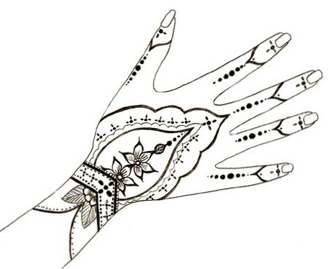

We’re all aware of the connection between the Sun and timekeeping. We know that the Sun rises in the morning and sets in the evening, and that somewhere in between the noon hour happens. If we’re lucky enough to have a sundial, we can be more precise, marking the hours according to a shadow cast on the face of the dial. But once the Sun goes down and the skies go dark, how are we to tell the hour without a clock or watch in hand?

In the same way that daytime hours are marked by the Sun, nighttime hours can be read in the stars if we know where to look. The pages that follow describe a method for telling time according to the position of **Caph** – a prominent star in the figure of **Cassiopeia,** the **Queen**. It works for any night of the year, and from any location in the Northern Hemisphere – oh-so-convenient when you’re waiting in the dark for the next camel caravan!

**The Queen’s Hand**

To find the time of night by the method that follows, you’ll have to locate the figure of **Cassiopeia**, queen of the northern sky. Begin by finding the **“Big Dipper**.**”** It’s comprised of seven prominent stars, relatively equal in brightness, and probably the most widely recognized figure in the sky. End-to-end, the Dipper measures a bit more than a hand-span, viewed at arm’s length with fingers splayed wide. It’s visible every night of the year from any location in the Northern Hemisphere, though its orientation changes over time - hour by hour and night by night it circles the northern skies, sometimes appearing “right-side-up,” and other times spilling its contents. In any case, face the Big Dipper and you know you’re looking north*ish*.

Next, find the stars **Merak** and **Dubhe** at the end of the Dipper’s bowl. These stars are known as “the pointers,” because a line drawn through them points to the North Star, **Polaris.** It’s the one star that stays put,no matter the hour of night or the time of year. Face Polaris, and you’re looking north – not just north*ish*, but the *Real Deal*.

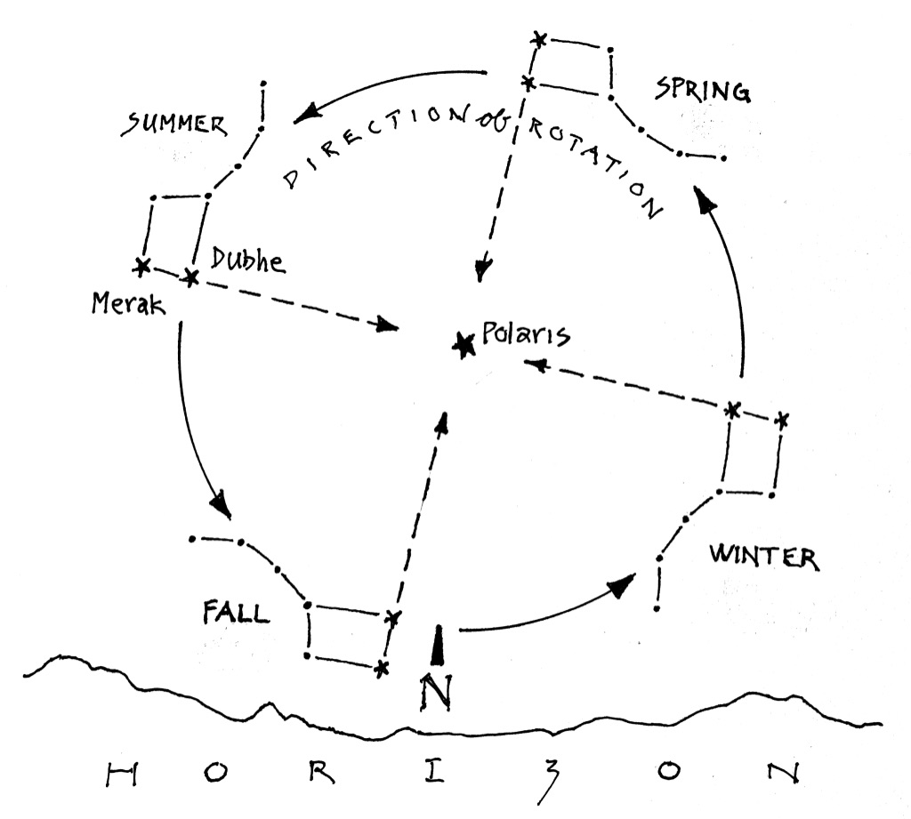

**Figure 1: Finding North by the Big Dipper**

*Merak and Dubhe point the way to the North Star, Polaris.*

*The diagram shows the approximate position of the Big Dipper, season by season*

*in the hours shortly after sunset.*

Now, return to the Dipper and look for the star **Megrez** – it’s the one that attaches the Dipper’s handle to its bowl. A line drawn from Megrez through Polaris will guide you to **Caph**, a star in the figure of **Queen** **Cassiopeia**. Like the Dipper, she rotates around Polaris through the hours of the night and the seasons of the year, always visible in the northern skies. Caph translates as “the stained hand” – reference, most likely, to the ancient practice of adorning the body with henna. It’s by means of the Queen’s lovely hand that we’ll be able to tell the time.

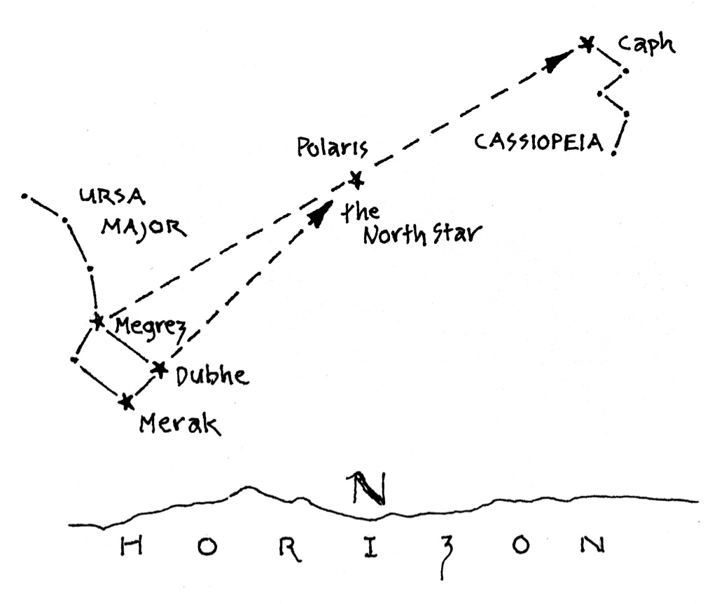

**Figure 2: Locating Caph in Cassiopeia**

*Megrez and Polaris point the way to the Hand of the Queen.*

*Caph can serve as the hand on a clock, as we’ll see in the pages that follow.*

**The 24 Hour Clock**

To tell the hour, you’ll need to envision the northern sky as a clock face, with Polaris at its center. But this clock face has its quirks: First, the clock turns *backwards*, because the stars we’ll use to mark the hour appear to rotate counterclockwise as we face north. Second, it’s a *24-hour clock*, starting with the zero hour of midnight. Hours 0 – 11 are **am** (ante-meridiem) and those numbered 12 – 23 are **pm** (post-meridiem).

Once you have this image of a clock nailed down, you’re ready to tell time by the Hand of the Queen.

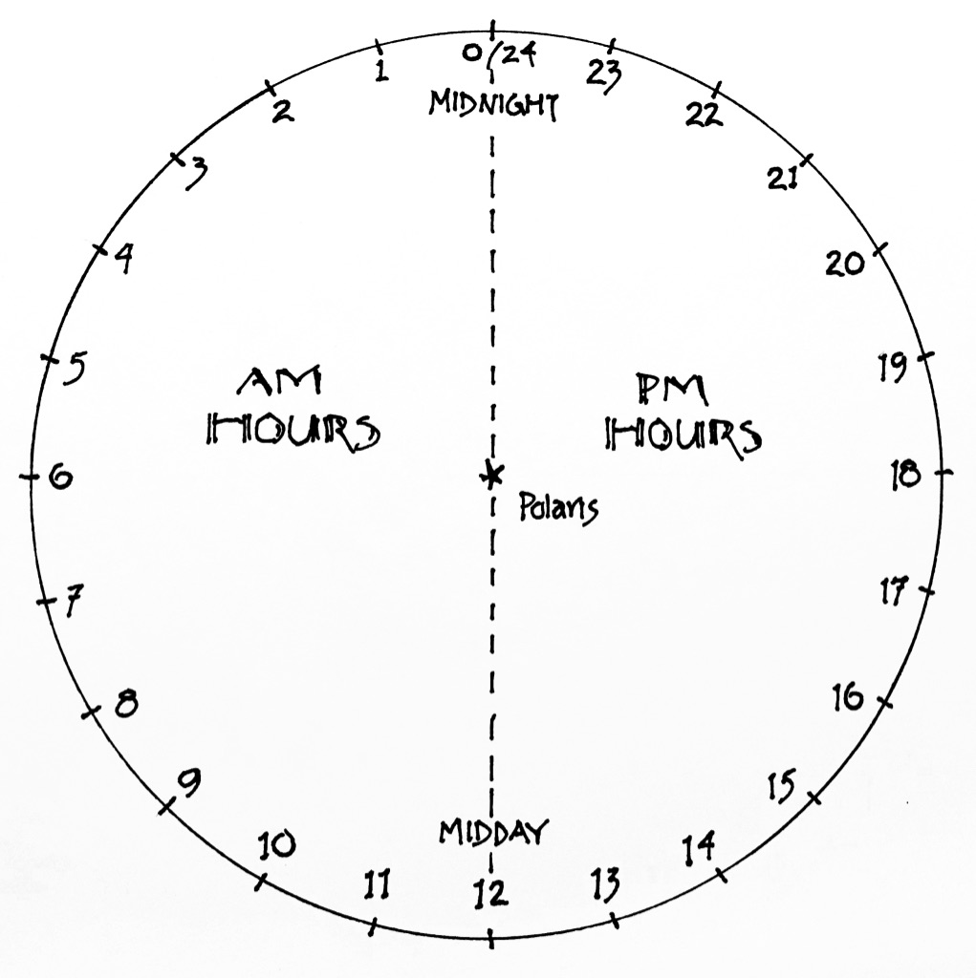

**Figure 4: The 24-hour Clock**

*Polaris at the center, and 24 hours marked around the rim.*

*Stars in the northern sky appear to rotate counterclockwise through*

*the hours of the night.*

**Telling the Time**

Step outside after dark and see if you can locate Caph. Remember that it’s in the figure of Cassiopeia, the Queen. With Caph in view, follow these steps to determine the clock hour:

1) Picture the 24-hour clock centered on Polaris. Next, imagine that Caph is attached to an hour hand on the clock. By your best estimation, to what hour on the clock is the Queen’s hand pointing? Fractions of hours count, if you want to be really accurate: For example, is the hand of the Queen at seven hours, or closer to seven and a half…? We’ll call this hour the “raw time.” Keep it in mind as you move on to the next step.

2) Next, some calculation: How many months will pass before the next Autumnal Equinox? The Equinox occurs on the 21st or 22nd of September – so, how many months away is it? Again, fractions count here: Is the Equinox six months away, or closer to five and three quarters…?

3) Double the number of months you counted in step 2.

4) Now add the number you got from step 3 to the raw time you got from step 1. If the sum is *greater than 24*, subtract 24. If the sum is *less than 24*, you can leave it alone. In either case, the number that results is the actual clock time, as measured on a scale of 24-hours. You can then convert your answer to a 12 hour scale if that makes more sense to you.

(*Note: the Queen is bound by tradition, and reckons the hour in Standard Time. If you subscribe to the modern caprice of Daylight Saving, you’ll have to add an hour to your calculations.)*

A few examples follow…

**Example 1:**

It’s the night of June 20th. Here’s the position of Caph in the Northern sky, imagined on the face of a 24-hour clock. Remember, the clock is centered on Polaris, the North Star.

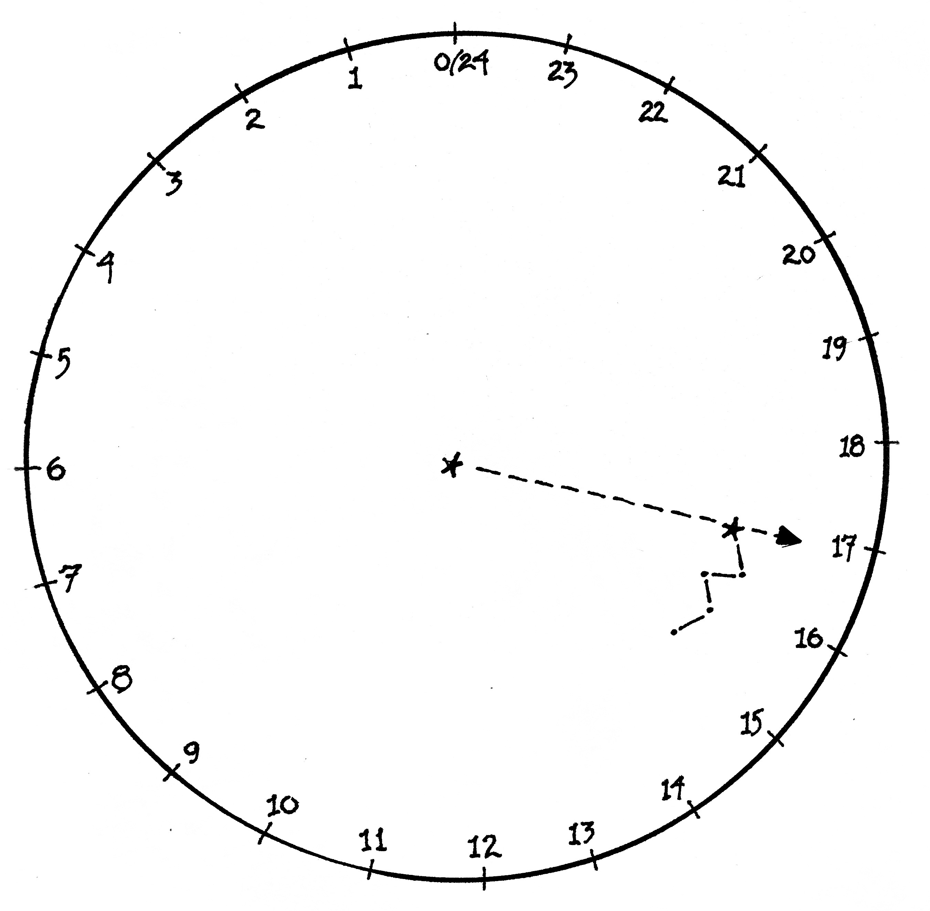

1) Caph is pointing to about 17 hours on the clock.

2) June 20th is about 3 months from the next Autumnal Equinox.

3) Multiply: 3 x 2 = 6

4) Add: 17 hours + 6 = 23 hours

The time is 23 hours on the 24-hour clock, or 11 pm.

**Example 2:**

It’s the night of December 5th. Here’s the position of Caph in the northern sky, imagined on the face of a 24-hour clock.

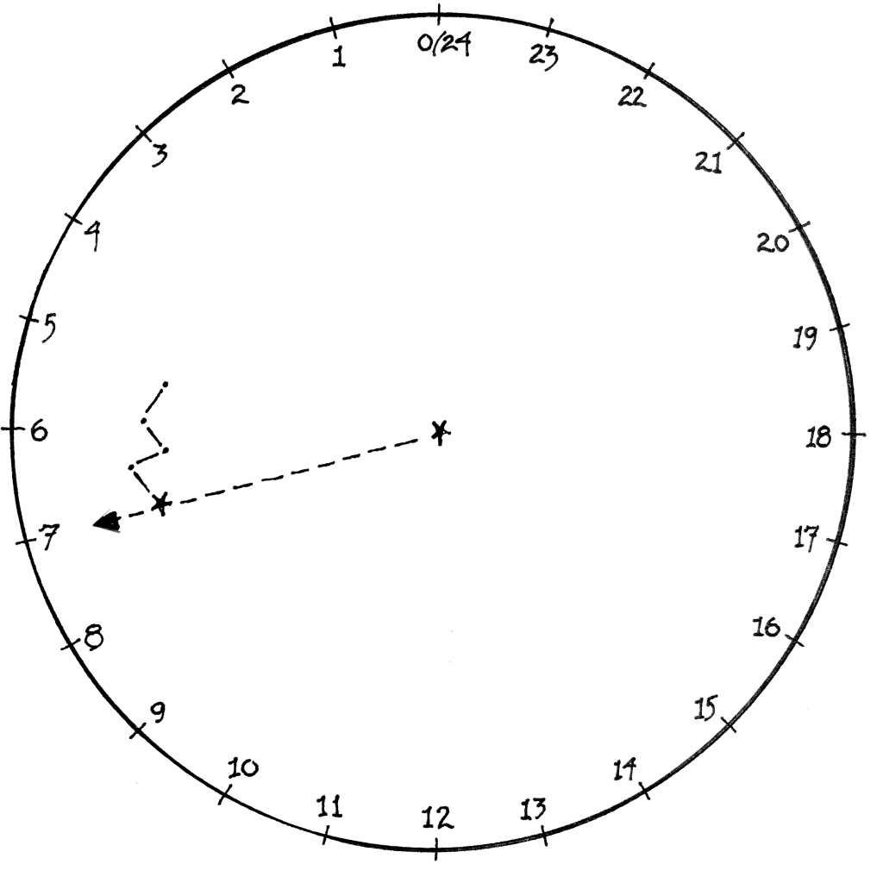

1) Caph is pointing to about 7 hours on the clock.

2) December 5th is about 9 and 1/2 months from the next Autumnal Equinox.

3) Multiply: 9 1/2 x 2 = 19

4) Add: 7 hours + 19 = 26 hours

26 is greater than 24, so subtract: 26 – 24 = 2.

The time is 2 hours on the 24-hour clock, or 2 am.

**Example 3:**

It’s the night of January 15th. Here’s the position of Caph in the Northern sky, imagined on the face of a 24-hour clock:

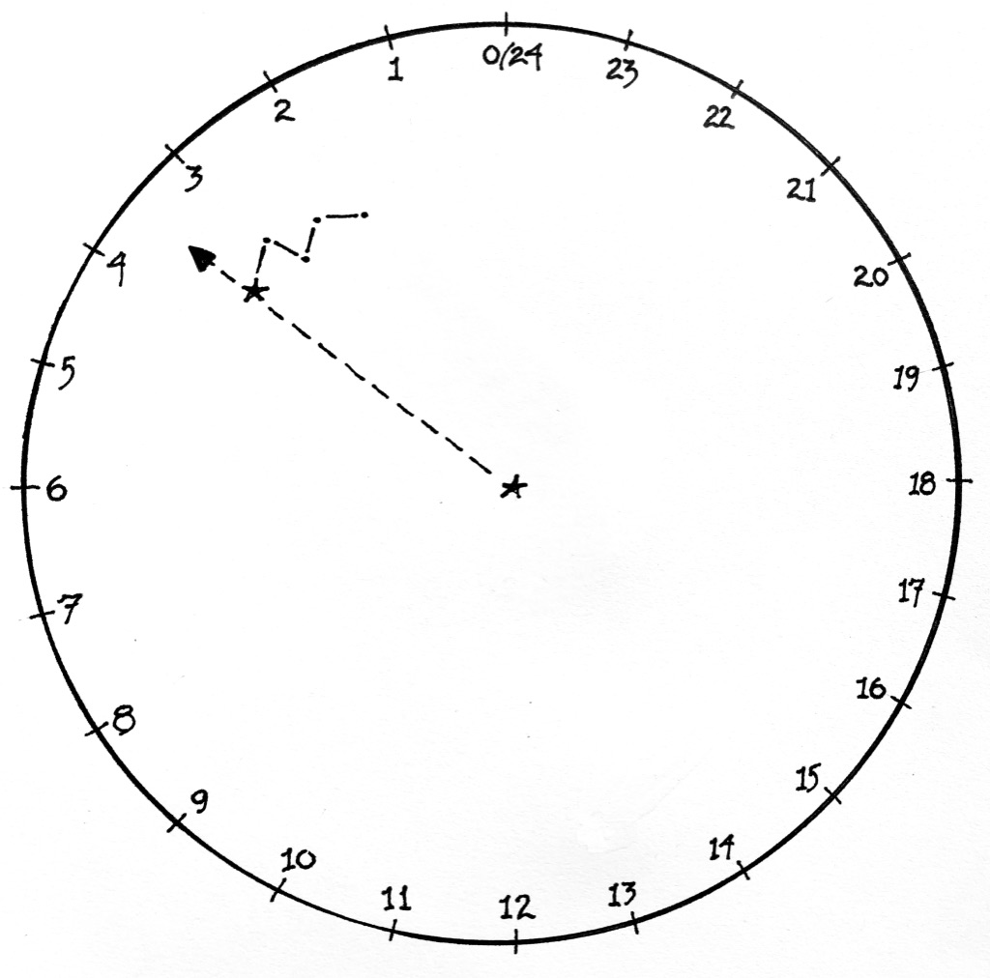

1) Caph is pointing to about 3 and 1/2 hours on the clock.

2) January 5 is about 8 and 1/2 months from the next Autumnal Equinox.

3) Multiply: 8 1/2 x 2 = 17

4) Add: 3 1/2 hours + 17 = 20 1/2 hours

The time is 20 and 1/2 hours on the 24-hour clock, or 8:30 pm.

**In Closing**

So, why does this work?

The ancients knew well the value of stars as keepers of time and date. In particular, it was widely known that the habits of stars are regular and predictable. Accordingly, any might serve as a timepiece, given knowledge of when and where it will appear.

Today it’s well understood that a star – *any* star – will reappear in the same location four minutes earlier than it did the night before. Conversely, and by the same reasoning, a star appears in the sky four minutes *later* than it will on the next night following. In the course of a week, then, the accumulated difference amounts to roughly half an hour, or two hours in the span of a month. These differences, of course, derive from our planet’s dance through space - a dance well beyond the imagination of the ancients, but source just the same for the predictable parade of luminaries overhead by which time has been reckoned for centuries.

Once the habits of a particular star are known, it’s possible to determine the hour by its location in the night sky, when weighed against a known point of reference. In the case of Caph in Cassiopeia, that point of reference is the stroke of midnight on the Autumnal Equinox. At that moment, the hand of the Queen is poised directly over the North Star, Polaris – right up there at the zero hour of our imagined 24-hour clock face, from whence it begins to clock the hours.

What better star (and from what better moment) to mark the passage of time through the hours and nights of the year?

© theblueskyclassroom