Direction and Time
by the Stars of Ursa Major

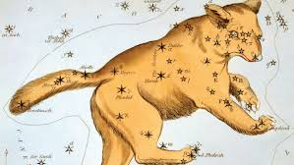

We’re all aware of the connection between the Sun and timekeeping. We know that the Sun rises in the morning and sets in the evening, and that somewhere in between the noon hour happens. If we’re lucky enough to have a sundial, we can be more precise, marking the hours according to a shadow cast on the face of the dial. But once the Sun goes down and the skies go dark, how are we to tell the hour without a clock or watch in hand?
In the same way that daytime hours are marked by the Sun, nighttime hours can be read in the stars if we know where to look. The pages that follow describe a method for telling time according to the position of the Pointers – two prominent stars in the figure of Ursa Major, known by many as the Big Dipper. It works for any night of the year, and from any location in the Northern Hemisphere – oh-so-convenient when you’re waiting in the dark for the next camel caravan!

The Procedure

1) locate the “Big Dipper.” It’s comprised of seven prominent stars, relatively equal in brightness, and probably the most widely recognized figure in the sky. End-to-end, the Dipper measures about a hand-span, viewed at arm’s length with fingers splayed wide. It’s visible every night of the year from any location in the Northern Hemisphere, though its orientation changes over time – hour by hour and night by night it circles the northern skies, sometimes appearing “right-side-up,” and other times spilling its contents. These changes are due to Earth’s movements through space. Nevertheless, face the Big Dipper and you know you’re looking northish.

2) Find the stars Merak and Dubhe at the end of the Dipper’s bowl. These stars are known as “the pointers.” A line drawn through them points to the North Star, Polaris – the one star that stays put, no matter the hour of night or the time of year. Face Polaris, and you’re looking north – not just northish, but the Real Deal.

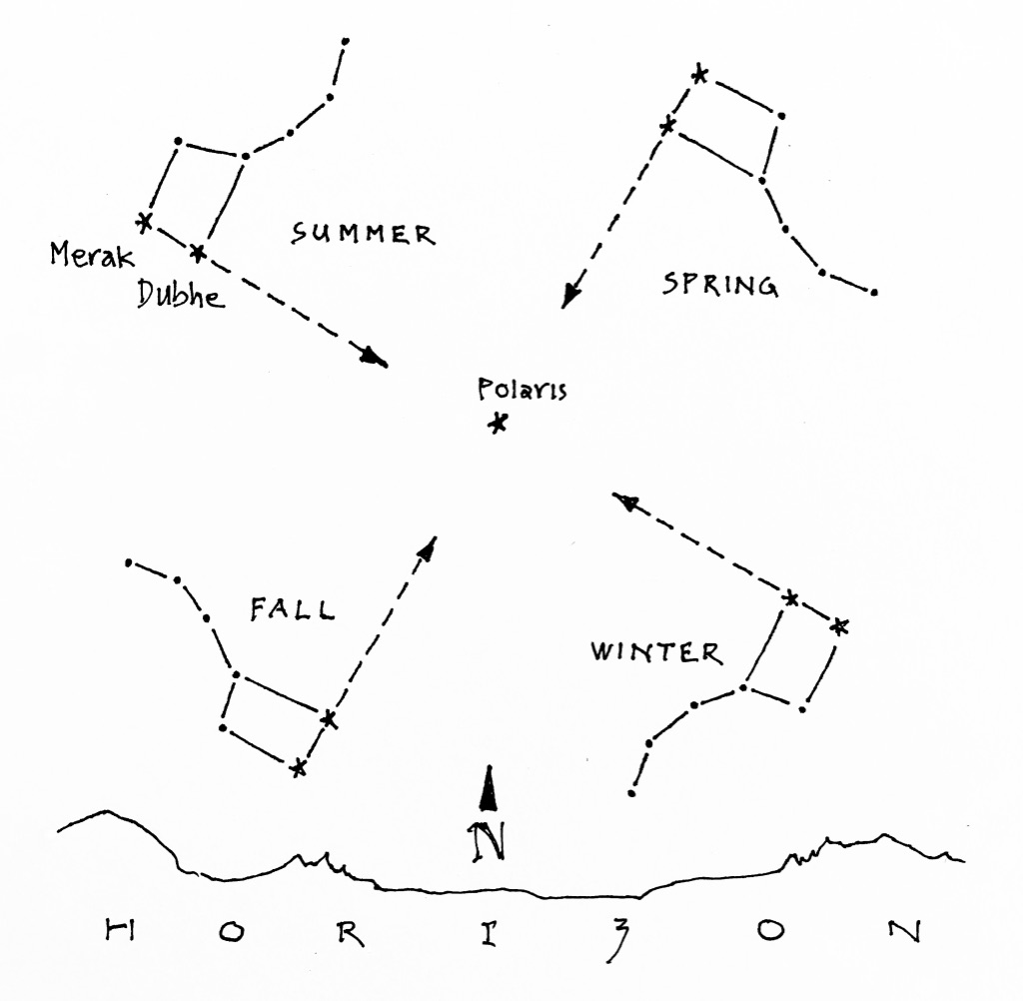

Figure 1: Finding North by the Big Dipper.
Merak and Dubhe point the way to the North Star, Polaris. The diagram shows the approximate position of the Big Dipper, season by season, in the hours shortly after sunset.

3) The line through Merak and Dubhe not only points the way to Polaris, but also serves as an hour hand for marking time. Imagine the hand attached to a clock face encircling Polaris, with the following quirks: First, it’s a 24-hour clock, marked with 24 hours around its rim, starting with the zero hour of midnight. AM hours are numbered 0 – 11, and PM hours are numbered 12 – 23. Second, the clock turns backwards, because stars of the Dipper rotate rotate counter-clockwise with the passage of time. Figure 2 illustrates the 24-hour clock face centered on Polaris.

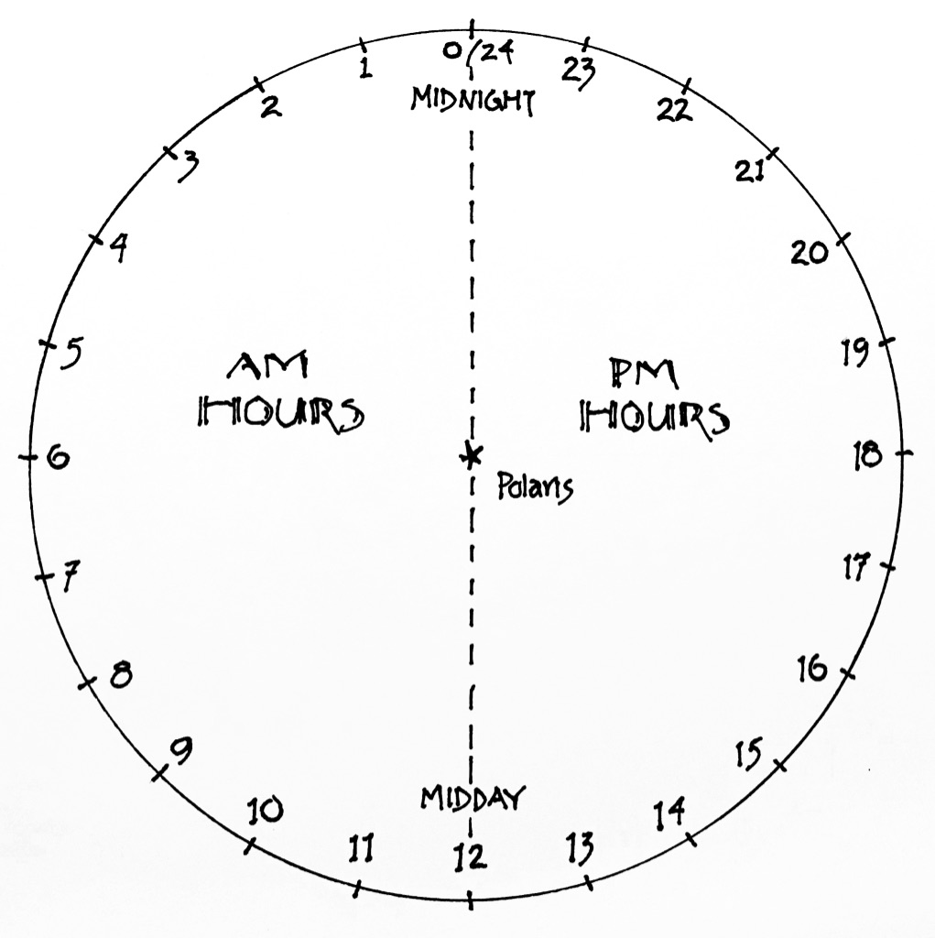

Figure 2: The 24-hour Clock
Polaris at the center, and 24 hours marked around the rim.
Stars in the northern sky appear to rotate counterclockwise through the hours of the night.

4) To tell the time, look at the line connecting the Pointers to Polaris, and decide where it falls on the face of the 24-hour clock. Fractions of hours count if you want to be really accurate. For example, is the line of the Pointers at two, or closer to two-and-a-half? We’ll call this number the “raw time.” Keep it in mind as you move on to the next step.

5) Next, some calculation: Based on today’s date, how many months forward is March 12th? Again, fractions count here: Is March 12th six months away, or closer to five and three-quarters…?

6) Multiply the number of months from step 5 by 2.

7) Add the number you got from step 6 to the “raw time” you got from step 4. If the sum is less than 24, you can leave it alone. If the sum is greater than 24, subtract 24. In either case, the number you end up with is the actual clock time, as measured on a 24-hour scale. (Note: You’ll need to add an hour if you’re running on Daylight Saving Time). You can convert your answer to a 12 hour scale if that makes more sense to you.

Examples follow…

Example A

It’s the night of June 1st. Here’s the position of the Dipper in the Northern sky, imagined on the face of a 24-hour clock. Remember, the clock is centered on Polaris, the North Star.

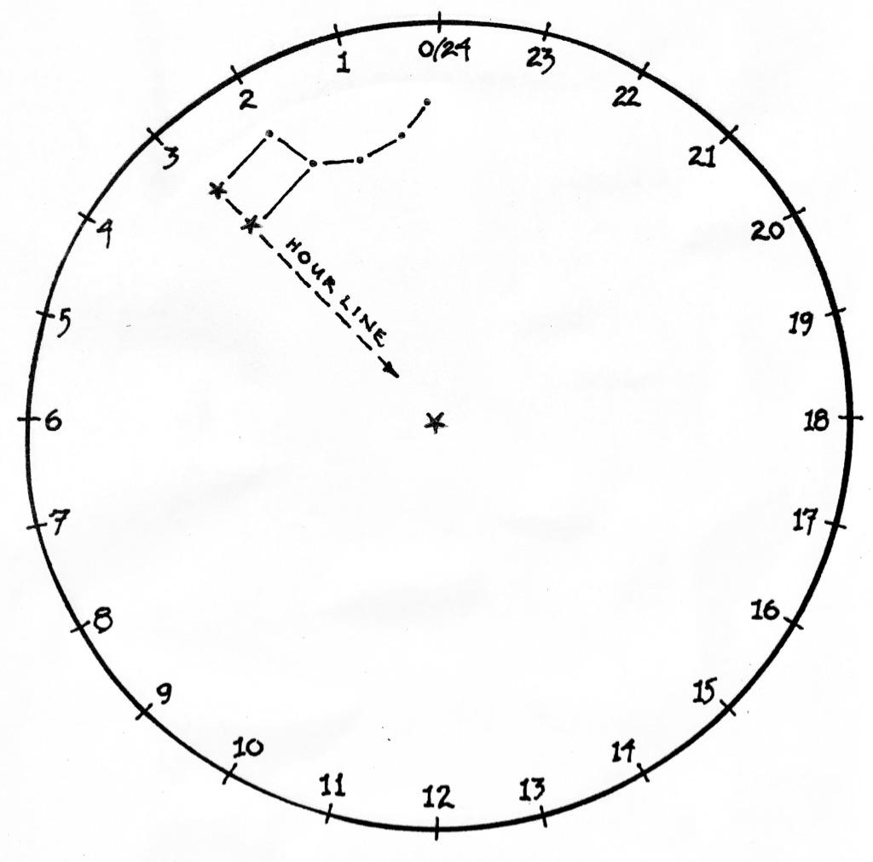

1) The hour line through the pointers is aligned to 3 hours on the clock.
This is the “raw time”

2) June 1st is about 9 1/2 months from March 12th.

3) Multiply: (9 1/2) x (2) = 19

4) Add: raw time of 3 hours + 19 = 21 hours
The time is 22 hours on the 24-hour clock, or 10:00 pm (PST)

Example B

It’s the night of November 25th. Here’s the position of the Dipper in the Northern sky, imagined on the face of a 24-hour clock. Remember, the clock is centered on Polaris, the North Star.

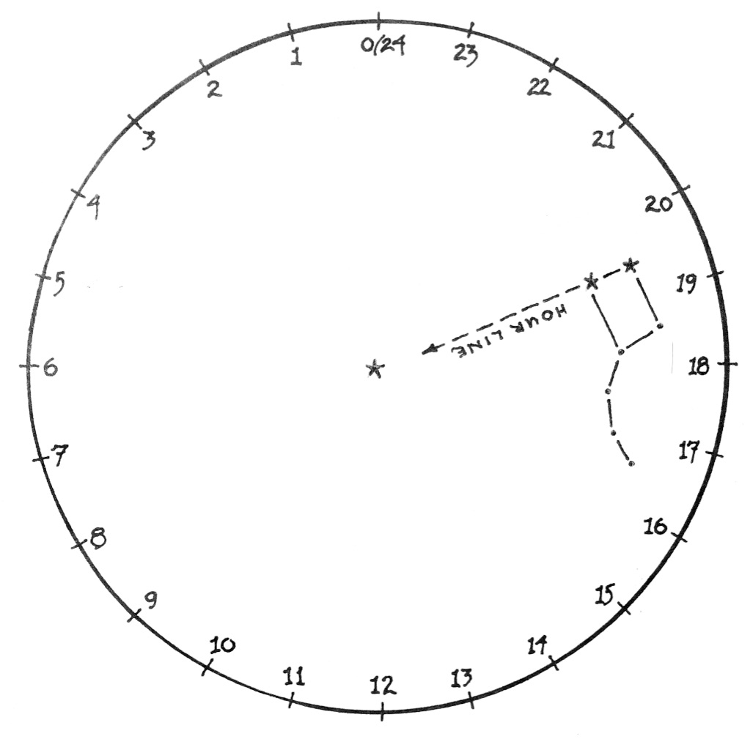

1) The hour line through the pointers is aligned to 19 1/2 hours on the clock.
This is the “raw time.”

2) November 25th is about 3 1/2 months from March 12th.

3) Multiply: (3 1/2) x (2) = 7

4) Add: raw time of 19 1/2 hours + 7 = 26 1/2 hours
Subtract: 26 1/2 - 24 = 2 1/2
The time is 2 1/2 hours on the 24-hour clock, or 2:30 am (PST)

In Closing

So, why does this work?
The ancients knew well the value of stars as keepers of time and date. In particular, it was widely known that the habits of stars are regular and predictable. Accordingly, any might serve as a timepiece, given knowledge of when and where it will appear.
Today it’s well understood that a star – any star – will reappear in the same location four minutes earlier than it did the night before. Conversely, and by the same reasoning, a star appears in the sky four minutes later than it will on the next night following. In the course of a week, then, the accumulated difference amounts to roughly half an hour, or two hours in the span of a month. These differences, of course, derive from our planet’s dance through space - a dance well beyond the imagination of the ancients, but source just the same for the predictable parade of luminaries overhead by which time has been reckoned for centuries.
Once the habits of a particular star are known, it’s possible to determine the hour by its location in the night sky, when weighed against a known point of reference. In the case of the Pointers in Ursa Major, that point of reference is the stroke of midnight on the 12th of March. At that moment, the hand of the pointers are poised directly over the North Star, Polaris – right up there at the zero hour of our imagined 24-hour clock face, from whence it begins to clock the hours. With that as our reference, it’s possible to determine the time for any hour of any night of the year.

© theblueskyclassroom

