The Stars of April
drawn for latitude 38° N
Early April @ 10 pm / late April @ 9 pm (PST)
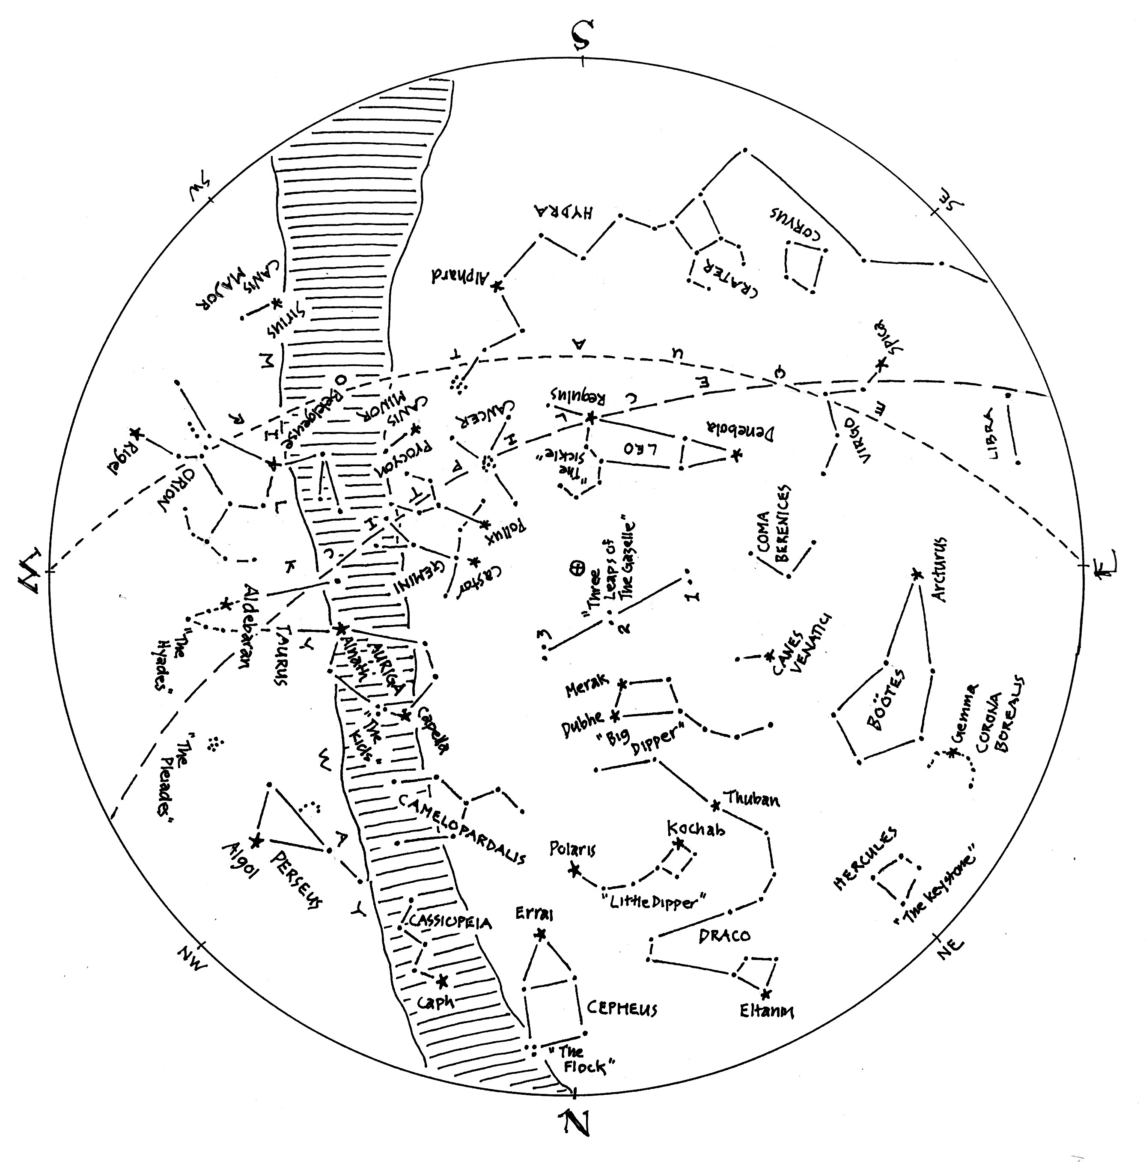

The Stars of April (lines only)
Here’s a chart of the April skies, without the labels. Try labeling it yourself when you think you’re familiar with all that it shows.

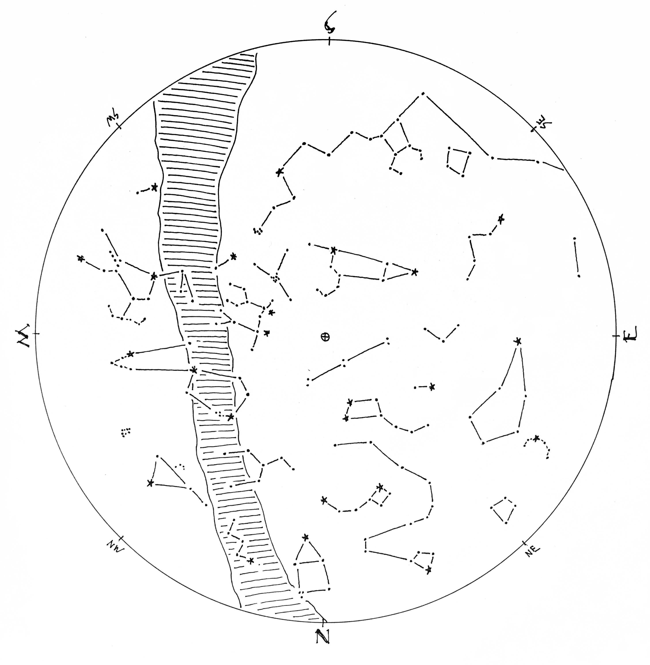

The Stars of April (blank)
The chart below shows some promininent stars in this month’s sky. Can you recognize them without their names or labels? You can print this chart and test yourself – connect the dots, draw the figures, see what you remember from your nights out under the stars… or, if you’d rather, invent some figures of your own.

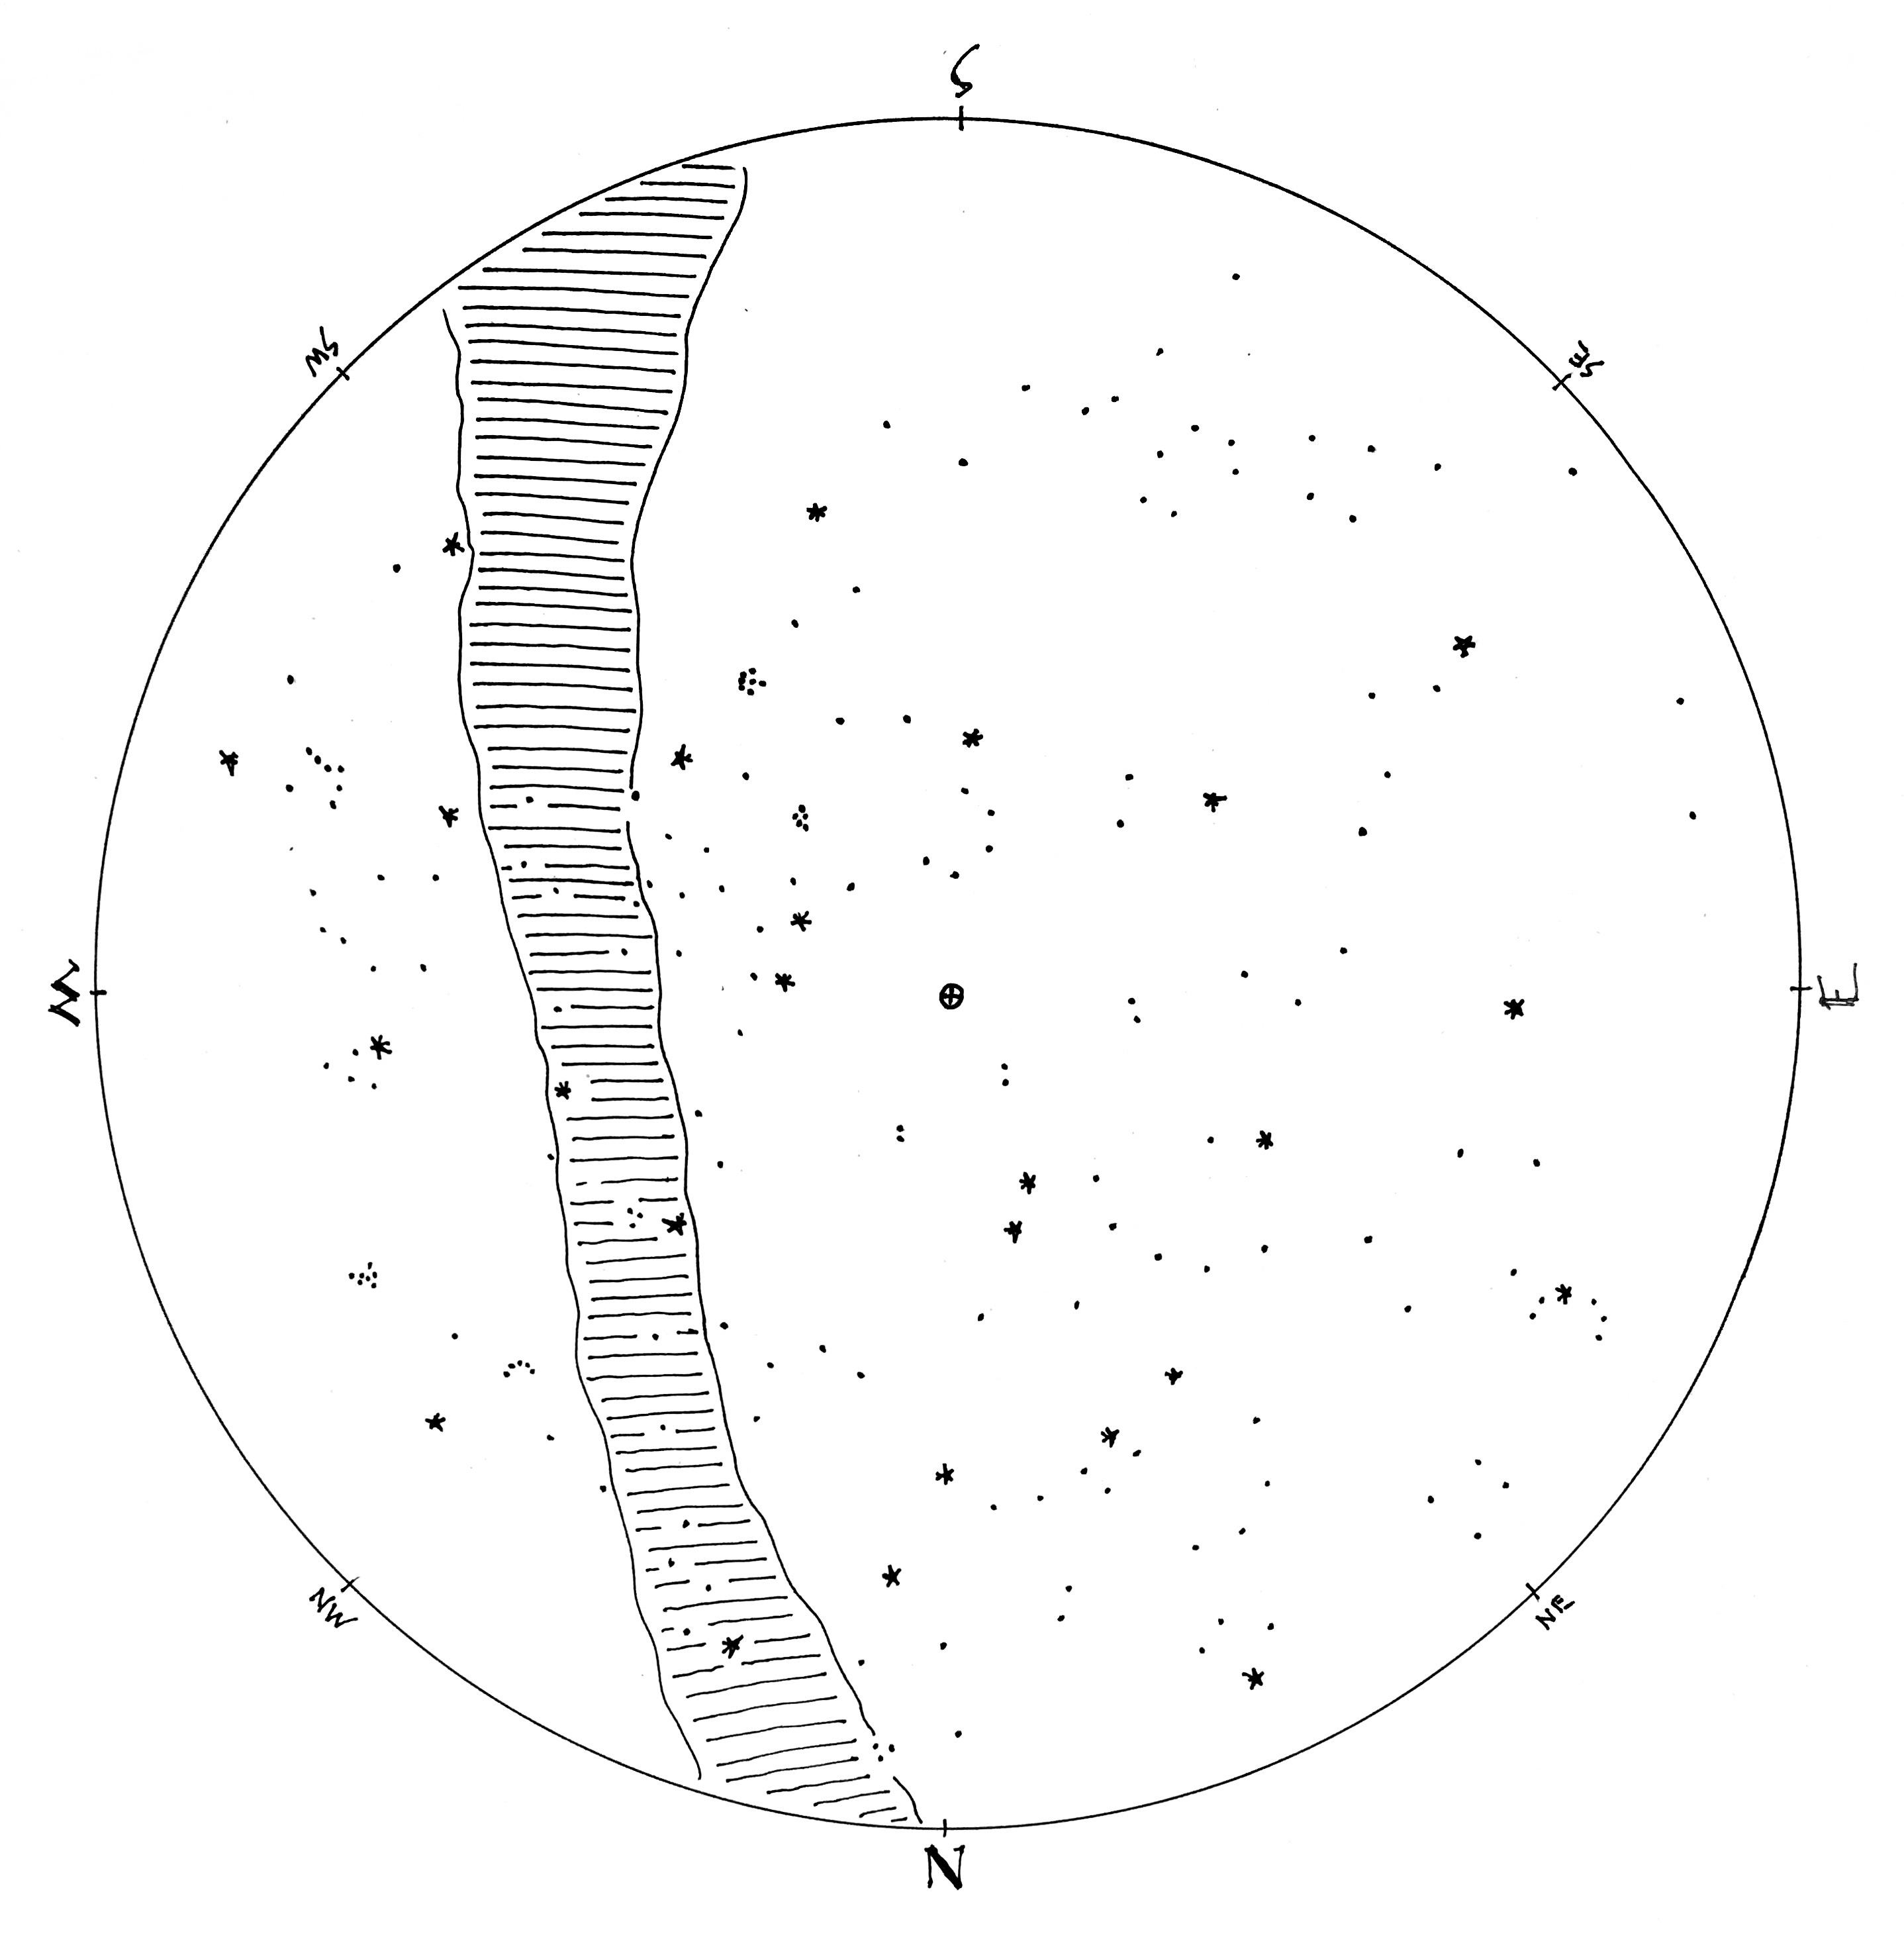

© theblueskyclassroom

