The Stars of June
drawn for latitude 38° N
Early June @ 10 pm / late June @ 9 pm (PST)

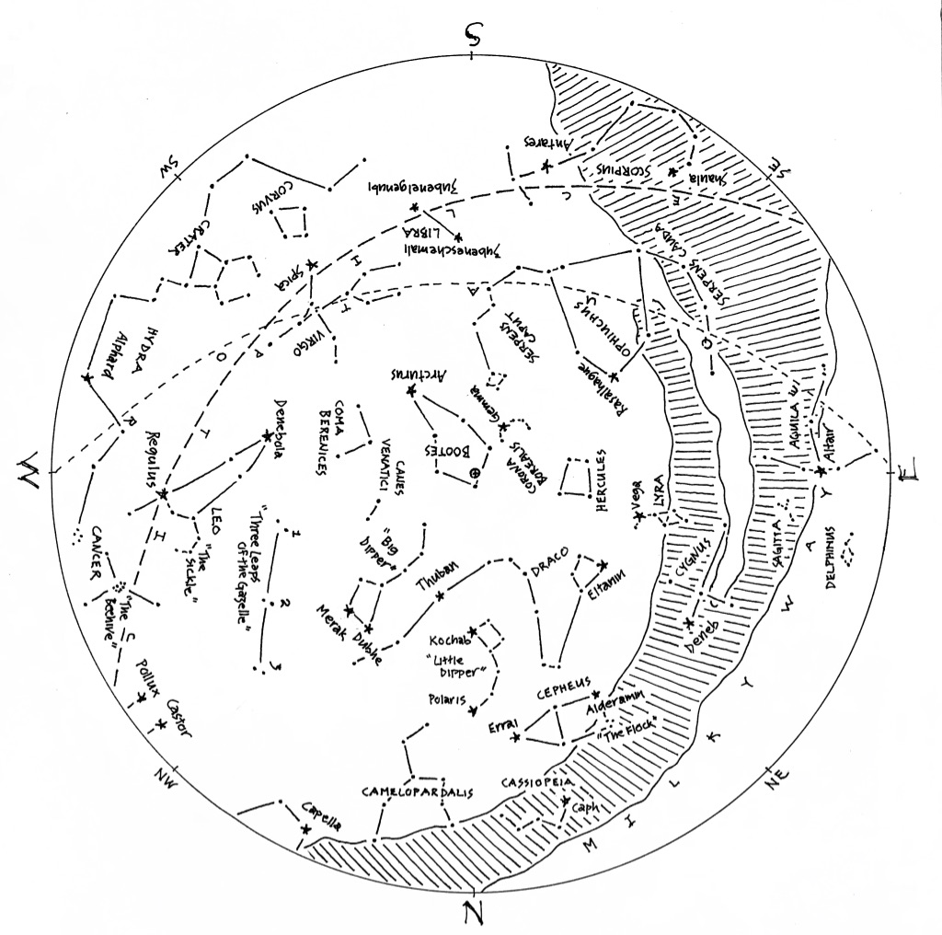

© theblueskyclassroom

The Stars of June (lines only)
Here’s a chart of the June skies, without the labels. Try labeling it yourself when you think you’re familiar with all that it shows.
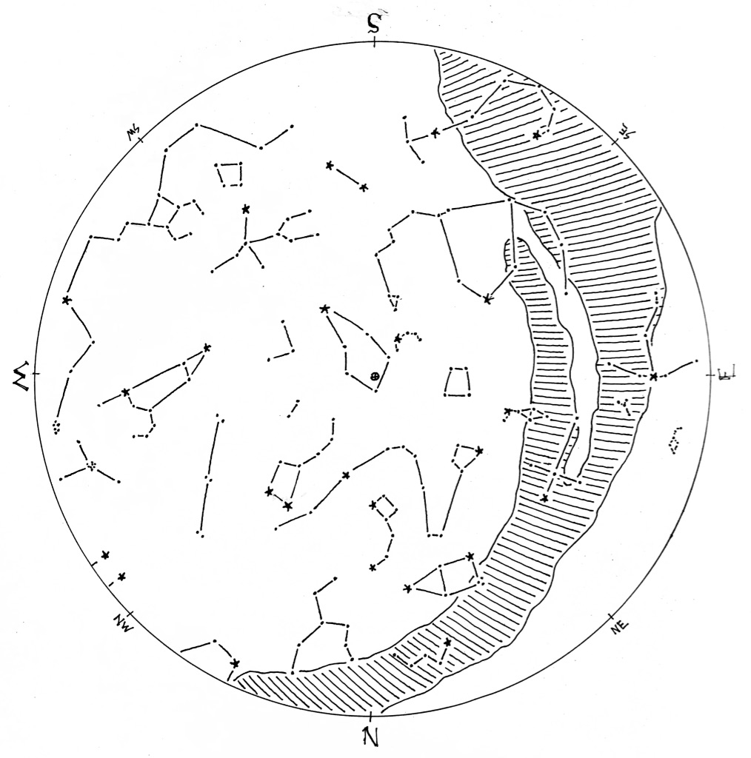

© theblueskyclassroom

The Stars of June (blank)
The chart below shows some prominent stars in this month’s sky. Can you recognize them without their names or labels? Print this chart to test yourself – connect the dots, draw the figures, see what you remember from your nights out under the stars… or, if you’d rather, invent some figures of your own!
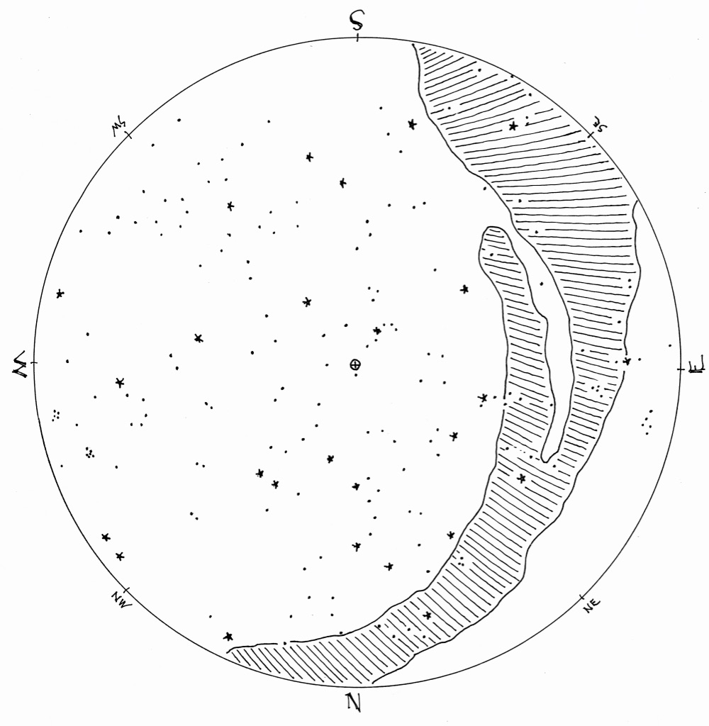

© theblueskyclassroom

