A Naked-eye Guide to the Night Sky
The Stars of July

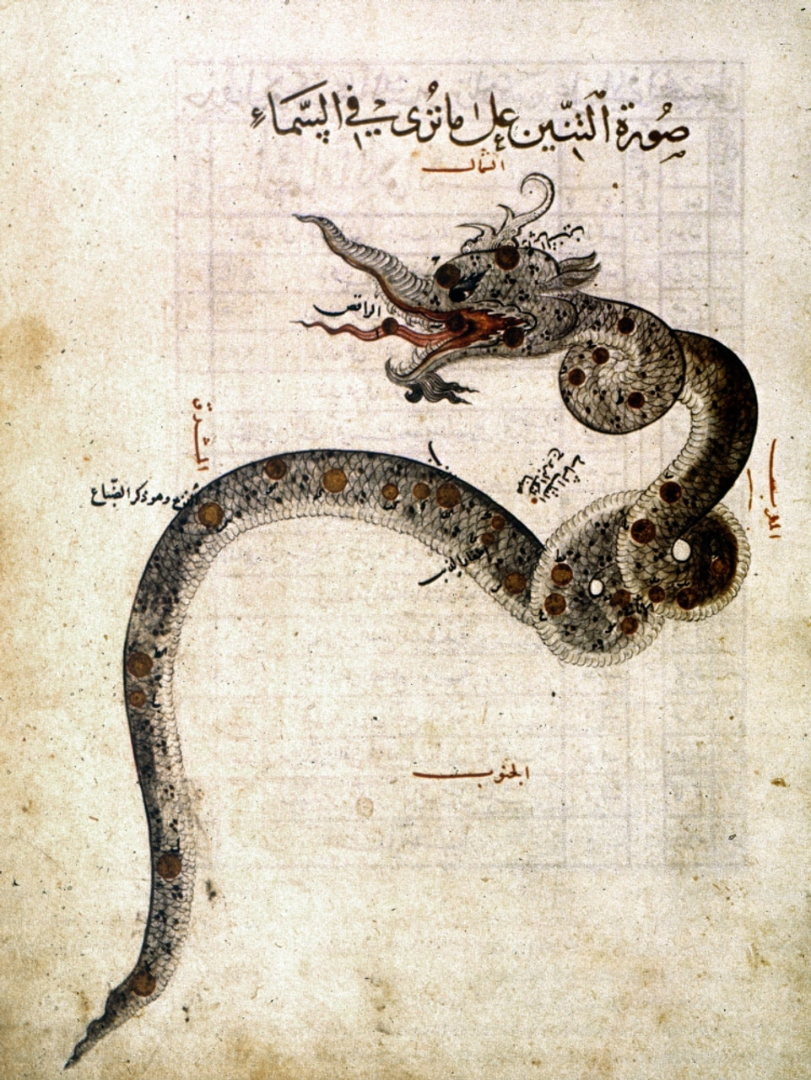

Draco, from Al-Sufi’s Treatise On The Fixed Stars, 1437 C.E.

The Sun has turned its back on northern skies, and is headed southward on its annual migration. But even in parting, it leaves behind the simmering warmth of days, a gift that will linger well into the weeks of fall. Nights, meanwhile, are short, with much to be seen overhead. Stars in the west are lining up to exit, while those in the east make new acquaintance. The band of the Milky Way climbs quietly higher, unveiling by degrees the core of the galaxy we call home.
The pages that follow will introduce you to the stars alight in this month’s sky. Printable maps are attached to the end of this guide - they depict the stars as seen from mid-northern latitudes in the hours shortly after sunset, and will serve reasonably well for the entire month. Viewing is best on a moonless night. You’ll want a vantage point with an uncluttered horizon, away from the glare of lights. A general sense of the cardinal compass directions is also helpful. If you’re not already familiar with how to read a map of the sky, there’s an attachment offering some pointers – you might take a few moments to look it over before your session with the stars. Otherwise, print the charts, grab a red-filtered flashlight, and head outside for an evening under summer’s darkened dome…

The Northern Sky

Begin your gaze with a look to northern skies. Most stars there will be familiar from recent months, but their positions have shifted with the passage of time. Easiest to find are likely those of the “Big Dipper” - seven stars of relatively equal brightness, forming the most widely recognized figure in the sky. Known in some cultures as “the Wagon”, you’ll find it this month about two or three hand spans above the northwest horizon, spilling its contents eastward.

Stars of the Dipper belong formally to the constellation Ursa Major, the Greater Bear. The association with a bear is unaccountably common across time and culture – unaccountable, because there’s nothing about the figure that remotely resembles a bear. Some suggest that ursa is a corruption of the Latin versa, which means “to turn” – a reference, perhaps, to the Dipper’s habit of circling the pole through the months and seasons of the year.
And yet… the Dipper’s association with the figure of a bear also appears in cultures far beyond the reach of classical Latin. As noted in previous months, many Native American traditions saw the Dipper as a celestial bear hunt, with stars of the Dipper’s bowl outlining the bear and those of the handle depicting three hunters in close pursuit. The hunt begins each year with the Bear’s emergence from its winter hibernation near the horizon, and plays out month after month in an arc across the northern skies. The story is thought to have originated in Siberia, and crossed the Bering land bridge with North America’s first human inhabitants - arguably the oldest tale told in the western hemisphere, shared and shared again around summer campfires in a hundred variations. July finds the Bear still afoot but wearied, while hunger weighs heavily on the hunters.
Now direct your gaze to the end of the Dipper’s bowl, marked by the stars Merak and Dubhe. The names derive from Arabic, and refer (yet again!) to the figure of a bear. More commonly, these stars are called “the pointers” because a line drawn through them points to Polaris, the North Star. Known in ancient Persia as the “Nail in the Sky”, Polaris is the only star that stays put, no matter the hour or season. Face Polaris, and you’re looking north – not just north-ish, but the Real Deal.

Once you have your bearings, it’s time to pull out your star chart. Facing north, hold the chart in front of you like a steering wheel, with “N” at the bottom, pointing toward the ground. That “N” on the chart represents the north point on the horizon in front of you, and stars in the lower half of the chart will match those you see in the northern sky. Remember that the center of the chart represents zenith, the point directly overhead - anything above that on the chart is actually in the sky behind you.

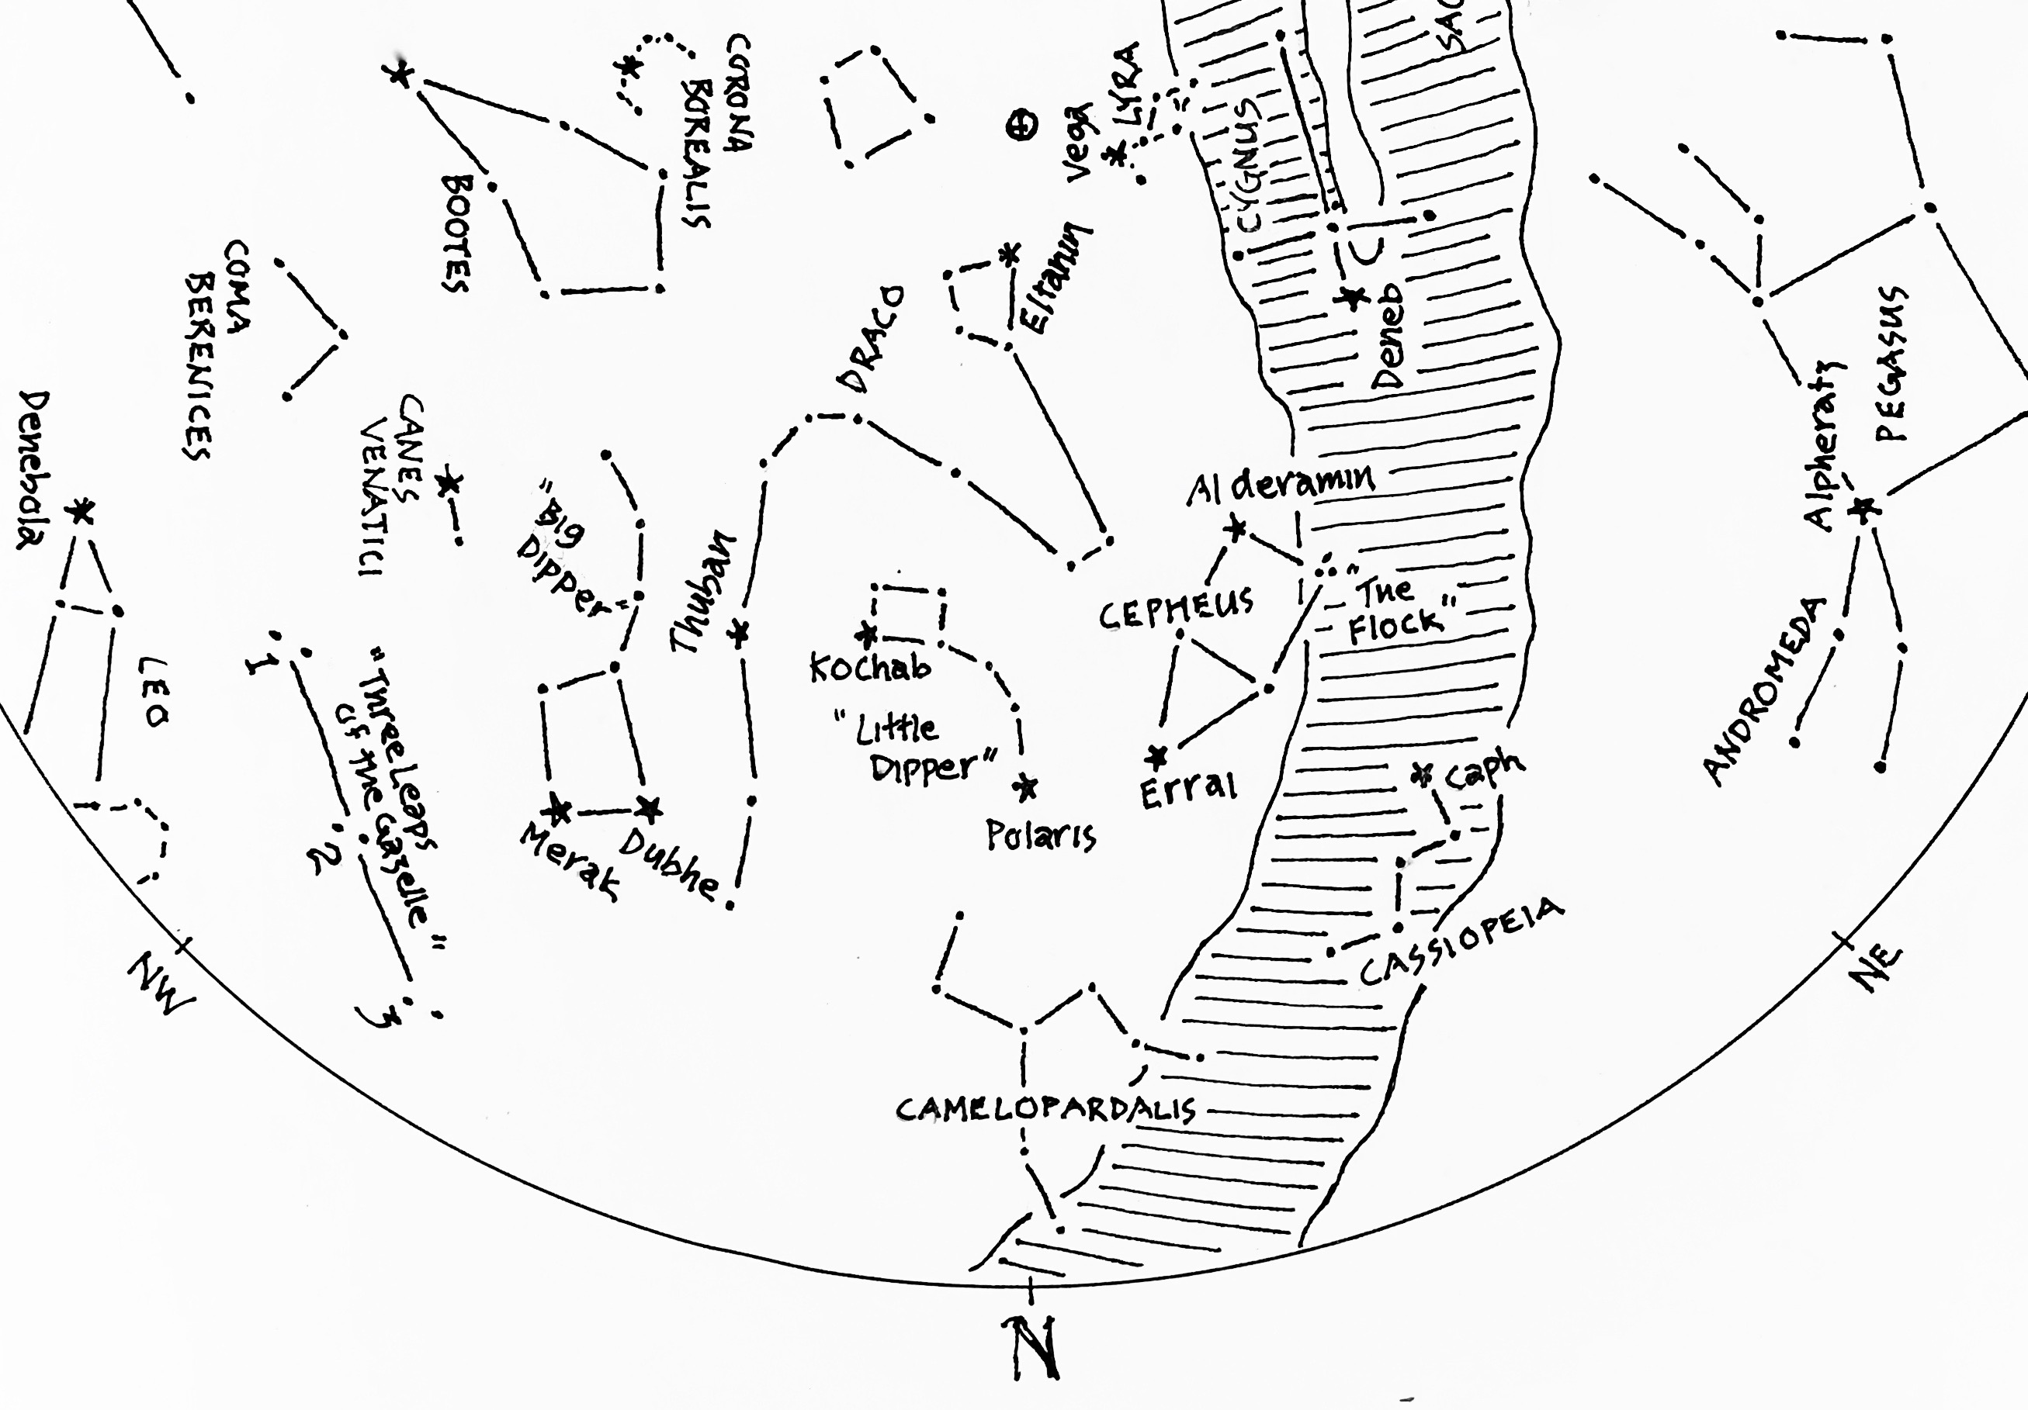
Figure 1: The Northern Skies of July
A detail from this month’s star chart:
The Dippers, a king and his consort, and a dragon lording over all.

From Polaris, look next for an arc of dim stars curving upward and left to end in a small rectangle. Tethered to the pole, these stars form the figure of the “Little Dipper”, the most visible part of Ursa Minor, the Lesser Bear. As with its larger companion, the image of a bear is surprisingly widespread. But alternatives exist. In the Cree Nation, stars of the Lesser Bear were seen as a family of dogs, sent by the Creator to keep constant watch over camps of The People. The Slavs, meanwhile, saw these stars as the embodiment of Perun, god of sky and thunder, storms and rains, and (well… why not?) oak trees.

Draped above the Little Dipper you’ll find the writhing figure of Draco, the Dragon. On these evenings of July, the Dragon’s head rears almost directly above the North Star, Polaris. Ancient Babylonians saw Draco as the embodiment of Tiamat, primeval goddess of chaos and doom, spurned in love and bent on wanton destruction. The Chaldean creation epic, Enuma Elish, describes how Tiamat’s demise and dismemberment established cosmic order, providing material for the world we inhabit: lands formed from her body, rivers drawn from her tears, and the vault of heaven upheld by the capacious arch of her ribs.

Thuban, a star in the tail of the Dragon, warrants particular attention. Owing to a wobble in Earth’s axis, Thuban served as North Star during construction of the Egyptian pyramids. The wobble – known today as precession of the equinoxes - was brought to light more than two thousand years ago, as explained in the guide to the stars of May. For now, of course, the mantle of Pole Star belongs to Polaris, but fame is fleeting. The drift of our planet’s axis confers the honor of Pole Star to a circle of several contenders – of little consequence in the course of a human lifetime, but noticeable over millennia. The result? Gradually, Polaris will let slip its hold on the pole. Freed of obligation, it will wander for thousands of years in ever-widening circles until the cycle begins anew. Figure 2 illustrates the drift of the pole, and identifies a few of the stars that serve as guides through the ages. Take note that the center of the circle lies within grasp of the Dragon – even in the wake of her demise Tiamat foments chaos, forever wrenching the pole askew in the northern sky.

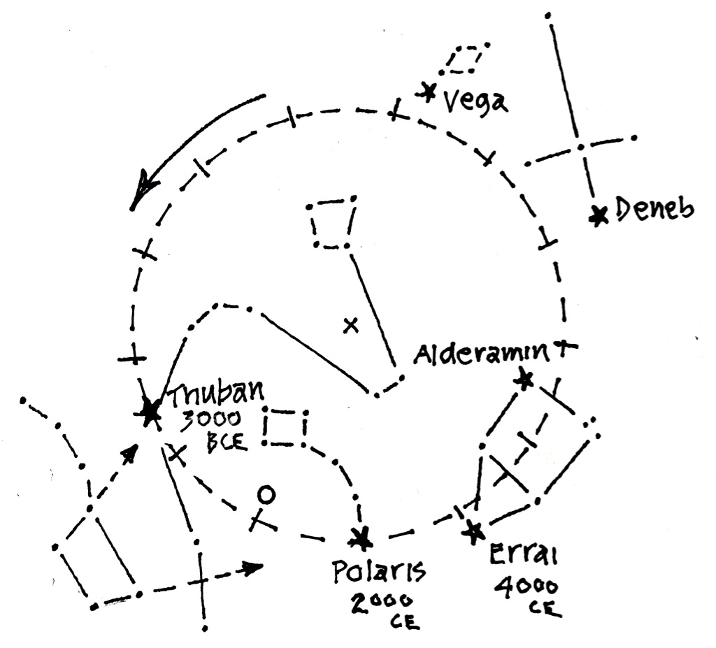

Figure 2: Migration of the North Celestial Pole
Detail showing precession of the Pole through figures of the northern skies.
Tic marks show the progress at intervals of 2,000 years.
Whether by accident or design, stars of the Big Dipper
point the way to both Polaris and Thuban.

Now look again to the Dipper’s pointers, and extend their line through Polaris to the next star you see. This is Errai, one of the stars in the figure of Cepheus. This group recalls the shape of a house you might have drawn as a five-year-old, but in these darks of July it’s come unmoored and appears to be tumbling across the sky. Ancient Greeks recognized Cepheus as the King of Aethiopia, garbed in royal robes. But Errai translates as “the shepherd”, suggesting a humble origin – look to a corner of the figure for three dim stars of “the flock”, tended closely by the shepherd through the hours of the night.

Below Cepheus, you’ll find the distinct zig-zag of five stars marking his consort Cassiopeia. You may already be familiar with the tale of retribution wrought by her boasts of beauty – a story to be told at length in November when she’s coiffed and fully upright. Indigenous North Americans, meanwhile, described this figure as the hide of a magnificent elk, stretched and pegged to dry in the sky - easily mistaken for stars, the five bright points we see in the darks were thought to be peg holes, shot through with light from a world beyond.

The figures we’ve identified in the northern skies are circumpolar – ever-present and always on view no matter the hour or season. Deemed “the imperishables” in ancient Egypt, they’ve inspired confidence and assurance for thousands of years in a world otherwise prone to disaster. Rivers may flood and empires may crumble, but stars of the northern skies are steadfast, turning reliably ‘round the pole through the hours of the night and seasons of the year.

The Western Sky

Shift your attention west with a quarter turn to your left. Rotate your star chart so that “W” is at the bottom, toward the ground. What you see in the bottom half of the chart will match the brightest stars in the western sky, as seen in Figure 3. Stars in the west have been making their way across the sky for several weeks, and you’ll likely recognize them from last month’s gaze. Now, as they steer for the horizon, we’ll wish them well before they make their exits.

Already dipping behind the western horizon is the figure of Leo, the Lion, but you’ll need a bit of luck to find it. Leo was a herald of spring, in full command of the sky through the season of birth and renewal. This month, however, finds the king of beasts heading for shade as temperatures rise, much as lions in Egypt sought summer respite on the banks of the Nile - you might spot bright Denebola, the fluff at the end of his tail, before the Lion disappears.

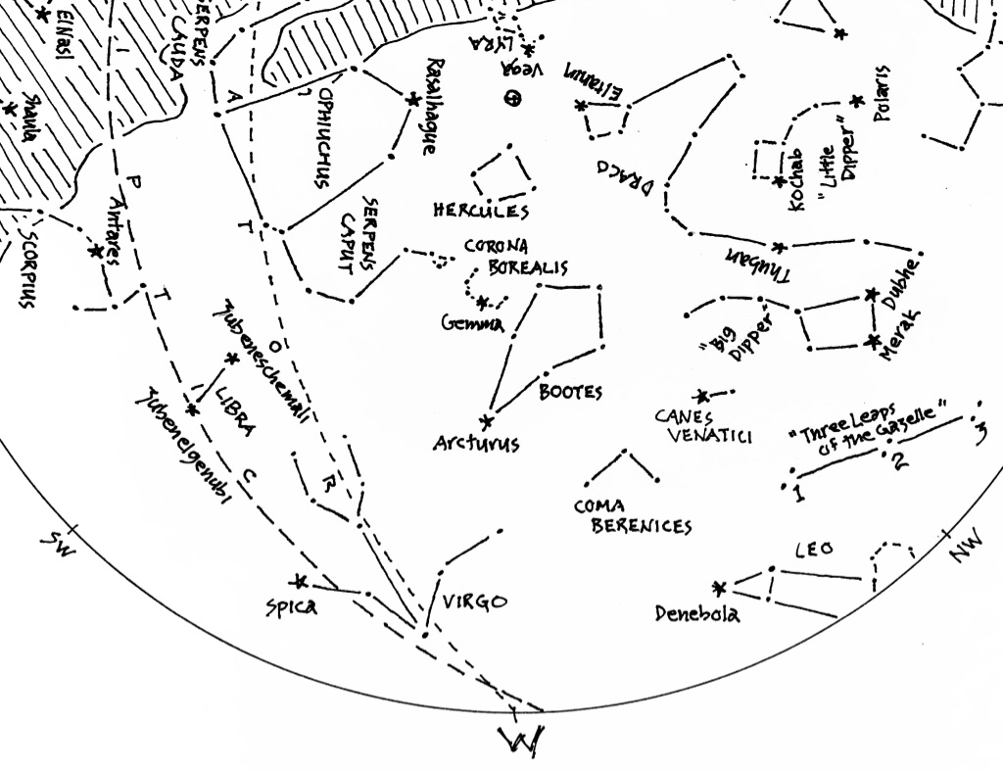

Figure 3: The Western Sky
Like distant memories of Spring…

Easier to find is the figure of Böotes, the Herdsman. The Arabs knew him as “the Shepherd of the Heavenly Flock”, faithful attendant to points of light grazing quietly in the darks. Elsewhere, he was regarded as a patron of agriculture and widely revered as inventor of the plough. Böotes has tilled the skies since his appearance in March, and even now remains hard at work into the evening hours. Brightest star in the figure is Arcturas - known for its ruddy complexion, a likely result of days spent toiling in the heat of summer.

The Herdsman is aided by his dogs Chara and Asterion - you’ll find them huddling to the right under the handle of the Big Dipper. Strays for centuries, they were finally adopted and christened Canes Venatici, the Hunting Dogs, in 1687. The brighter of the two is sometimes called Cor Caroli, in memory of Britain’s King Charles. Legend has it the star burned with unusual brightness on the day of the king’s execution - a spark of alarm in the eye of man’s best friend.

Difficult to locate but worth the effort is Coma Berenices - tresses of an Egyptian queen, tacked to the sky as a votive offering. Last we’ll see of this one, adorned with the ringlets and finger-curls of a thousand galaxies, and bejeweled with filaments of star-stuff beyond what even a queen could imagine.

Next, look left of the Herdsman for the lovely half-circle of stars known as Corona Borealis, the Northern Crown. In recent weeks, the Crown passed nearly overhead, likened by some to a smoke hole in the celestial longhouse. Others saw the Crown as seven dancing maidens – in the deepening darkness, listen for the sound of their ankle bells ringing in time to the drumbeat of summer.

Further left and closer to the horizon, a brighter star beckons. This one is Spica, brightest in the Zodiac figure of the Virgin. Like the Herdsman, she’s a devoted steward of the land, known in ancient times as “the Lady of the Fields.” Some have cast her as Erigone, daughter of the winemaker Icarius. This month finds her nearly prone, lovingly tending to rows she planted in May, thoughts set on the feast she’ll lay when she hosts the Sun for the equinox of Fall.

Taken together, the three brightest stars in July’s western skies - Denebola, Arcturus, and Spica - comprise the asterism known as the Spring Triangle. Weeks ago, they and their cohorts announced a turn toward the warming of days. Now, in the darks of July, the triangle fades westward, in accordance with the cycle of seasons writ in the stars overhead.

Before turning eyes to the southern sky, look for the figure of Hercules, looming high in the west above the Herdsman. Greek mythology recounts his labors of atonement and redemption – twelve of them in all, with more than a few played out in the theater of lights overhead. Last month found him at zenith, bearing the weight of the sky on his shoulders. Now, at the height of summer, he labors under the weight of other obligations. Ever alert, he eyes a flock of Stymphalian birds taking wing in he darks - first spied in May as they emerged from their nests, they promise destruction to forest and field. Their presence is unwelcome at best, and Hercules is steadfast in his vow to drive them away. We’ll encounter them later, in the guise of the Summer Triangle, when we turn attentions eastward. To the north, meanwhile, a bounty of Golden Apples ripens at the pole, and Hercules eyes them with intent to lay claim. According to poets of antiquity, the apples Imbue sunsets with color, and confer immortality to anyone lucky enough to taste them. Rare, indeed, are treasures such as these - so rare, in fact, that for hundreds of years they’ve been closely attended by the seven Hesperides, clear-voiced daughters of the evening, imagined by some to be stars of the Little Dipper. There will be more to say about the Apples come August, when the last blush of summer is upon them.

The Southern Sky

Position yourself to view the southern sky with another turn to the left. Rotate your star chart so “S” is at the bottom, pointing toward the ground. You’ll know for sure that you’re facing south if Polaris, the North Star, is directly behind you.

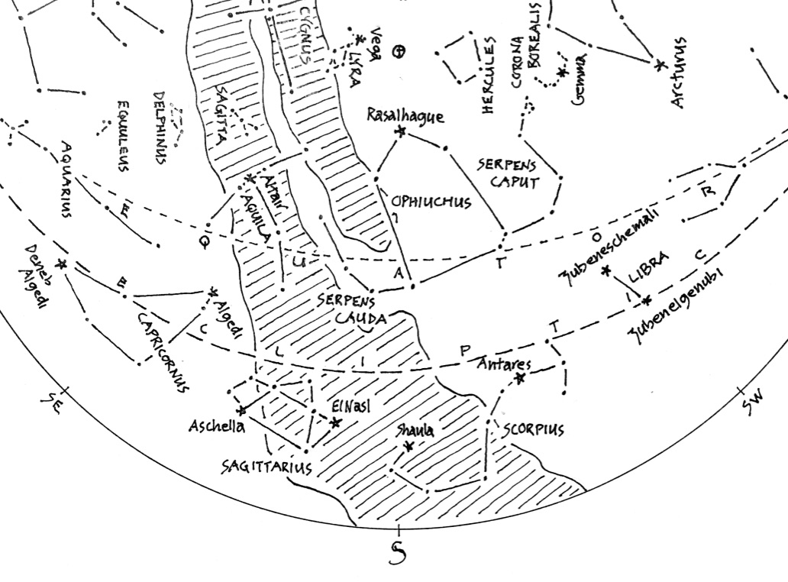
Figure 5: The Southern Sky
A scorpion, snakes, and (thankfully!) a doctor in the house.

Stars in the south are an evening’s main attraction. After months in the wings, they enter the scene well-rehearsed and ready to entertain. This month, the house lights dim to reveal the distinctive figure of Scorpius, the Scorpion, poised at center stage astride the celestial equator.

Visible from any seat in the theater, Scorpius renders tales from every culture. In Vedic tradition, stars of the Scorpion depict an earring stolen from the goddess Aditi. The Rigveda describes Aditi as the personification of a boundless sky, and her earrings, borne from the churning seas, were tokens of divine authority. Return of the earrings restored cosmic order, as celebrated today in the Hindu festival of Naraka Chaturdashi. Pacific Islanders, meanwhile, saw stars of the Scorpion as a fishhook, used by the trickster Maui to raise islands from the ocean floor – strikingly similar to a tale in Ojibwe oral tradition, where stars of the Scorpion portray Nanabozho, a shape-shifting trickster who fashioned land from mud in the wake of a primordial flood. Heaped on the back of a turtle, the mud survives today as North America in the guise of Turtle Island.

Despite its varied adornments, the image of a scorpion is hard to miss. Brightest star in the figure is Red Antares, widely recognized as the Scorpion’s beating heart. The name translates as “Rival of Mars,” and derives from the star’s close resemblance to the distinctive desert planet. Above and right of Antares, an arc of three stars marks the Scorpion’s head and claws - then left and downward you’ll find Shaula, loosely translated from Arabic as “the menacing sting.” To the Persians, Antares was “pillar of the west”, one of four Royal Stars believed to uphold the sky. In antiquity, the Royals marked time and season by means of their relation to the passage of the Sun. Antares was herald of the autumnal equinox, playing host to the Sun in the season of ripening grain.

Alchemists in the Middle Ages paid special attention to Antares, believing that iron could be turned to gold when the star was conjunct the Sun in winter. Wishful thinking, perhaps… but as it turns, the alchemists were not far off. Crushing pressures in the cores of stars fuse lighter elements into heavier ones, releasing energy in the process. The energy radiates outward, counterbalancing the inward pressures that forged the heavier elements to begin with. In this way, hydrogen becomes helium, helium becomes carbon, and so on up the periodic table of elements to the stage of iron production - whereupon fusion of even heavier elements consumes, rather than releases energy. At this point, a star collapses inward on itself then rebounds outward, spewing a cocktail of newly-minted elements into space to become oceans, barking dogs, redwood trees, and pretty much anything else you can name in the physical world we inhabit. The implosion is known as a supernova, and it results in a rapid formation of elements even heavier than the limits imposed by iron, up through and including elements like… gold. In short, iron becomes gold in the spectacular death throes of a star.

So what, then, of Antares? The colors of stars are biographies, and the ruddy hue of Antares reads like a final chapter. Low on stores of lighter elements, Antares is primed to forge gold from iron, just as alchemists had once hoped to do themselves. Exactly when the miracle will occur is anyone’s guess, but estimates place it within the next million years – long wait for an alchemist, perhaps, but just a few beats away for the heart of the Scorpion. Of course, it’s also possible that Antares has already called it quits. But even at the speed of light, news of the event – whenever it occurs - will take hundreds of years to arrive. Still, it’s fair to wonder: Is it possible to pan gold from an incoming stream of interstellar dust..? There’s no harm in preparing now, should one be on its way.

Historically, the Scorpion has been subject to alterations. In antiquity, its claws were imagined farther right, in the pair of prominent stars now marking the Zodiac sign of Libra. Recognized today as the Scales, the names of these stars betray their origins: Zubeneschemali and Zubenelgenubi, or “northern claw” and “southern claw” in Arabic. Presently, the southern claw lies less than a degree from the ecliptic, the path of the Sun, Moon and planets across the background of stars – with a bit of luck, you might see the claw eclipsed by the passing Moon in the weeks and months ahead.

Like the Scales of Libra, the Scorpion belongs to the Zodiac, playing occasional host to the Sun on its annual migration across the background of stars. In truth, however, the Sun’s visitation with the Scorpion is exceedingly brief, lasting only nine days in late November. From there, the Sun migrates into the domain of Ophiuchus, the Snake Handler, where it lingers through mid-December – a consequence of invisible boundaries established and agreed upon by the International Astronomers Union nearly one hundred years ago.

Ophiuchus is an imposing figure but a challenge to find, owing to its capacious size and lack of prominent stars. Begin by finding Rasalhague, brightest in the figure, whose name translates as “head of the Serpent Bearer.” From there, it takes some imagination to make out a pair of arms dangling downward to grasp the writhing snake Serpens. The snake is divided into two: Caput (Latin for “head”), and Cauda (Latin for “tail”). You can spot the serpent’s head twisting upward to the right, eyeing with interest the Northern Crown. Known by some as Serpentarius, the Snake Handler is purported to represent Asclepius, god of healing and medicine, who learned his arts by watching a snake restore life to another with herbs. Snakes have since been revered as symbols of transformation, evidenced by their shedding of skin, and the Rod of Asclepius survives today as an emblem of the medical profession.

The ancient Chinese saw the stars of Ophiuchus in another light. To them, it reminded of a marketplace, with stalls of vendors embraced by the gentle curves of the Serpent. Whether from snakes or vendors, or from the bellies of imploding stars, one can only imagine what remedies might be procured from the celestial apothecary overhead.

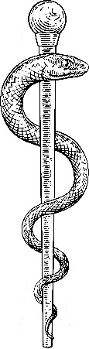

Last figure of prominence in the southern sky is Sagittarius, the Archer. You’ll find it left of the Scorpion, bathed in the luminous glow of the Milky Way. ElNasl translates as “tip of the arrow” and Ascella means “armpit” – vague references to a figure drawing a bow, but you’ll likely find it easier to picture a teapot with steam of the Milky Way issuing from its spout. Take a moment to trace the band of the galaxy northward, to the figure of Cassiopeia behind you, and you’ll see that it dims noticeably. A view toward the north looks away from the Galaxy’s center, with fewer stars to light the sky. Southward, the Galaxy brightens, testament to the multitudes of stars at its core. Much more will be said of the Archer and the Galaxy when they take center stage in August.

The Eastern Sky

We’ll complete our circuit of the sky with a view to the east - turn again, and adjust your chart accordingly. You’ll know you’re facing east if Polaris, the Pole Star, is directly to your left.

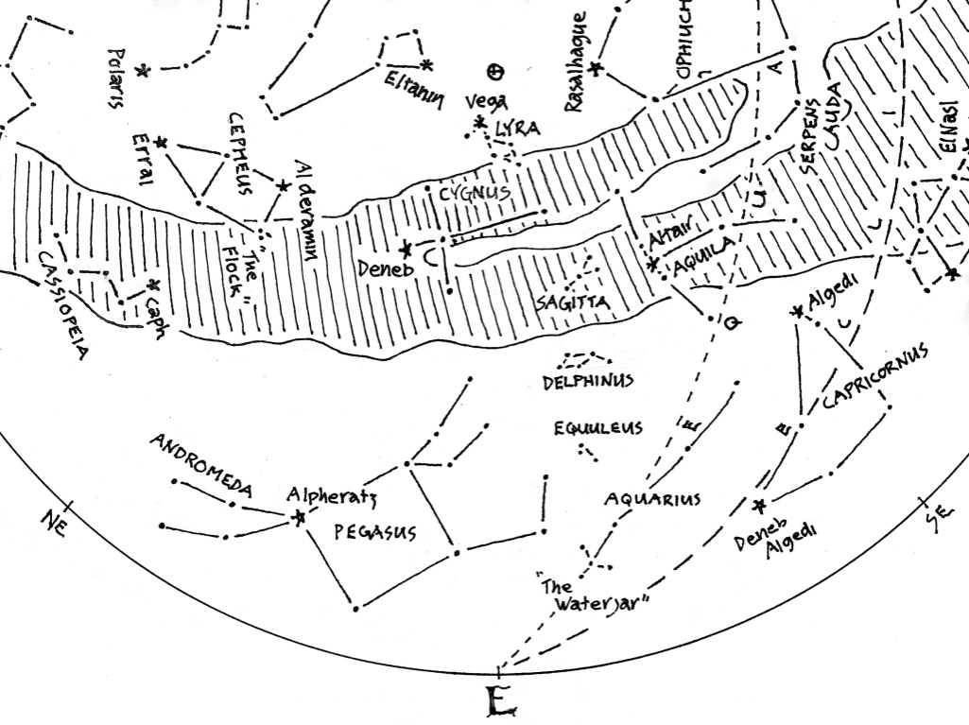
Figure 6: The Eastern Sky
The joys of summer:
Horses, birds, and the charms of beautiful music

Stars in the east hint at performances to come in the months ahead. For now, they stand in the wings, warming their voices and awaiting notice. Three of particular promise are the stars of the Summer Triangle, earlier described as a flock of Stymphalian birds, and each the brightest in a figure of its own. First and highest of the three is Vega, a bright blue star burning fast and hot. Vega has long been associated with birds – its name translates to “swooping eagle,” though it belongs formally to the figure known as Lyra, the Harp of Orpheus. The harp is outlined by four dim stars dangling close by Vega. Legend has it that music from the Harp charmed animals, and that rivers changed direction to be nearer its sound.

The second star of the Summer Triangle is Deneb, below and left of Vega. Deneb is Arabic for “tail,” and it marks the tail of Cygnus, the Swan. Look to the right of Deneb for the Swan’s wings and neck outstretched in full flight. The Swan is also known as “the Northern Cross,” for reasons apparent come December.

Third in the Summer Triangle is Altair, brightest star in the figure of Aquila, the Eagle. Altair is flanked by two companions, Tarazed and Alshain, marking the shoulders of the eagle’s outstretched wings. The Eagle soars from the south toward the figure of the Swan – two great birds destined for a dalliance in the skies of summer.

A handful of other figures, less conspicuous than those of the Triangle, are also edging into this month’s eastern sky. One of them is Sagitta, the Arrow, seen just to the left of Altair in the Eagle. The Arrow is easy to miss, but has made appearance on charts for over two thousand years. Next, directly beneath, look for Delphinus, the leaping Dolphin, guide and comfort to sailors since antiquity. Lower still, look for Equuleus, the Foal - dim and wobbly perhaps, but known as “The First Horse” for rising ahead of the great winged Pegasus.

Closer to the horizon, you’ll find two more figures of the Zodiac. One is the large, dim triangle of Capricornus, the Goat-fish, seen just to the left of the Archer. The strange image originated with the Sumerians. Two thousand years ago the Goat-fish hosted the Sun for the Winter Solstice, marking the southern-most reach of the ecliptic and lending its name to the Tropic of Capricorn. Further left you might also spot Aquarius, the Water-Bearer. In antiquity, its appearance coincided with seasons of rain and flood, prompting a likeness with the Egyptian god of waters. Reason enough, it seems, for the sign of the Water-Bearer to mark the western shore of an expanse known since antiquity as The Celestial Sea. The Sea will spill across the southern horizon in the months ahead, and there will be many denizens of the deep to spy there. Taken together, these stars and others remind of the intimate connection the ancients saw between heavens and Earth through the seasons of the year – a connection waiting to be rekindled amid the noise and bustle of the modern world.

The Sky Overhead: Zenith

We’ve made full circuit of the skies of July. Now set your chart aside, lie back on the ground, and take in the Big Picture. Stars in the west are bound for slumber, while those in the east awaken for a season aloft. Southward, the center of our Galaxy slips quietly past, while stars of the north mark time in their waltzes around Polaris.

In the darks of July, the Milky Way is especially prominent, connecting points north and south with a luminous arc passing almost directly overhead. It was long suspected that the Milky Way is comprised of stars, but confirmation had to await invention of the telescope. Today, it’s well understood that our Sun is but one of a multitude – billions of stars assembled into a flattened disk, the whole of it spinning in space like a pinwheel. From a vantage point on Earth, it can be hard to picture, but realize that every star visible to the naked eye – our Sun included – is part of the disc, carried along in a cosmic gyre on a scale beyond imagination.

And yet… within the gyre, every star has a mind of its own. Like a swarm of bees taking wing on a summer afternoon, our galaxy moves through space with a singular intent, belying a chaos of motions within. As for our Sun, it’s winging toward a point known poetically as The Apex of the Sun’s Way. Located between the Harp of Orpheus and the figure of Hercules, the Apex passes directly overhead at midsummer. Nothing to see there - just an indistinct point toward which you and everything in your physical world is speeding at something like twelve miles per second. To what end? Perhaps the Sun, like a river, is drawn to sounds of the harp. For now, it’s anyone’s guess.

In the meantime, realize that our universe is dynamic, subject to motions set in play billions of years ago and unfolding nightly in the stars above our heads. So when you’ve had your fill of all that’s to be seen in the skies of July, close your eyes, listen for the music… and feel the pull of star on bone.

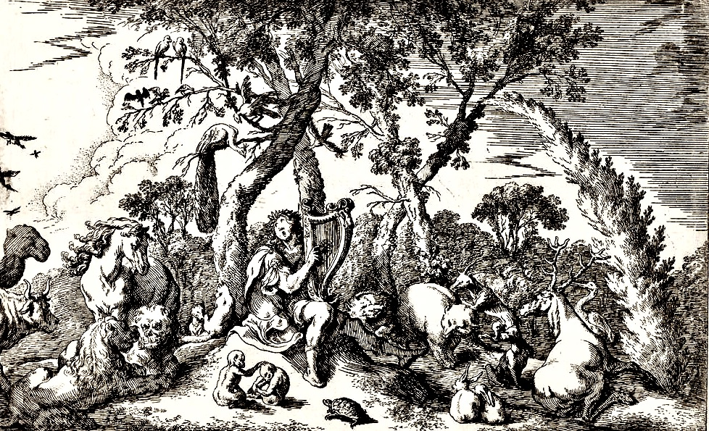

Orpheus Charms the Trees and Animals with His Music
Johann Baur (1607 - 1641)

The Stars of July
drawn for latitude 38° N
Early July @ 11 pm / late July @ 10 pm

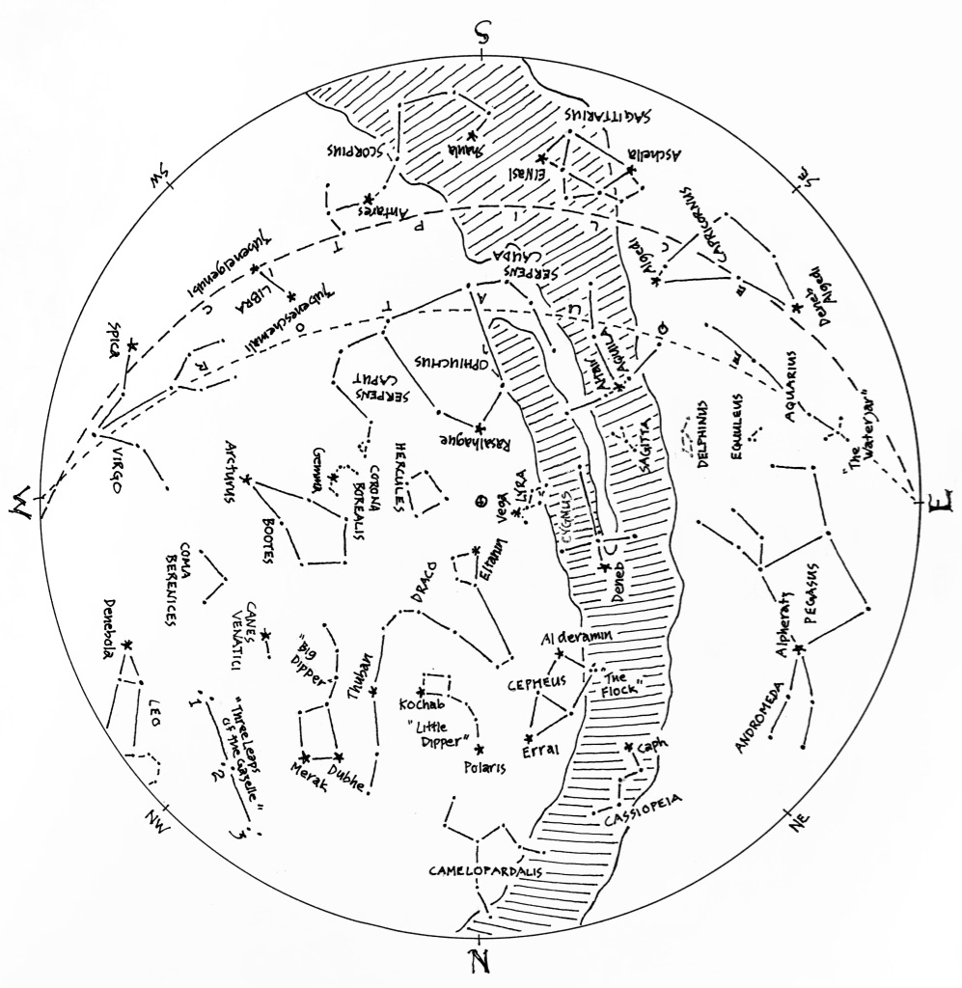

The Stars of July (lines only)
Here’s a chart of the July skies, without the labels. Try labeling it yourself when you think you’re familiar with all that it shows.

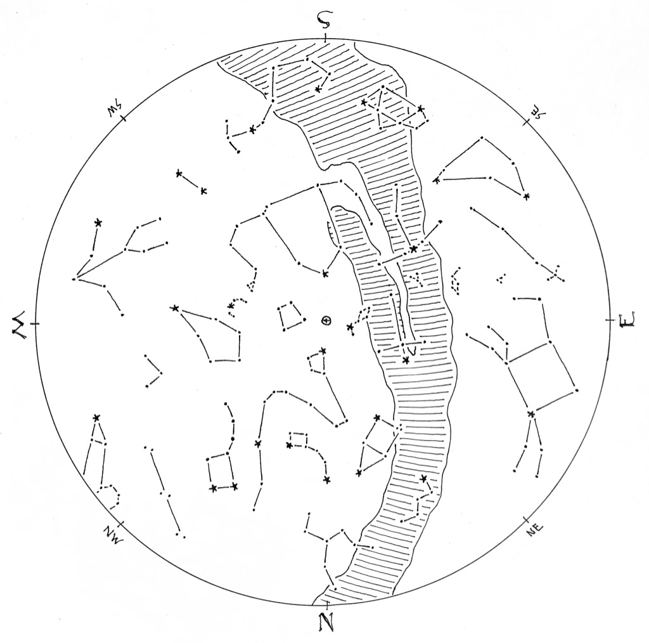

The Stars of July (blank)
The chart below shows some promininent stars in this month’s sky. Can you
recognize them without their names or labels? You can print this chart and test
yourself – connect the dots, draw the figures, see what you remember from your
nights out under the stars… or, if you’d rather, invent some figures of your own!

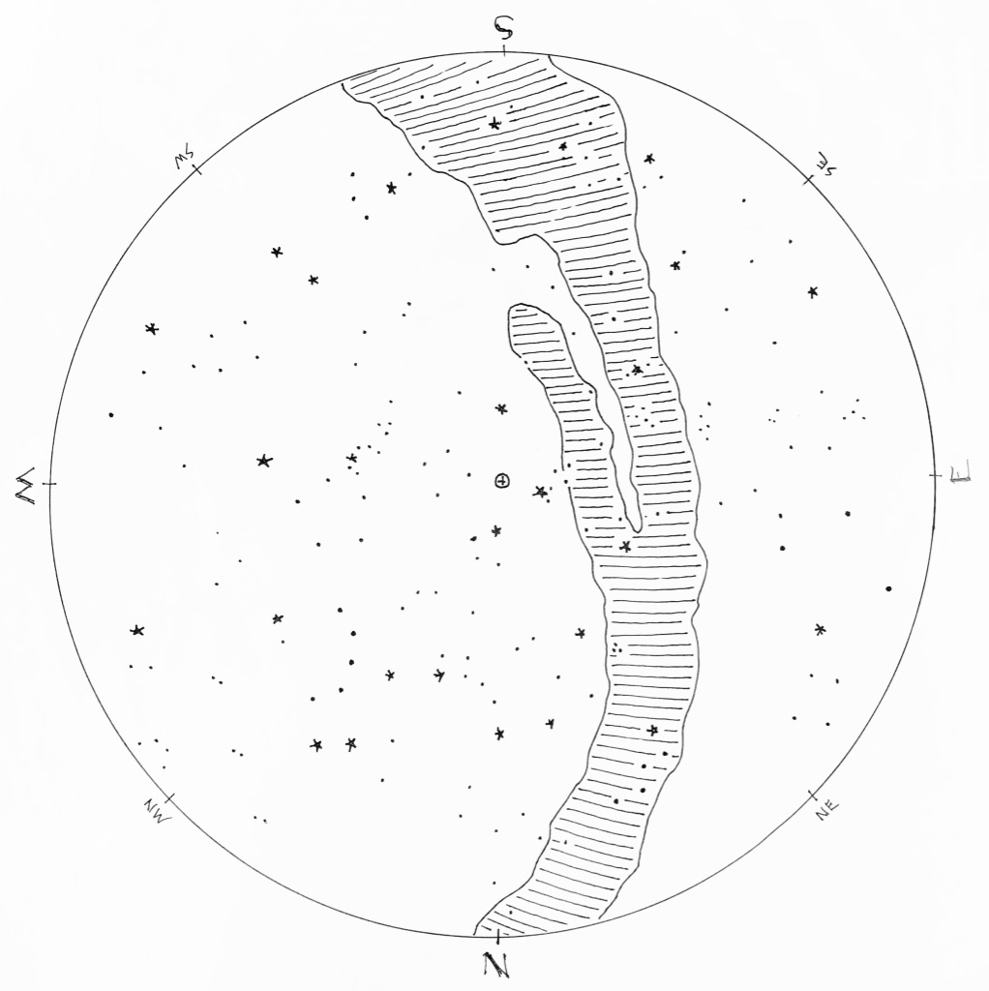
© theblueskyclassroom
A Naked-eye Guide to the Night Sky
How to Read a Star Chart

No one needs instructions on how to look at the stars. You wait until dark, you head outside, and you look up. Pretty simple. But if you want to learn the stars – if you want to know their names and come to recognize the figures they form, month after month and season after season – you might turn to a star chart for guidance.
A star chart is a lot like any other map you might have seen: It shows where things are located, identifies features by name, and lays out a picture of familiar or prominent landmarks. But a map of the sky differs in many ways from a map of the ground, and you might find it useful to get your bearings before you head out to acquaint yourself with the stars.
First, it helps to imagine the sky as a dome, arching overhead. When rendered on paper, the dome flattens into a circle, like the one seen in Figure 1. The outer edge of the circle represents the horizon. It’s marked with the compass directions, but notice that they’re arranged differently than the way we usually see them. This is because a map of the sky looks upward, the reverse of downward, and it throws the placement of compass directions a little helter-skelter. Don’t worry if this is confusing - it will all become clear when you get outside to use a chart.
Everything inside the horizon circle is the sky – again, imagined as a dome, and flattened on paper. At the center of the chart you’ll often find a symbol marking “zenith”, the point in the sky directly overhead. The word zenith comes from an Arabic expression meaning “the way or path of the head”.
Finally, know that a chart is not complete – it shows just a few of the brightest stars in the sky for a given time of year. To include everything that’s visible in the night sky would be impossible!

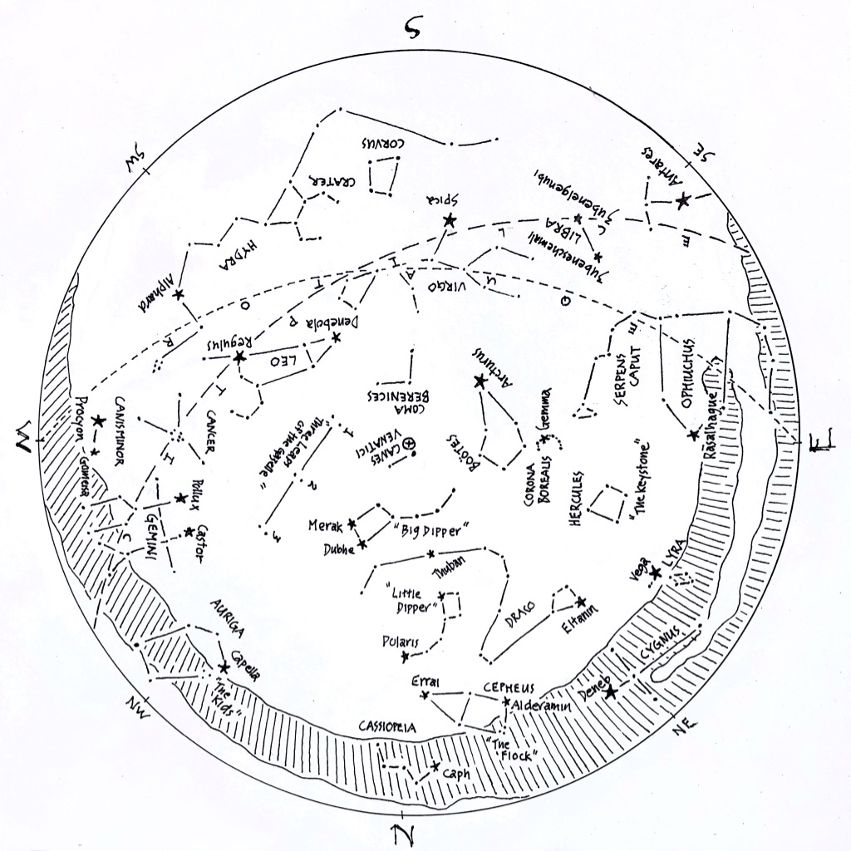

Figure 1: A sample star chart.
Drawn for the skies at around 9:30 pm. in mid-May,
Compass directions are listed around the horizon ring.
At the center of the chart, a (+) symbol inside a tiny circle of its own marks zenith, the point in the sky directly overhead.

Keep in mind that the planet you’re standing on is moving – it spins on its axis once per day, and orbits the Sun once per year. Both of these motions determine what stars will be visible at a particular hour for a given night. The star chart shown above is drawn for the skies of mid-May, about two hours after sunset. If you were to use it at a time or date very different than that, the chart would be less accurate, and you’d have a harder time matching it to the sky overhead.
To read a star chart, it’s held in hand like a steering wheel. The chart is rotated so that the direction you’re facing is at the bottom of the chart. Held in this way, the curve at the bottom of the chart represents the horizon, and everything in the lower half of the chart depicts the sky in front of you. Remember that the center of the map represents the point in the sky directly overhead – as you hold the map like a steering wheel, everything in the upper half is actually found in the sky behind you. If you want to look at those objects in the sky, you need to face that direction and rotate the map so that the new direction of sight is at the bottom of the map. As before, everything in the lower half of the map will match what you see in the sky ahead of you.
By turning your body to face different directions, and by turning the star chart to match your view, you can relate what’s on the map to what’s visible in every quarter the sky. The detail in Figure 2, below, shows the May star chart oriented to view the southern sky.
If you prefer to lie down to look at the stars, a star chart works in this case as well. Simply lay on the ground with your head pointing north, looking upward at the sky. Hold the map above you, again like a steering wheel, so that the northern mark on the horizon ring is pointing toward the north as well. In this orientation, the cardinal compass directions on the map will match those on the horizon around you, and stars on the map will match what you see in the sky. Of course, you may need to move the map aside a bit to see the stars hiding behind (above???) it.

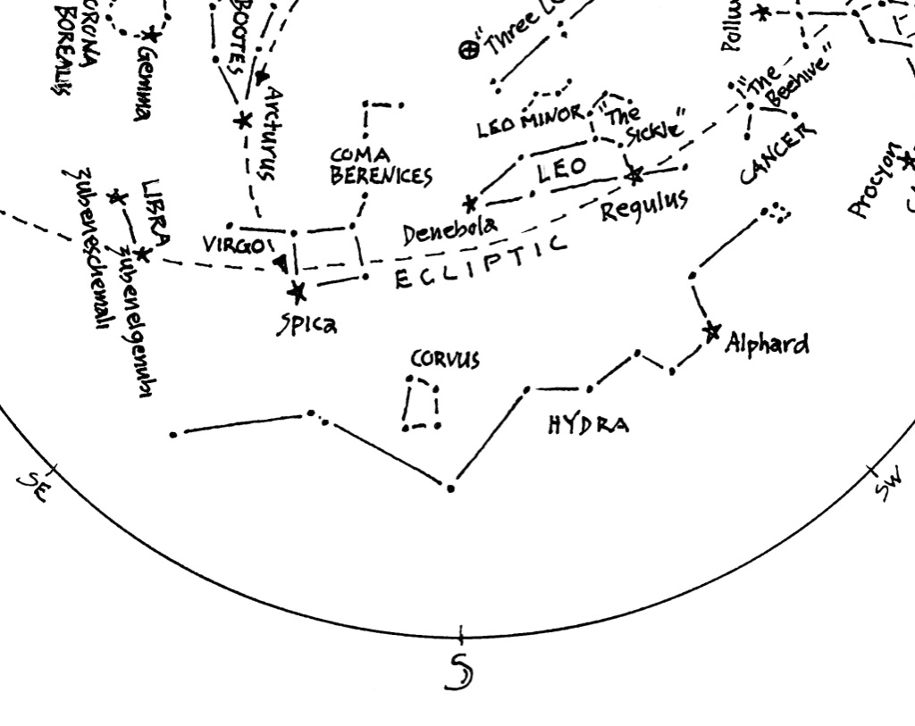
Figure 2: Detail from the chart in Figure 1
Star chart oriented to view the southern sky. South horizon is at the bottom of the chart. Zenith, the point directly overhead, is marked with (+). Stars and figures in the lower portion of the chart match those visible in the southern sky.

Last, a note about lighting. Many stars are dim and difficult to see, even under the best conditions and darkest skies. As you look at the night sky, your eyes will adapt to the dark, opening slowly to admit more light. But if you illuminate the map to read it in the dark, your eyes may respond by closing down again and becoming less sensitive. For this reason, a red-filtered flashlight is recommended for reading a star chart in the dark. Red light does not affect our eyes the way white lighting does, and so a red light will allow you to read a star chart without the risk of closing your eyes off to the dimmer stars in the sky.

You might already have a headlamp with a red bulb option, and that will work just fine. Otherwise, you can easily modify an ordinary flashlight to be red-filtered: Just cover the lens of the flashlight with masking tape, and color the tape with a red marker. A Sharpie works great. So does a red crayon. It may take a few layers of tape and marker to get the light to quiet down sufficiently. You’ll want enough light to read your star chart in the dark, but not so much that it blinds your eyes to the stars. It may take some experimenting to find what works best.
Equipped with a map of the sky and your red-filtered light, you’re ready to head out under the stars. But know that it can take a while to understand everything in the charts – don’t expect every bit to make sense on the first trip out. Fortunately, the stars on one night will be pretty much the same as the stars on the next, and on the next after that, and the next after that… the skies change ever-so-slowly as our planet wends its way around the Sun in its yearly orbit, so there’s no rush in getting acquainted.
But the more time you spend with the stars, the more familiar they’ll become. Take your chart out as often as you can. Make a habit of taking a peek at the sky before you’re off to sleep – just a few minutes is enough to refresh and reacquaint with the stars overhead. And as you greet them by name, and trace with your fingers the figures and shapes they form, the skies overhead will draw ever closer as a part of the place you call home.

© theblueskyclassroom

