A Naked-eye Guide to the Night Sky
The Stars of August

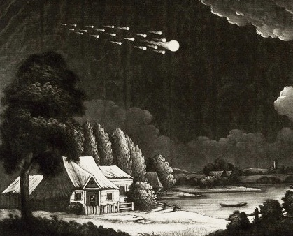
Meteor Shower in the Night Sky. Henry Robinson, 1783.

August is not just the name of a month. The word also describes something regal or majestic. And what could be more majestic - or august – than a sky strewn top to bottom with the lights of stars, the sweep of our galaxy, and the year’s most celebrated shower of meteors?
In some traditions, August heralds the start of fall. For the Celts, the month began with observance of Lammas, the cross-quarter midpoint between solstice and equinox. Commencement of the harvest was celebrated by baking bread from the season’s first cut of wheat.

To be sure, even as the warmth of summer lingers, signs of autumn are in the air. Is it something in the slant of light? Something in the colors of leaves? Or is it something audible in the voice of the wind? Whatever the case, the midday Sun is sinking by degrees. By mid-month the familiar stars of summer will have begun their slow retreat to the west, while elsewhere in the darks a host of figures will make new appearance to herald the change of seasons.
The pages that follow will introduce you to the stars alight in this month’s sky. Printable maps are attached to the end of this guide - they depict the stars as seen from mid-northern latitudes in the hours shortly after sunset, and will serve reasonably well for the entire month. Viewing is best on a moonless night. You’ll want a vantage point with an uncluttered horizon, away from the glare of lights. A general sense of the cardinal compass directions is also helpful. If you’re not already familiar with how to read a map of the sky, there’s an attachment offering some pointers – you might take a few moments to look it over before your session with the stars. Otherwise, print the charts, grab a red-filtered flashlight, and head outside for an evening under an august sky….

The Northern Sky
Begin your gaze with a look to northern skies. Stars found there are brimming with patience. Month by month they circle the pole in quiet contemplation, awaiting notice and offering guidance and counsel to any who would ask. Easiest to find are stars of the “Big Dipper”– seven lights of relatively equal brightness, by many accounts the most widely recognized figure in the sky. Stars of the Dipper belong to a group known formally as Ursa Major, the Great Bear, but history abounds with alternatives. Ancient Sumerians, unacquainted with the likes of bears, saw these stars as the Wagon. Month by month, it wheels its way across the northern skies. Last month found it about two hand-spans above the northwest horizon, spilling its contents. August eves find it similarly disposed, though lower in the sky in accordance with the season.

The end of the Dipper’s bowl is marked by the stars Merak and Dubhe. Their names derive from Arabic, and refer (once again) to the figure of a bear. But Merak and Dubhe are also known as “the pointers,” because a line drawn through them steers the eye to Polaris, the North Star. Known historically as Stella Navigatoria, Polaris has guided travelers across oceans and deserts for centuries. Face Polaris, and you’re looking north, no matter the hour or season.
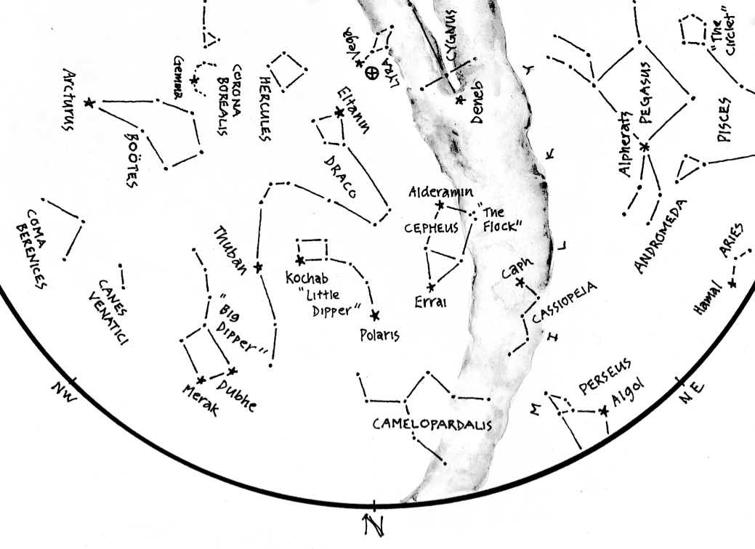
Figure 1: The Northern Skies of August
Golden apples, and the celestial hearth
.
From Polaris, a string of stars curves upward and left to form the “Little Dipper”, known also as Ursa Minor, the Lesser Bear. As with its larger companion, the image of a bear is hard to reckon. Ancient Greeks saw these stars as the Hesperides, clear-voiced Daughters of the Evening whose garden bore apples made of gold. Legends held that the apples conferred immortality to any who tasted them – reason enough to enlist the aid of a dragon, Ladon, to safeguard them from thieves. Today, the Dragon survives in the guise of Draco, draped this month above the Hesperides. Hour after hour, the maidens and their dragon circle the northern sky, ever protective of the golden treasures ripening at the pole.
As it turns, they have reason to worry. Spectral analysis of light from Polaris confirms that it’s a yellow supergiant – a golden apple, as it were, hung in plain view and ripe for the picking. And picked it will be – the Naked-eye Guide to July explained how a wobble in Earth’s axis displaces the celestial pole through a series of stars over a span of 26,000 years. Unfazed by maidens and their dragon, the greedy fingers of time will eventually wrest Polaris from the pole, plucking it like a golden apple from the garden of the Hesperides.
Returning now to the pointers Merak and Dubhe, extend a line beyond Polaris to the next star you see. This is Errrai, a prominent star in the figure of Cepheus, the King. Classical depictions show a monarch seated on a throne, but there’s humility beneath the royal veneer. Errai translates as “shepherd”, a name well-suited to a star that never sets - hour after hour it circles the northern sky, comfort and kin to shepherds through the long darks of night. With luck, you might spot “the Flock” quietly grazing elsewhere in the figure.
In oral traditions of the Pawnee Nation, stars of Cepheus embody the prophet Pahukatawa. His name translates as “knee-prints by the water” – all that remained of him in the aftermath of tribal warfare. Lost to his grieving family, his spirit miraculously reappeared to inspire hope in a time of duress and deprivation. Diseases subsided and buffalo returned in a story of faith renewed by the lights overhead.
Continuing clockwise, look for the distinct zig-zag of five stars marking Cassiopeia, Queen and consort to the King. The star atop the figure is Caph, which translates to “hand” - Imagine it clutching a mirror, into which the Queen gazes in self-admiration. While she’s otherwise distracted, take a moment to note that a line drawn from Caph through Errai, the shepherd, points roughly to Polaris - a convenient guide to the pole star if the Dipper’s pointers are obscured.
August eves find the figures of Cassiopeia and Ursa Major at equipoise, in perfect parity just east and west of the pole star. In Navajo tradition, the figures are known as Whirling Woman and Whirling Man – deified elders who set a moral example through their fidelity and close attention to the celestial hearth. The hearth itself was held to be the pole star, around which the heavens and every aspect of domestic and civil life revolved.

In point of fact, Whirling Man and Whirling Woman know all too well the challenge of striking balance amid dizzying realities of lives lived aloft. Take a moment to relocate the star Caph, and extend from there a line through Megrez, the star connecting Big Dipper’s bowl to its handle. The line so described is a fragment of the Equinoctial Colure – science-speak for a celestial tightrope strung between stations
of the Sun at the equinoxes. Westward, the line is anchored in the constellation of Virgo, home to the Sun in the season of harvest. To the east, the line is anchored in the constellation of Pisces, where the Sun seeks renewal in the freshening breeze of spring. And so it is that Whirling Man and Whirling Woman balance nimbly on a line strung across the heavens, ever alert to the turn of seasons through the wheel of the year.

Last in our look to the north is a hint of the figure of Perseus, the Hero. He’ll make full appearance in September with a story to tell, but his entrance is preceded with fanfare: In the darks of mid-August, the Hero throws forth a spectacle known as the Perseid Meteor Shower. More to say about the fireworks when we conclude our gaze. For now, look for the Hero in three brightish stars inching clear of the northeast horizon

The Western Sky

Now shift your attention westward with a quarter turn to the left. Rotate your star chart so “W” is at the bottom, toward the ground. What you see in the bottom half of the chart will match the brightest stars in the western sky, as seen in Figure 2.

Stars in the west have commanded the sky for months. Now, they steer for the horizon much as our own star, the Sun, seeks respite at the close of day. Night by night they drop lower, but echoes of their stories still reverberate in memories of the season just passed. Most prominent among them is the imposing figure of Bootes, the Herdsman, hard at work in the fading light of late summer eves. Brightest star in the figure is red Arcturus, a giant among stars and third brightest in the sky. Oft times credited with invention of the plough, the Herdsman has been associated with the practice of agriculture since the time of ancient Babylon. His appearance in March coincides with the season of planting, and he works the fields overhead through the long days of summer. There’s still much work to be done, and the Herdsman will remain aloft until the last harvest is gathered come September. Close beside him run his faithful dogs, Canes Venatici. Darkness looms, but their energy is boundless -watch them nip at the heels of the Greater Bear as it roots for berries around the pole.

Between and slightly below the Herdsman and his dogs, look for the wispy locks of Coma Berenices. Named for the hair of an Egyptian queen, the figure lies in the direction of our galaxy’s northern axis. A look in that direction is upward and out of the disk of the Milky Way toward reaches of emptiness beyond our home.

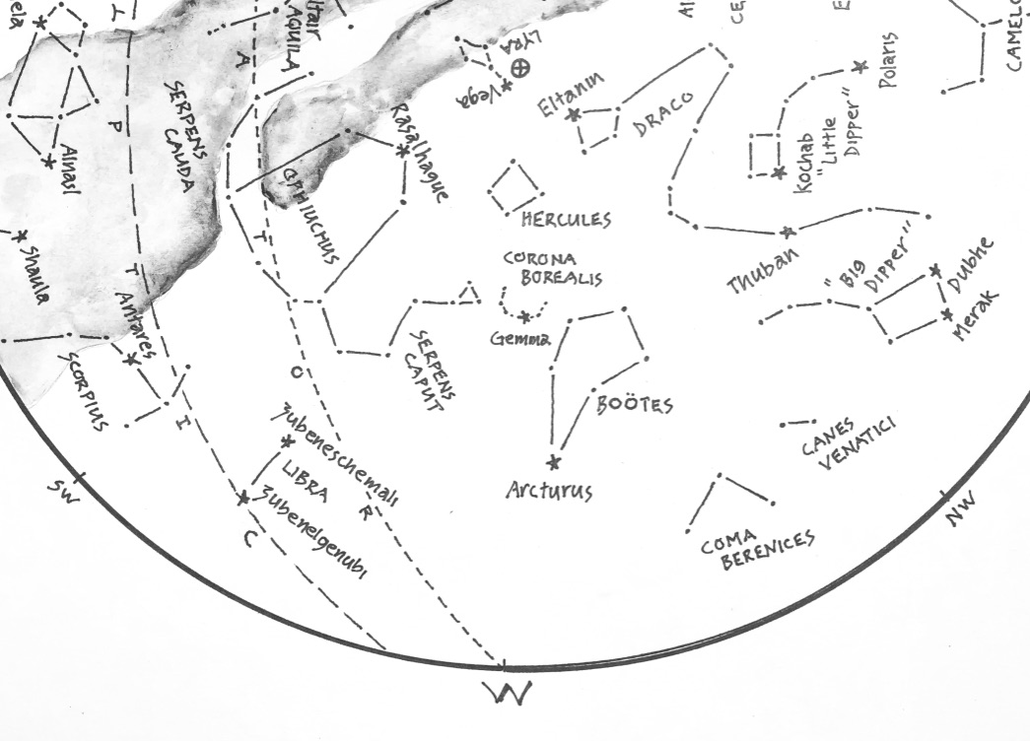
Figure 2: The Western Sky
Arc to Arcturus…

Legend claims that Bernice’s hair was a votive offering stolen from the temple of Apollo. In these weeks of August it’s easy to imagine Berenice’s golden tresses being hauled away by an unknown hand as they sink toward the horizon.

Just left of the Herdsman you’ll find Corona Borealis, the Northern Crown. Brightest star in this lovely figure is Gemma, truly a prize in any sky. The Crown inspires many interpretations: A string of jewels perhaps, or elsewhere a smoke hole in the celestial sweat lodge. Others see a clutch of departed maidens, hopes set on dancing barefoot again in the warmth of summer sands - listen closely for the sound of their ankle bells as they touch lightly down in the coming hours.

Now follow the horns of the Crown upward to the “keystone” of Hercules. The Greeks knew Hercules as the Kneeling Man, and recent months found him at zenith, upholding the weight of the sky. But it was only a ruse – his eyes and intentions were fixed on the golden apples of the Hesperides, seen earlier near the Pole. This month, whether from fatigue or disinterest, he appears to have set aside his starry burden, and pines for a rest in the west. Close nearby, the Dragon trains eyes on the Kneeling Man, glad to be rid of him and his suspect intentions.

Look next for Ophiuchus, the Snake Handler, poised slightly south of west. The figure can be hard to identify owing to its sprawling size, but the brightish star Rasalhague is a good place to start – the name translates from Arabic as “head of the snake charmer.” Formerly known as Serpentarius, the figure is testament to the long association between snakes and healers. As for the snake, you’ll find it here in pieces: the tail, Serpens Cauda, curls upward in warning to the left, and the head, Serpens Caput, rears upward to the right, eyes transfixed by the Gem in the Northern Crown.

Complete your gaze of the western skies by finding the Scales of Libra – two brightish stars below the snake handler, emblems of balance by virtue of their similar appearance. Formerly bound to the figure of Scorpius the Scorpion, their names betray their origins: higher of the two is Zubeneschemali and the lower is Zubenelgenubi – “northern claw” and “southern claw” in Arabic. We’ll acquaint with the Scorpion shortly, when we turn attention to the southern skies.

The Southern Sky

Position yourself to view the southern sky with another turn to the left. Rotate your star chart so “S” is at the bottom, pointing toward the ground. You’ll know for sure that you’re facing south if Polaris, the North Star, is directly behind you.

Just right of center stage you’ll find red Antares, brightest star in the figure of Scorpius and steward of the southwest winds. The Scorpion’s body curves downward and left from Antares, then upward to end at Shaula, “the sting.” In Hindu mythology, the figure was imagined as an earing worn by Aditi, goddess of the boundless sky.

In Navajo tradition, the string of stars below Antares represents tracks of a rabbit, and only when the tracks are oriented as they are in the month of August is hunting of rabbits allowed to commence. Pacific Islanders, meanwhile, saw stars of the Scorpion as a coconut palm, laden with fruit and leaning westward under the weight of its bounty.
For northerners, the Scorpion never strays far from the horizon, preferring warmer climes to the south. A charter member of the Zodiac, It sits astride the ecliptic and hosts the Sun as it approaches its lowest point in the cycle of a solar year. Ancient Babylonians were thus inspired to see the Scorpion as a herald of winter and darkness, a dusky reputation further supported by a number of “temporary” stars that appeared over time in the Scorpion’s vicinity. Known today to be supernovae – brief and spectacular displays of stars in their death throes – they were seen by the ancients as wrinkles in an otherwise dependable cosmos, and the Scorpion was widely regarded as a symbol of malevolence and chaos.

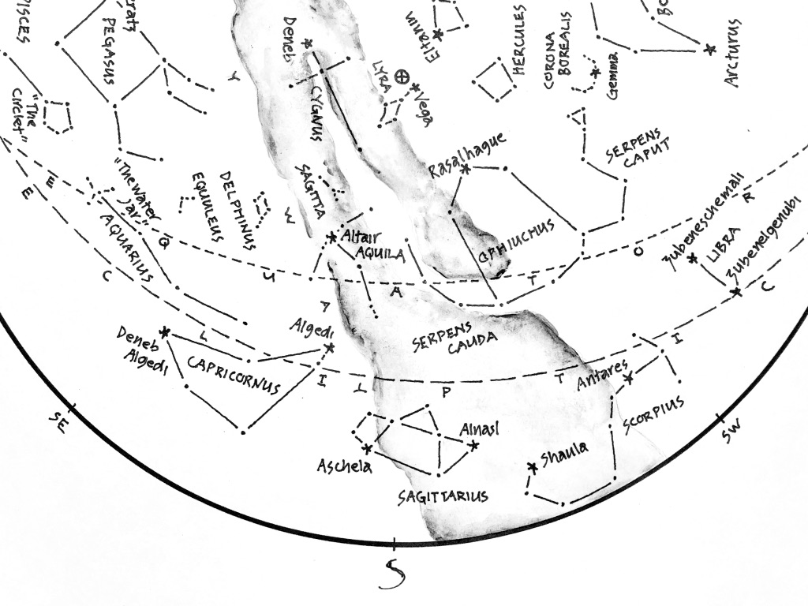

Figure 3: The Southern Sky
Home of the winter Sun.

Next, look left of the Scorpion for the figure of Sagittarius, the Archer. It, too, clings to the horizon, buried in the glow of the Milky Way. The Archer itself is hard to picture in the arrangement of stars - you’re more likely to recognize the familiar form of a teapot, with steam of the Milky Way issuing from its spout. The star Elnasl translates as “the point” in reference to the Archer’s arrow - as luck would have it, a handy signpost to the center of our galaxy, 30,000 light years distant and alight with a multitude of stars.

On these evenings of August the Galaxy is especially prominent, connecting north and south points on the horizon with a luminous arc passing nearly through zenith. The fact that it’s comprised of stars was long suspected, but only confirmed after invention of the telescope. For most of human history, it was eyed with uncertainty: a bridge perhaps, or a river… or, as its name implies, a splash of spilt milk. Some saw it as the Road of Souls, alight with campfires of the dead on their journey to the hereafter. So… is it stars, or is it souls? Either way, whether by luck or design, the Archer’s arrow points to a gathering in the southern skies of summer.

Continuing left of the Archer you’ll find the Goat-Fish, Capricornus. The strange and unlikely image was the invention of ancient Sumerians. It’s a dim triangle of stars, and difficult to discern amid brighter stars in the neighborhood. The star Algedi translates as “head of the goat.” Opposite, look for Deneb Algedi – “tail of the goat”, as one might expect. Thousands of years ago, the Goat-Fish played host to the Sun on the winter Solstice, from which point the solar year began anew.

The Goat-Fish stands on the western shore of the Celestial Sea, an expanse of sky awash with watery figures we’ll meet in the months ahead. For now, look for Aquarius, the Water-Bearer, in a strand of stars above and left of the Goat-Fish. The figure’s gentle undulation is vaguely reminiscent of an ocean swell. The strand is tied to a Y-shaped cluster known as “the Water-Jar”. For the ancients, passage of the Sun through the stars of Aquarius heralded the promise of rain. Sadalmelik, a star close by the Water Jar, translates as “lucky Star of the King”, reference perhaps to bounties of spring that follow the downpours of winter.
The Scorpion, Archer, Goat-Fish and Water-Bearer belong to the Zodiac. They and their cohorts line the ecliptic, path of the Sun, Moon, and planets across the backdrop of stars. The Moon is especially energetic, cycling though the Zodiac in the course of a month. The planets are slower by far, owing in part to their retrograde motion - moments of doubt and indecision when they stop to admire the view, or move backwards in search of something dropped or forgotten. This penchant for planets to retrace their steps confounded astronomers for centuries, thwarting attempts to understand the mechanics of the clockwork overhead.
The Sun, meanwhile, plods steadily eastward along the ecliptic at the rate of one degree per day - roughly the width of an up-raised finger as seen at arm’s length. The word “degree” derives from an ancient root meaning “to go” or “walk” – inspired by observations of the Sun’s annual stroll through the background of stars. You can see this movement unfold by watching signs of the Zodiac nearest the horizon just after sunset or just before sunrise. Over time, the signs will be seen to shift in relation to the Sun. The movement, of course, is illusion, brought on by our planet’s waltz through space. But the illusion is compelling, and over the course of a year the Sun appears to make a full circuit of the ecliptic, visiting in turn each of the twelve signs of the Zodiac. The geometry is wonderfully convenient: One degree per day works (roughly) to thirty degrees per month, equivalent (roughly) to one full cycle of the Moon; three passes of the Moon, and the Sun travels (roughly) ninety degrees - a quarter circle, equivalent (roughly) to a season, and four such seasons equate to a year. Inexact? Well, yes…. but close enough to have informed calendars since the beginning of time.
The constancy of the cosmic clockwork has served for thousands of years as welcome relief from the messy realities of a world prone to disaster. Dis-aster: literally, “against the stars” - a nod to the lights above, steady in their courses and held in high esteem for their measured predictability. So unlike the world close at hand, where

systems fail, empires crumble, and winds of fortune swirl with uncertainty. The stars appear unwavering, the Imperturbable arbiters of space and time with nary a disruption of their clockwork precision.
Or so it would seem - in truth, the stars are not immutable. They’re subject to caprices unfolding on timescales far beyond the confines of human experience and comprehension. Only over long arcs of time are changes in the cosmos apparent. Two thousand years ago, the Greek astronomer Eratosthenes observed that Antares, brightest star in the Scorpion, was out-shone by Zubeneschemali in the Scales of Libra. But three hundred years later, Ptolemy of Alexandria observed that the two were of equal brightness. And so the question: Had Antares grown brighter, or had Zubeneschemali dimmed? Either case confirms that we live in a universe where change is one of the rules. And so we wait and watch in the darks, alert for hints of a wrinkle in the fabric overhead.
For now, remember that August heralds a change of season. As the Sun sets westerly, stars to the south – a quarter turn along the horizon - show where it will take up lodging in the months ahead. Of course, you’ll not see those stars behind the glare of daylight, but you can well imagine them as they appear now, strung shoulder-to-shoulder across the southern skies.

The Eastern Sky
Direct your attention now to the eastern skies, and adjust your chart accordingly. You’ll know you’re facing east if Polaris, the Pole Star, is directly to your left.
Last month’s eastern sky was dominated by the Summer Triangle - three conspicuous stars, each the brightest in a figure of its own. This month they ride even higher, carried aloft on the back of the Milky Way. Brightest of the three is Vega. It belongs to the figure of Lyra, the Harp, along with five dimmer stars close beside. In the hands of Orpheus, the Harp is said to have charmed rivers with its music, and drowned the calls of sirens as they tempted sailors at sea.
Vega is one of the most studied stars in the sky. Twelve thousand years ago it commanded attention as the Pole Star, before the wobble in Earth’s axis gradually cast it aside. Once freed from obligation, it wandered the skies in ever-widening circles for centuries, serving as herald for the change of seasons. Later, it was the first star to be photographed. Later still, it was the first to have its color spectrum analyzed, as a means of determining its chemical composition. Accordingly, it serves today as a standard for gauging the brightness and colors of other stars. One may wonder what other ambitions await Vega before it reclaims the pole in thirteen thousand years, but for now it appears content to command the darks of summer skies.
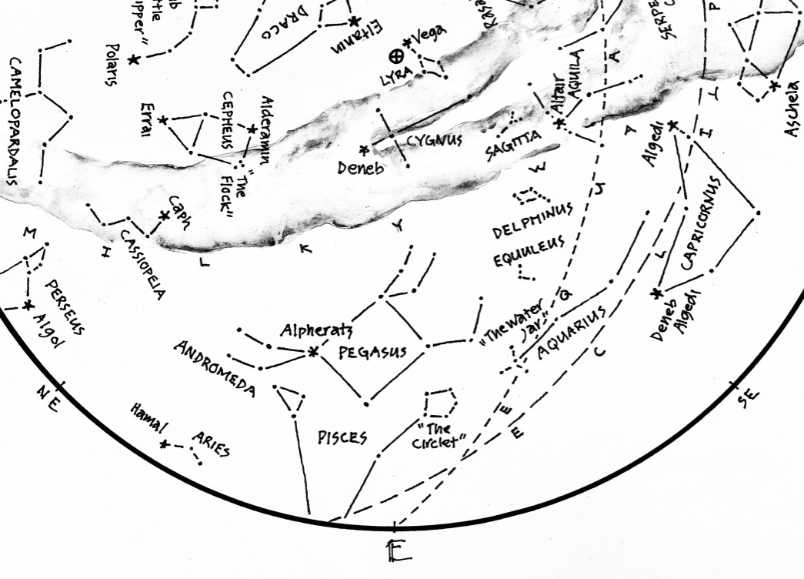
Figure 4: The Eastern Sky
Some of the smallest - and one of the largest.

Now look below and slightly left of Vega for Deneb, another star of the Summer Triangle and brightest in the figure of Cygnus the Swan. Deneb is Arabic for ‘tail” - you can spot the Swan to the right, winging southward in anticipation of shorter days. By December it will have molted, shedding feathers to reveal itself as the Northern Cross.
Complete the Summer Triangle by finding Altair, brightest star in the figure of Aquila, the Eagle. Some traditions saw the Eagle as a messenger, in full command of the void between heavens and Earth. Others saw a vulture, revered for scavenging bodies and returning souls skyward.

The stars of the Summer Triangle figure prominently in the tale of the Weaver and the Cowherd, star-crossed lovers banished to opposite sides of the River of Stars. The story survives today as inspiration for the Chinese Festival of Double Sevens. Each year, on the seventh day of the seventh lunar month, the Weaver and Cowherd – embodied in the stars Vega and Altair – unite for a single evening of conjugal bliss, crossing the Milky Way on a bridge of magpies through the figure of the Swan. On the Gregorian calendar, the Night of Sevens usually falls in the month of August, as fine a time as any for a tryst on a riverbank of stars.

Dim by comparison but worthy of attention, another trio awaits discovery in the eastern skies. Look first for Sagitta, the Arrow, close by Altair of the Eagle. The Arrow has survived in map and myth for over two thousand years. To the Greeks it was “Oistos”, and to the Arabs “al-sahm” - an arrow by any name, loosed to fly among the stars. Next, look for Delphinus, the Dolphin, cavorting in the darks below the Arrow - easy to miss, but cherished for centuries as a patron of sailors. The stars on the Dolphin’s back bear the curious names of Sualocin and Rotanev. Curious, that is, until they’re read backwards: Nicolaus Venator, name of the Italian astronomer who secretly (and permanently) enshrined himself among the stars. Last and lower still, see if you can find Equuleus, the Foal. It’s hardly a wisp of light, the smallest figure formally recognized in the northern hemisphere.

Now shift your sense of scale and look for the Great Square of Pegasus, an imposing group of four stars left of the Foal. Pegasus is the Great Winged Horse of antiquity, famed for its role in the story of Perseus – as already mentioned, a tale to be told in the months ahead. For now, the Horse commands the eastern sky, neck straining forward and legs furiously pumping front and rear. The figure appears upside-down to northerners, but the image of a horse is hard to miss.

The star at the northern-most corner of the square is Alpheratz, Arabic for “the horse’s navel.” Interestingly, it’s a star shared by two different figures: those hind legs of the galloping horse are actually the figure of Andromeda, daughter of Cepheus and Cassiopeia. Archetype for the classic maiden-in-distress storyline, she clings precariously to the belly of the horse, awaiting arrival of Perseus.

Last in the eastern skies, look for a lovely pentagon of stars below the figure of the Horse. These stars are known as “the Circlet”, and they represent one of the fishes in the Zodiac sign of Pisces. The other fish is harder to discern in a group of stars below the maiden Andromeda. The sign of the Fishes will become more apparent in the weeks ahead. For now, note on your star chart that the Circlet lies close by an intersection of the Ecliptic and the Celestial Equator – the “First Point of Aries”, home to the Sun come the Equinox of Spring.

The Sky Overhead: Zenith
We’ve made a complete circuit of the skies of August. Now set your chart aside, lie back on the ground, and take in the Big Picture. Stars in the west are bound for slumber, while those in the east awaken for a season aloft. Southward, the center of our Galaxy slips quietly past on the back of the Archer, as stars in the north mark time in their circles around Polaris.
You’re likely familiar with “shooting stars” – those fleeting streaks of light that spark a thrill when they appear in the darks overhead. Meteors, as they’re properly

known, are fragments of rock or metallic debris heated to incandescence as they hurl through Earth’s atmosphere. Typically numbering several per hour, they can appear at any time of night, at any time of year. Most are smaller than a pea and disintegrate before they reach our planet’s surface, but larger “fireballs” sometimes survive the fall to Earth. It’s estimated that between 5 and 40 tons of interstellar debris falls on our planet every day. To put that into perspective, consider that as much as 25% of the dust on the ground around you arrived from space. Estimates like these are based in part on studies conducted in Antarctica, where astronomers collect and measure debris from space preserved in layers of annual snowfall.
The rain of debris is relatively constant, but sometimes an abundance of dust presents as a “shower.” These occur when our planet encounters a cloud of debris left by a passing comet, and they happen predictably over the course of a year as the planet passes through streams of dust and clutter in its annual journey around the Sun. Such is the case in the month of August, as Earth passes through remains from Comet Swift-Tuttle. This comet orbits the Sun every 133 years, re-seeding the neighborhood with a fresh load of dust and debris on every go-‘round. Earth’s passage through the cloud of dust produces the annual Perseid Meteor Shower, so-named because the meteors involved appear to radiate from the figure of Perseus, glimpsed earlier near the northeast horizon. In truth, Perseid meteors have nothing whatever to do with the stars of the celebrated Hero - stars lie at unimaginable distances, while meteors that streak the sky are confined in the grasp of our planet’s atmosphere.
The Perseid Shower begins each year around July 17th, and peaks on or near the 12th of August. It’s a favorite among sky-watchers, known for producing up to a hundred meteors per hour. But don’t be surprised if you fail to see more than the usual handful of streaks across the sky during your early evening stargazes. Meteors are more common in the hours after midnight, for reasons illustrated in Figure 5.
The diagram offers a simplified illustration of Earth’s two primary motions: Daily rotation on its axis, and annual revolution around the Sun. Note as well the little smattering of specks in the diagram – debris in the wake of Comet Swift-Tuttle. At any given time, half of the planet is bathed in sunlight (see D for “daytime”), and half faces away into the darkness of space (see N for “nighttime”). As the Earth rotates, we’re carried alternately through the daytime and nighttime halves of the planet – MD in the diagram represents our location at midday, and MN shows our location at midnight. R and S, meanwhile, represent our positions at sunrise and sunset, respectively. Now, setting Earth loose on its orbital path, you can see that in the hours between sunset (S) and midnight (MN) our view into space shows where we’ve been – a lot like looking into a rear-view mirror as we drive down a highway. On the other hand, in the hours between midnight (MN) and sunrise (R), a view into space shows where we’re headed - like peering through a windshield, into a rain of falling stars.
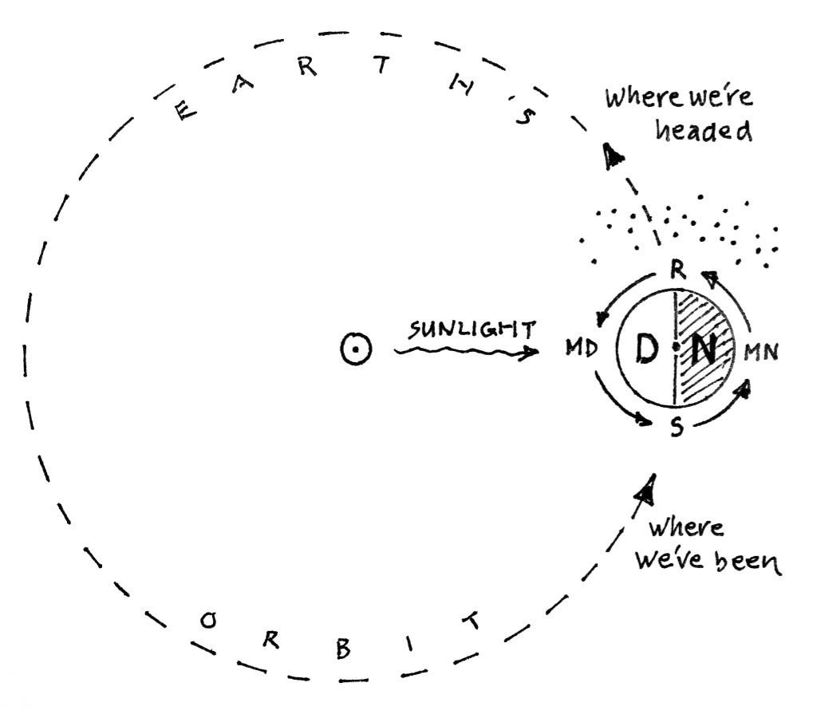
Figure 5: The Mechanics of Meteor Showers
Like so many bugs on a windshield….

Under ideal conditions, meteors are bright enough to present in a spectrum of colors, signatures of the chemical compositions of the meteors themselves: reds for oxygen and nitrogen, orange for sodium, yellow for iron, blue-green for magnesium, and violet for calcium. All of which serves to remind that elements here on Earth – elements assembled into things like rocks and air, oceans and whales, redwood trees, blue jays, and yes, even the neighbor’s barking dog – came from out there, forged in the bellies of stars. In Norse mythology, stars were imagined as sparks flung from the forge of creation, but the image is equally suited to showers of meteors. As you bask in the rain of Perseids, listen closely for the distant ring of hammers in the darks above.
All told, meteors and the shifting skies behind them serve to remind that we inhabit a rock sailing through space, affording us views into realms beyond with its every twist and turn. And so we return to where we began, to promises regal and majestic: to kings and queens, to dragons and heroes, to a river of stars coursing overhead, and to skies alight with a shower of meteors, falling like leaves in the change of season - to august skies, in every sense of the word.

© theblueskyclassroom

The Stars of August
drawn for latitude 38° N
Early August @ 11 pm, mid-month @ 10 pm, late August @ 9pm

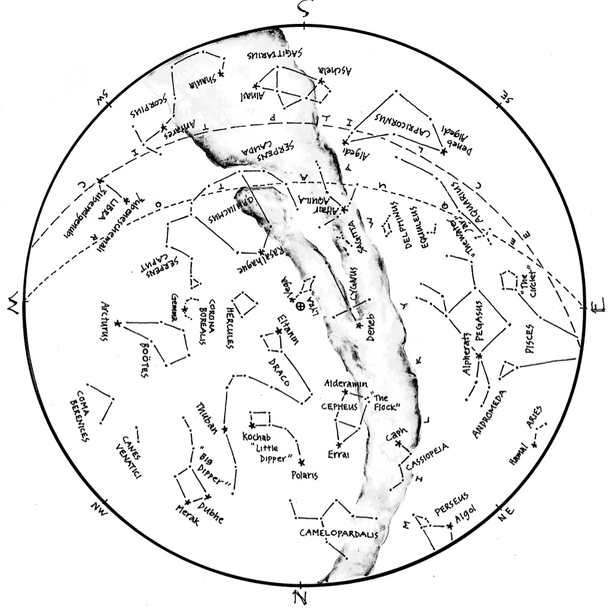
© theblueskyclassroom

The Stars of August (lines only)
Here’s a chart of the August skies, without the labels. Try labeling it yourself when you think you’re familiar with all that it shows.

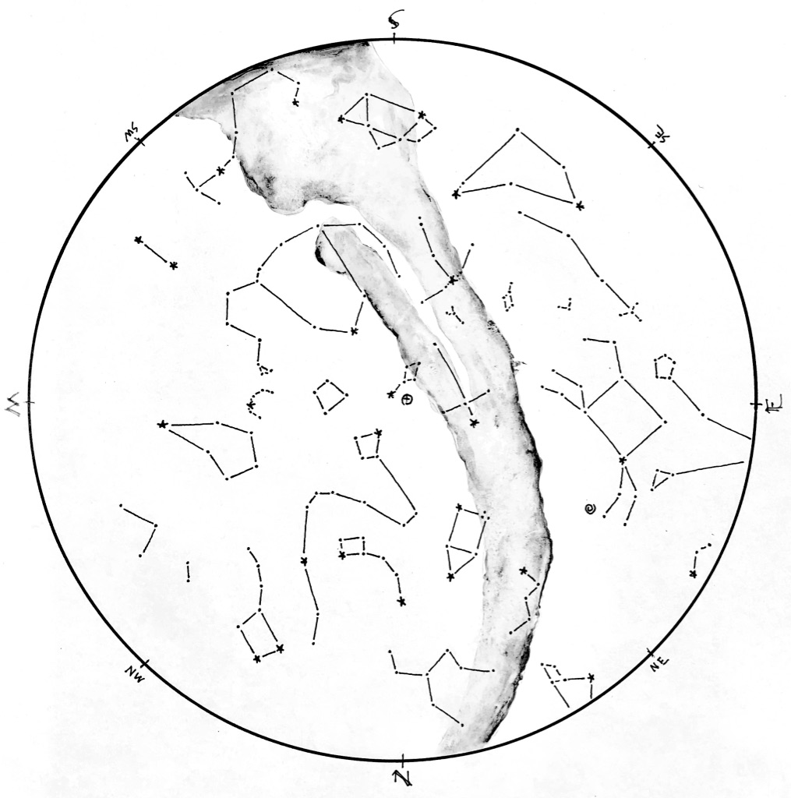

© theblueskyclassroom
The Stars of August (blank)
The chart below shows the promininent stars in this month’s sky. You can print the chart and test yourself - connect the dots, draw the figures, see what you remember from your nights out under the stars… or, if you’d rather, invent some figures of your own!

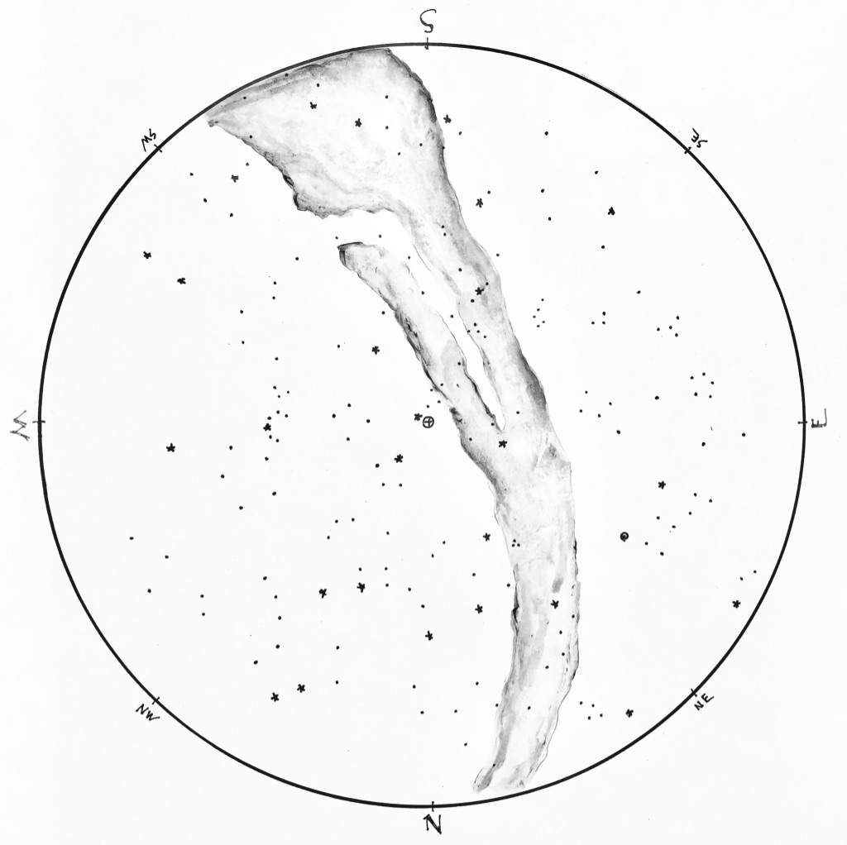
© theblueskyclassroom

A Naked-eye Guide to the Night Sky
How to Read a Star Chart

No one needs instructions on how to look at the stars. You wait until dark, you head outside, and you look up. Pretty simple. But if you want to learn the stars – if you want to know their names and come to recognize the figures they form, month after month and season after season – you might turn to a star chart for guidance.
A star chart is a lot like any other map you might have seen: It shows where things are located, identifies features by name, and lays out a picture of familiar or prominent landmarks. But a map of the sky differs in many ways from a map of the ground, and you might find it useful to get your bearings before you head out to acquaint yourself with the stars.
First, it helps to imagine the sky as a dome, arching overhead. When rendered on paper, the dome flattens into a circle, like the one seen in Figure 1. The outer edge of the circle represents the horizon. It’s marked with the compass directions, but notice that they’re arranged differently than the way we usually see them. This is because a map of the sky looks upward, the reverse of downward, and it throws the placement of compass directions a little helter-skelter. Don’t worry if this is confusing - it will all become clear when you get outside to use a chart.
Everything inside the horizon circle is the sky – again, imagined as a dome, and flattened on paper. At the center of the chart you’ll often find a symbol marking “zenith”, the point in the sky directly overhead. The word zenith comes from an Arabic expression meaning “the way or path of the head”.
Finally, know that a chart is not complete – it shows just a few of the brightest stars in the sky for a given time of year. To include everything that’s visible in the night sky would be impossible!

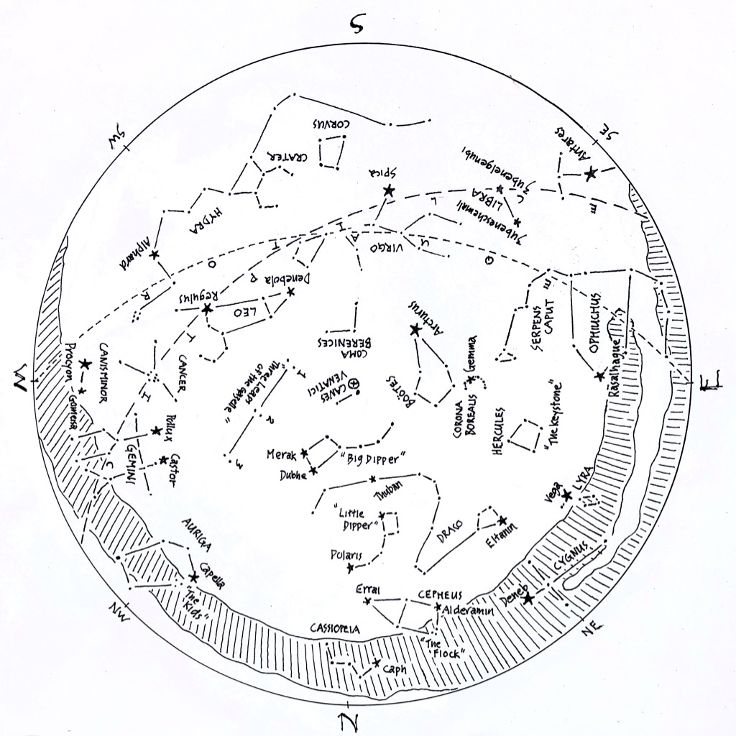

Figure 1: A sample star chart.
Drawn for the skies at around 9:30 pm. in mid-May.
Compass directions are listed around the horizon ring.
At the center of the chart, a (+) symbol inside a tiny circle of its own marks zenith, the point in the sky directly overhead.

Keep in mind that the planet you’re standing on is moving – it spins on its axis once per day, and orbits the Sun once per year. Both of these motions determine what stars will be visible at a particular hour for a given night. The star chart shown above is drawn for the skies of mid-May, about two hours after sunset. If you were to use it at a time or date very different than that, the chart would be less accurate, and you’d have a harder time matching it to the sky overhead.
To read a star chart, it’s held in hand like a steering wheel. The chart is rotated so that the direction you’re facing is at the bottom of the chart. Held in this way, the curve at the bottom of the chart represents the horizon, and everything in the lower half of the chart depicts the sky in front of you. Remember that the center of the map represents the point in the sky directly overhead – as you hold the map like a steering wheel, everything in the upper half is actually found in the sky behind you. If you want to look at those objects in the sky, you need to face that direction and rotate the map so that the new direction of sight is at the bottom of the map. As before, everything in the lower half of the map will match what you see in the sky ahead of you.
By turning your body to face different directions, and by turning the star chart to match your view, you can relate what’s on the map to what’s visible in every quarter the sky. The detail in Figure 2, below, shows the May star chart oriented to view the southern sky.
If you prefer to lie down to look at the stars, a star chart works in this case as well. Simply lay on the ground with your head pointing north, looking upward at the sky. Hold the map above you, again like a steering wheel, so that the northern mark on the horizon ring is pointing toward the north as well. In this orientation, the cardinal compass directions on the map will match those on the horizon around you, and stars on the map will match what you see in the sky. Of course, you may need to move the map aside a bit to see the stars hiding behind (above???) it.

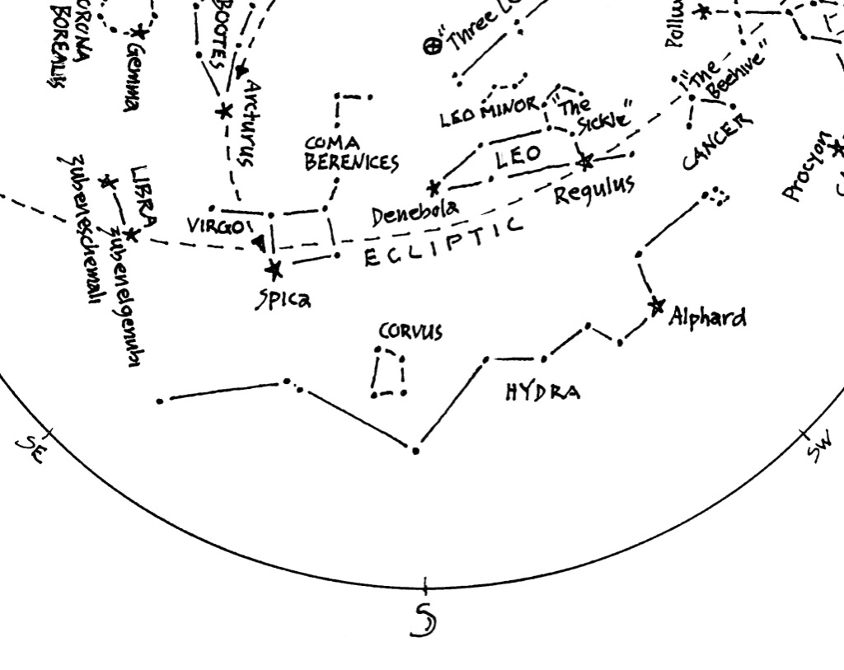
Figure 2: Detail from the chart in Figure 1
Star chart oriented to view the southern sky. South horizon is at the bottom of the chart. Zenith, the point directly overhead, is marked with (+). Stars and figures in the lower portion of the chart match those visible in the southern sky.

Last, a note about lighting. Many stars are dim and difficult to see, even under the best conditions and darkest skies. As you look at the night sky, your eyes will adapt to the dark, opening slowly to admit more light. But if you illuminate the map to read it in the dark, your eyes may respond by closing down again and becoming less sensitive. For this reason, a red-filtered flashlight is recommended for reading a star chart in the dark. Red lighting does not affect our eyes the way that bright white lighting does, and so a red light will allow you to read a star chart without the risk of closing your eyes off to the dimmer stars in the sky.

You might already have a headlamp with a red bulb option, and that will work just fine. Otherwise, you can easily modify an ordinary flashlight to be red-filtered: Just cover the lens of the flashlight with masking tape, and color the tape with a red marker. A Sharpie works great. So does a red crayon. It may take a few layers of tape and marker to get the light to quiet down sufficiently. You’ll want enough light to read your star chart in the dark, but not so much that it blinds your eyes to the stars. It may take some experimenting to find what works best.
Equipped with a map of the sky and your red-filtered light, you’re ready to become better acquainted with the stars overhead. And as you greet them by name, and trace with your fingers the figures and shapes they form, the skies overhead will draw ever closer as a part of the place you call home.

©theblueskyclassroom

