The Stars of October
drawn for latitude 38° N
Early October @ 10 pm, late October @ 9pm (PST)

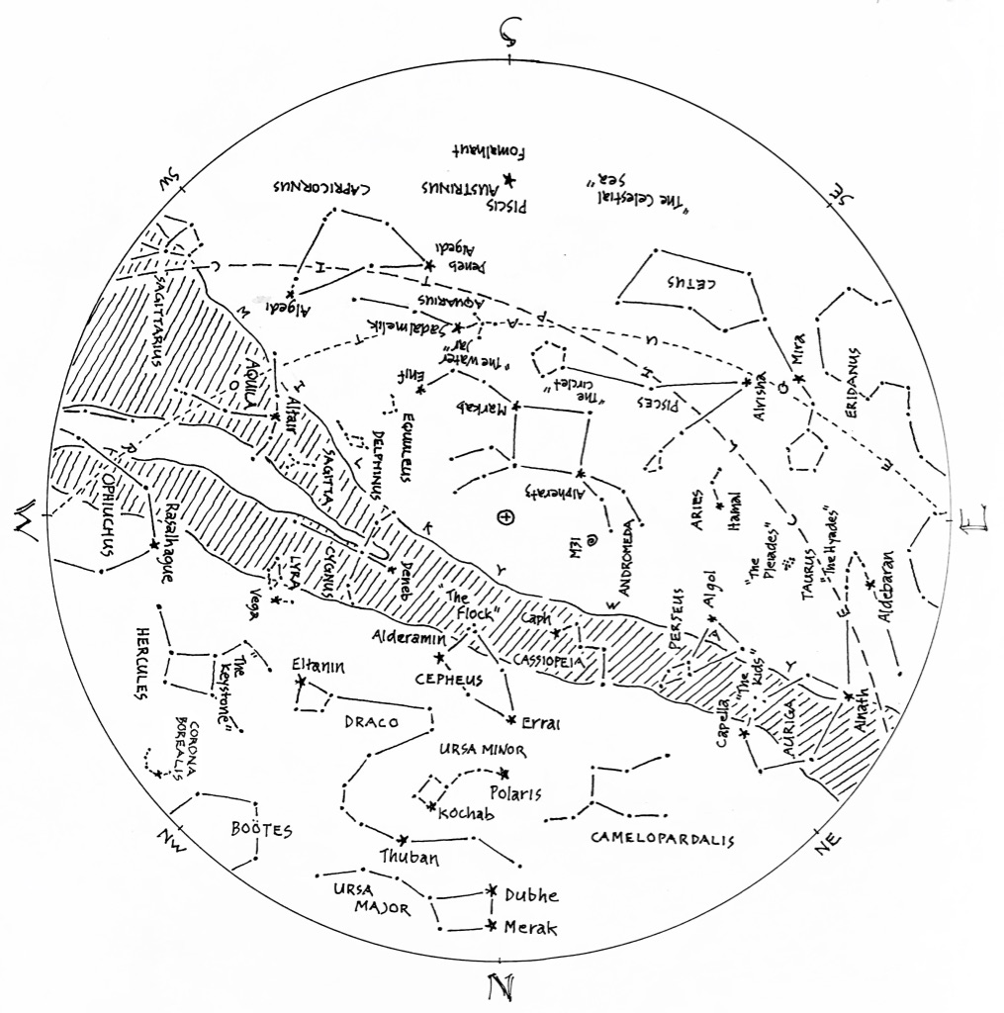

© theblueskyclassroom

The Stars of October (lines only)
Here’s a chart of the October skies, without the labels. Try labeling it yourself when
you think you’re familiar with all that it shows.

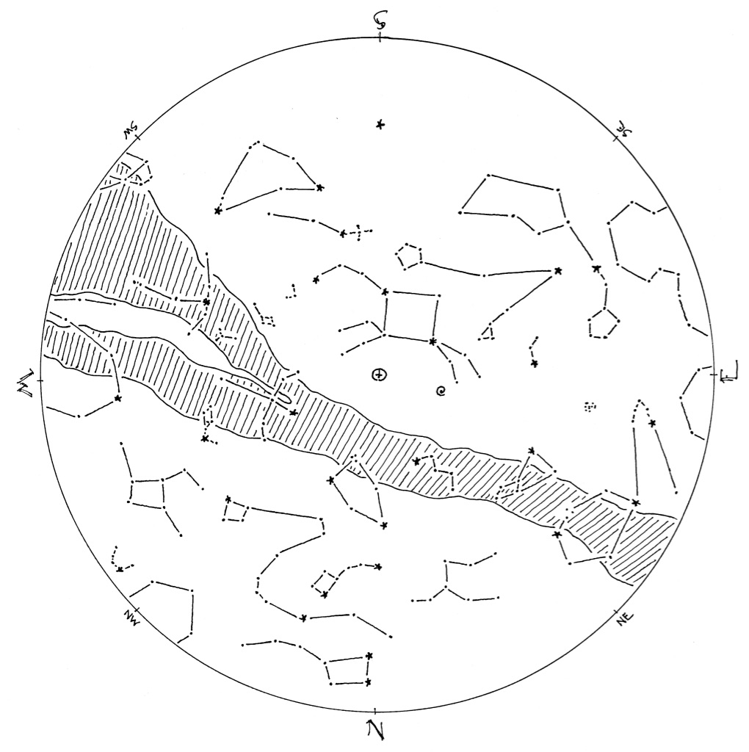

© theblueskyclassroom

The Stars of October (blank)
The chart below shows some promininent stars in this month’s sky. Can you recognize them without their names or labels? Print this chart to test yourself – connect the dots, draw the figures, see what you remember from your nights out under the stars… or, if you’d rather, invent some figures of your own!
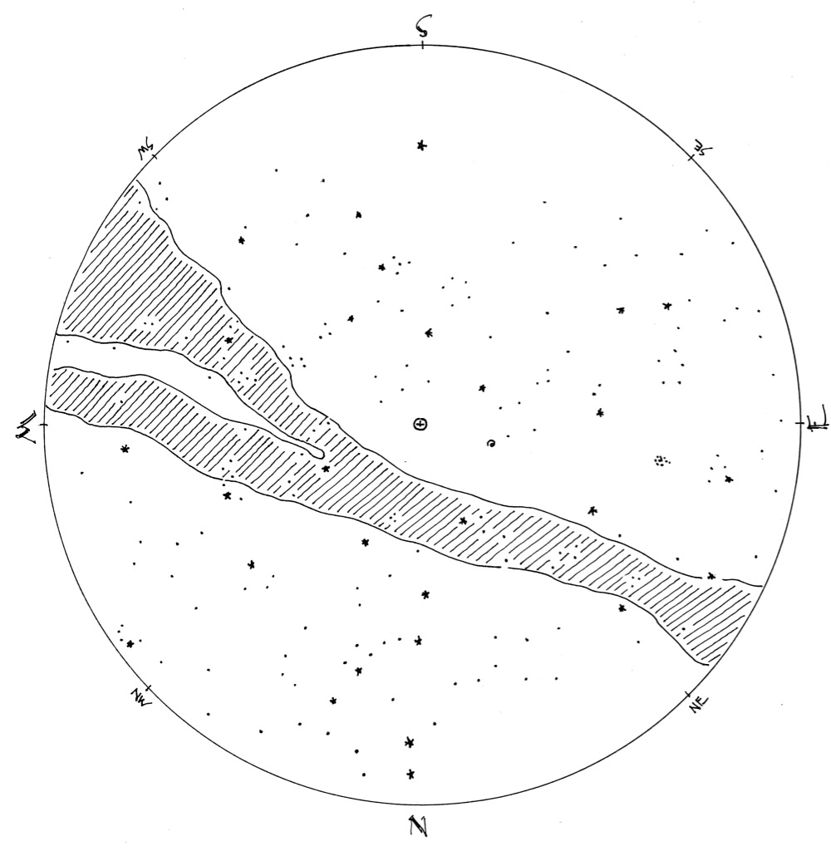

© theblueskyclassroom

